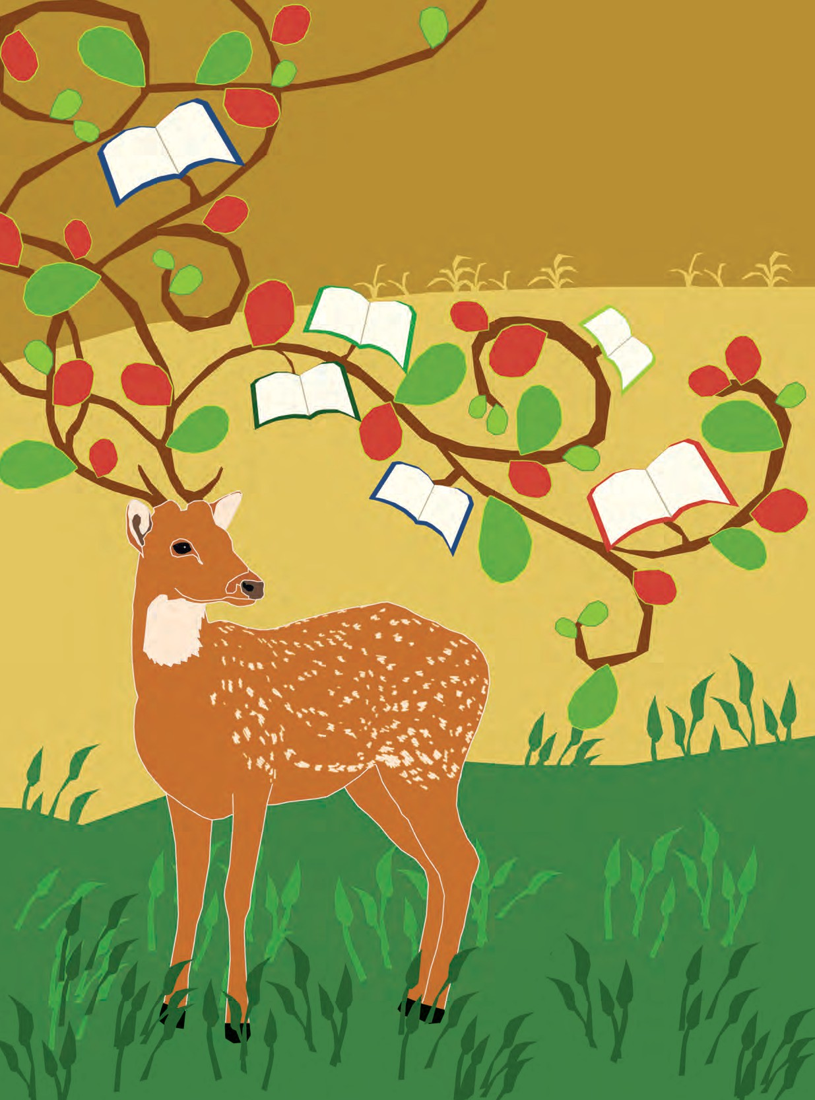

**The Constitution of India**

**Chapter IV A**

**Fundamental Duties**

**ARTICLE 51A**

**Fundamental Duties- It shall be the duty of every citizen of India-**

1. to abide by the Constitution and respect its ideals and institutions, the National Flag and the National Anthem;
2. to cherish and follow the noble ideals which inspired our national struggle for freedom;
3. to uphold and protect the sovereignty, unity and integrity of India;
4. to defend the country and render national service when called upon to do so;
5. to promote harmony and the spirit of common brotherhood amongst all the people of India transcending religious, linguistic and regional or sectional diversities, to renounce practices derogatory to the dignity of women;
6. to value and preserve the rich heritage of our composite culture;
7. to protect and improve the natural environment including forests, lakes, rivers and wild life and to have compassion for living creatures;
8. to develop the scientific temper, humanism and the spirit of inquiry

and reform;

1. to safeguard public property and to abjure violence;
2. to strive towards excellence in all spheres of individual and collective activity so that the nation constantly rises to higher levels of endeavour and achievement;
3. who is a parent or guardian to provide opportunities for education to his child or, as the case may be, ward between the age of six and fourteen years.

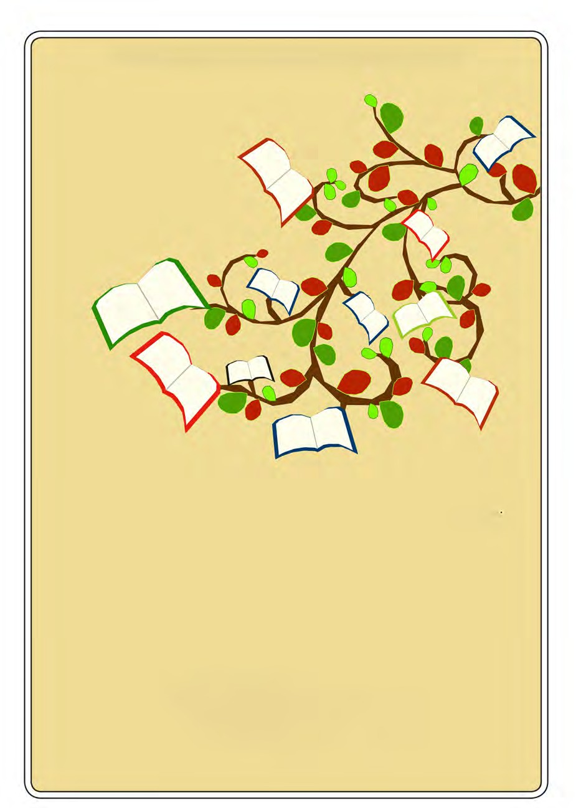

The Coordination Committee formed by GR No. Abhyas - 2116/(Pra.Kra.43/16) SD - 4 Dated 25.4.2016 has given approval to prescribe this textbook in its meeting held on 3.3.2017

**ENGLISH**

KUMARBHARATI

# STANDARD NINE

**Maharashtra State Bureau of Textbook Production and Curriculum Research, Pune.**

The digital textbook can be obtained through DIKSHA APP on a smartphone by using the Q. R. Code given on title page of the textbook and useful audio-visual teaching-learning material of the relevant lesson will be available through the Q. R. Code given in each lesson of this textbook.

**First Edition : 2017 Fifth Reprint : 2022**

**© Maharashtra State Bureau of Textbook Production and Curriculum Research, Pune - 411 004.**

The Maharashtra State Bureau of Textbook Production and Curriculum Research reserves all rights relating to the book. No part of this book should be reproduced without the written permission of the Director, Maharashtra State Bureau of Textbook Production and Curriculum Research, ‘Balbharati’, Senapati Bapat Marg, Pune 411004.

**English Language Committee :**

Dr Prabha Sampath, Chairman

Dr Manjushree Sardeshpande, Member Dr Rohit Kawale, Member

**English Language Study Group :**

Shri. Akhil Bhosale Dr Jyotimani Rocque

Dr Muktaja Mathkari, Member

Dr Shruti Chaudhary, Member Shri. Shridhar Nagargoje, Member Shri. Nilesh Kedare, Member

Smt. Dhanavanti Hardikar, Member-Secretary

**Cover :** Abha Bhagwat

**Illustrations :** Anupriya Joshi Ashna Advani

**Co-ordination :**

Dhanavanti Hardikar

Academic Secretary for Languages Santosh J. Pawar

Assistant Special Officer, English

**Production :**

Smt. Manjusha Sagrolikar Shri. Nilkantheshwar Patil Shri. Pundalik Kaviraj Smt. Renu Dhotre

Smt. Saraswathi Suram

Shri. Sharad Pandhare Smt. Smita Pore Shri. Amol Kamble Shri. Anil Petkar

Shri. Ashok Gaikwad Shri. Mohan Bapat Shri. Balkrishna Shinde

Shri. Bhuvnesh Kumbhar

Shri. Dagdu Garkar Dr Gajendra Mugale Dr Juee Kulkarni

Shri. Mahesh Dudhankar Shri. Nadeem Khan

Shri. Rajiv Sangpal Shri. Raju Korde Shri. Rakesh Jadhav

Shri. Santosh Gaikwad Smt. Yogita Patil

**Invitee :**

Smt. Samannaz Irani

**Publisher :**

Sachchitanand Aphale Chief Production Officer



Rajendra Chindarkar Production Officer

Rajendra Pandloskar Asst. Production Officer

**Paper :**

70 GSM Creamwove

**Typesetting :**

DTP Section (Languages) Textbook Bureau, Pune.

**Printer :**

**Print Order No. :**

Vivek Uttam Gosavi **Controller** Maharashtra State Textbook Bureau, Prabhadevi,

Mumbai - 400 025.

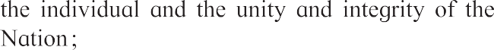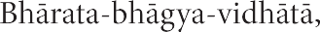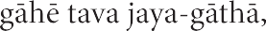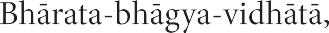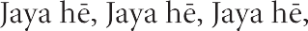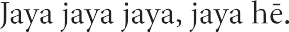

**Preface**

Dear Students,

A most hearty welcome to Std IX. We are happy to place this textbook ‘**English Kumarbharati**’ in your hands.

English has been a part of your studies since Std I. So far, you have learnt to use English for communication in most situations. You have enjoyed some interesting stories and passages in the previous textbooks. You have completed many projects. You have read the works of many well-known authors. Now that you are in Std IX, you will do all this and also learn to use English with a better understanding of the language and the way it is used.

English is not just a subject in your curriculum. It is the medium through which you learn all other subjects. A good command over the language will make it easier for you to study other subjects, too. Our main aim is to help you use English with confidence. We want you to be able to ask questions, gain knowledge and new skills, be creative and to spend your free time joyfully. That is why, we want you to take part in all the activities and exercises in the ‘Warming up’ and ‘English Workshop’ sections with enthusiasm. Talk to your teacher freely about the problems and difficulties you face while studying this textbook. Many of the activities are designed to show you ways of thinking and learning on your own. The more you use them, the better you will learn.

We will be happy if you share your feelings about the contents of this book with us. We hope you enjoy studying it throughout the year.

Wish you all the best in your studies !

**Pune**



**Date :** 28 April, 2017

Akshayya Tritiya Indian Solar Year : 8 Vaishakh 1939

**(Dr Sunil Magar) Director**

Maharashtra State Bureau of Textbook Production and Curriculum Research, Pune.

* Talk about one’s opinions or point of view.
* Communicate displeasure, disagreement, difference of opinion politely but firmly.
* Communicate pleasure, appreciation, support politely.
* Interpret lines from a literary piece.
* Advocate a cause.

**Listening**

* Summarize a story, conversation, play, informative speech or debate.
* Think critically about the information being presented.
* Note the difficult/unfamiliar bits while listening so as to ask questions later.
* Analyse and evaluate the argument being presented.
* Appreciate different styles of presentation.
* Appreciate an effective presentation, understand the features that make it effective.
* Reflect on what is heard/presented.
* Understand different interpretations of a literary piece.

**Reading**

* Read patiently till the end of the piece.
* Understand the overall structure of a literary piece: stanzas and refrain in a song, stanzas and rhyme scheme in a verse, the various threads in a story/play, etc.
* Understand the writer’s intention.
* Understand the literal as well as the suggested/ implied meaning.
* Understand and appreciate wit and humour in writing.
* Read carefully to understand a new concept/ idea.
* Read so as to compare/contrast different points of view.
* Relate and evaluate the information against one’s previous knowledge and develop further insight.
* Judge/find the authenticity/source of a piece of writing.
* Relate a literary piece of writing to one’s own experience.
* Appreciate precision, clarity, transparency in writing.
* Understand and appreciate use of literary devices, figures of speech, etc.

**Statement of Competencies : First Language**

The student should be able to -

**Speaking**

* Contribute meaningfully to conversations.
* Initiate a conversation in English (with friends, elders, etc.).
* Make efforts to improve his/her own pronunciation and speech.
* Demonstrate a process/activity clearly.
* Explain a concept or a problem.
* Present a report based on a survey, notes, information gathered from other sources.
* Use

quotations,

idioms,

proverbs

appropriately.

* Describe something in a certain way to achieve a certain effect.

**Writing**

* Write correctly. (Avoiding mistakes in spelling, grammar, etc.)
* Attempt calligraphy and decorative writing.
* Review and if necessary correct his/her own work as a matter of habit.

•

•

•

•

•

Write formal letters in the expected format. Explain a concept/an idea in short.

Express one’s own thoughts and ideas coherently and effectively.

Expand on a theme.

Report

an

event/happening

using

an

appropriate format – a news item, a personal observation (diary), etc.

* Attempt creative writing in different forms – stories, poems, skits, dialogues, cartoons, jokes, playlets, etc.
* Review a book/a film/a TV programme/a play, etc.
* Attempt using different styles of writing and different literary devices.
* Attempt using different techniques to make his/her writing more effective.
* Translate different types of informative texts from mother tongue into English and English into mother tongue.
* Translate literary pieces from mother tongue into English and English into mother tongue.
* Use resources from other languages while speaking/writing in English.
* Frame probing questions to find additional information, to find precise answers to one’s query.
* Compile data in a convenient form.
* Present information in a concise, lucid manner, choose appropriate graphics to do so.
* Use facilities like online applications, know how to make online payments, etc.
* Use the computer/internet for the purpose of translation/transcription.
* Prepare a presentation with the help of a computer.
* Appreciate and/or critically examine programmes, films, etc. available through mass media/internet etc.

* Paraphrase a word/phrase.
* Compile lists of useful words, expressions, idioms, definitions, formulas, etc.
* Make notes for personal references while listening/reading.
* Remember and recall necessary information (and the way it is organised) with the help of personal notes.
* Revise increasingly larger chunks of information mentally.
* Identify which learning strategies work best for oneself and use them.

**Study Skills**

* Parts of Speech :

Determiners - articles, demonstratives, possessive, quantifiers, numerals

* Sentence Structure :

Subject-verb agreement; transformation of sentence (voice), types of clause

* Vocabulary and word building : Compound words
* Punctuation :

colon and semi-colon

* Speech :

stress, intonation, rhyme

* Figures of speech :

Euphemism, antithesis, irony, pun

* Idioms and proverbs

**Language Study**

* 1. Life
  2. A Synopsis - The Swiss Family Robinson
  3. Have you ever seen ... ?
  4. Have you thought of the verb ‘have’ ...
  5. The Necklace

2

5

12

15

17

**Contents**

**Unit One**

Let’s Begin ! 1

**Unit Two**

* 1. Invictus
  2. A True Story of Sea Turtles
  3. Somebody’s Mother
  4. The Fall of Troy
  5. Autumn
  6. The Past in the Present

27

30

36

39

49

52

**Unit Three**

* 1. Silver
  2. Reading Works of Art
  3. The Road Not Taken
  4. How the First Letter was Written

59

61

68

72

**Unit Four**

* 1. Please Listen !
  2. The Storyteller
  3. Intellectual Rubbish
  4. My Financial Career
  5. Tansen

80

84

93

100

105

Language Study 109

## Let’s Begin !

**Know your Teacher**

Interview your teacher.

Use the following points -

* His/Her name
* The qualities he/she likes best in his/her students
* His/Her favourite English author/ book/film, etc.
* His/Her favourite teacher in school or college, and the reasons why he/ she liked that teacher.
* What your teacher would like you to focus on in Std IX.

**Priorities**

Hold a discussion in the classroom to decide your priorities for this year’s work. Together with your classmates and teacher, number the following in order of priority. You may add more features to this list.

* pronunciation
* speaking
* listening to English programmes on radio and TV
* reading something in English every day
* learning rules of grammar
* learning rules of punctuation
* learning to correct your own work
* writing independently
* memorising spellings
* copying words and lines from the board/books

(You may add to this list.)

**En - trance**

To empower ourselves in En let us -

,

●

●

●

●

●

en (*delight in*)

en (*make best efforts*) to en (*improve*) our

en *(ask to find out)* about

en (*imagine*)

●

en (*make richer*)

our

.

.

.

.

.

.

●

en (*gain knowledge and understanding*) ourselves !

**The Bigger - the Better**

Form groups of 10 students each, seated in a circle. Keep your paper and pen ready.

At the start, the group leader begins by writing **any 1** letter of the alphabet and passes the paper to the next student. The second one should add a second letter, but make sure it does not spell a complete word (an, be, is, etc) and pass it to the next. Each student should think and add a letter to help form a bigger and bigger word. The spelling of the word should not end when he/she adds a letter. If it does, he / she is **out**. Then start with a new letter.

The student left, after the rest in the group are out, is the winner.

Tip : The word excite can be stretched to exciting instead of having it end with ‘e’.

1

* 1. **Life**

**Unit One**

**Warming up !**

1. There are many popular lines like :-
   * ‘Life is a game - play it well’.
   * ‘Life is a journey - keep going ahead’.

Discuss and write down a few such metaphorical lines about ‘life’. You can make them up yourselves.

(1)

(2)

(3)

(4)

(5)

1. Prepare as many ‘acrostics’ using the word LIFE, as you can. Two examples are given below.

Live Liberty

You can turn it into a game, using a time - limit. Make sure your acrostics are related to ‘life’.

In Integrity

Freedom Fraternity

Ever Equality

1. Listen carefully and write the word in the appropriate column.

|  |  |
| --- | --- |
| Positive Feelings | Negative Feelings |
|  |  |

**Teacher :** hopeful, lonely, happy, jealous, surprised, shy, loving, proud, cheerful, anxious, nervous, excited, embarrassed, scared, silly, comfortable, peaceful, depressed, enthusiastic, motivated, inspired, threatened, crushed, angry

* + Note that it is possible to feel both kinds of emotions at the same time. Have you experienced it ? Try to describe the situation in short.

2

## Life

Life, believe, is not a dream, So dark as sages say;

Oft a little morning rain Foretells a pleasant day :

Sometimes there are clouds of gloom, But these are transient all;

If the shower will make the roses bloom, Oh, why lament its fall ?

Rapidly, merrily, Life’s sunny hours flit by,

Gratefully, cheerily, Enjoy them as they fly.

What though death at times steps in, And calls our Best away ?

What though Sorrow seems to win, O’er hope a heavy sway ?

Yet Hope again elastic springs, Unconquered, though she fell,

Still buoyant are her golden wings, Still strong to bear us well.

Manfully, fearlessly, The day of trial bear,

For gloriously, victoriously, Can courage quell despair !

* + - What do the sages say ?
    - What does the rain often foretell ?
    - What should we do during joyful times in life ?
    - Who does ‘our Best’ refer to ?
    - Why are the wings of hope ‘golden’ ?
* sway : controlling influence
* transient : temporary
* buoyant : that which can rise upwards
* lament : express grief or regret

*- Charlotte Bronte*  quell : end, suppress

3

   **ENGLISH WORKSHOP ** 

1. Pick out from the poem, two lines each that reflect an optimistic (positive) attitude and pessimistic (negative) attitude.

Optimism : (1) Pessimism : (1)

(2) (2)

1. Give other ‘-ly’ adverbs of similar meaning for the following. Use a thesaurus if needed.
   1. rapidly 🡒 (e) manfully 🡒
   2. merrily 🡒 (f) fearlessly 🡒
   3. gratefully 🡒 (g) gloriously 🡒
   4. cheerily 🡒 (h) victoriously 🡒
2. Pick out three examples of interrogation (rhetorical questions) from the poem.
   1. Explain in your own words the point that each one makes.

|  |  |
| --- | --- |
| **Interrogation** | **Explanation** |
| (1) |  |
| (2) |  |
| (3) |  |

* 1. Explain the metaphor in the following lines :
     1. Oft a little morning rain Foretells a pleasant day
     2. Sometimes there are clouds
     3. ... the shower will make the roses bloom
     4. Life’s sunny hours flit by
  2. Pick out four examples of personification. Write what is personified in each :

(1) (3)

(2) (4)

* 1. ‘And calls our Best away’ is a gentle way of expressing the unpleasant idea of a loved one dying. It is an example of euphemism. Think and write down 3 or 4 ways in which we can express the idea of ‘death’ in a tactful and gentle manner.

(1) (3)

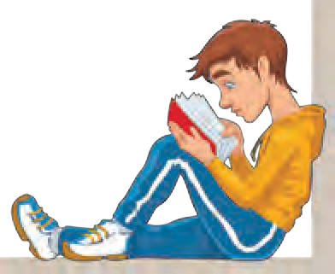(2) (4)

1. ‘..... and that’s how I realised that courage and hope can help me overcome any major mishap/problem in life.’ Write an episode / experience from your own life that leads to the above conclusion.
2. **Read :** ‘The Psalm of Life’ - a poem by H. W. Longfellow.

4

## A Synopsis - The Swiss Family Robinson

   **Warming up ! **  

1. Do you know any stories about people who were lost in uninhabited places and were later rescued ? Name them.
2. Think of one of your favourite interesting stories and fill in / draw an outline-chart like the one shown below.

**Title of the Story**

Climax

(The most interesting / exciting point)



Scene 3

Scene 2

The problem resolved

Normalcy restored End

Scene 1

Change/problem/ challenge

* + Many times, the climax is near the end. A few stories end with a climax to achieve greater effect.
  + Find the meaning of ‘anticlimax’ .
* Write as many scenes as there are in the story.

1. Divide the class into groups of 4-6. Each group selects for itself, one of the difficult situations listed below. Each group imagine themselves to be in that situation.

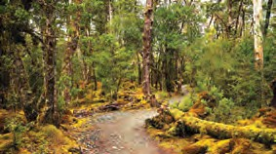

(a) **marooned on an island** (b) **lost in a forest** (c) **stranded on the highway**

A group of passengers are marooned on an island in the middle of the ocean.

1. group of pilgrims walking through a thick jungle have lost their way.

A team of players from an office have got down at the wrong place on a highway at night. It is a lonely spot.

* + Describe their surroundings in 4-5 sentences.
  + Write the reactions of the companions using exclamations.
  + Using your imagination, write what is the only ray of hope for them.
  + Two members of the group are going out to try to get help. They can take any five things with them. Write what they choose, and why they choose it.

5

## A Synopsis - The Swiss Family Robinson

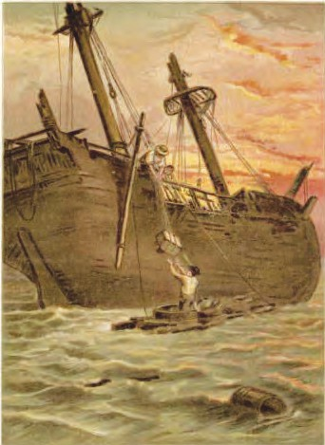

* In what way is

a work of fiction different from a fact file ?

* How did the family reach the tropical island ?
* hold : Here, space in a ship for cargo
* evacuated : left the ship to save themselves
* reef : rocks and sand etc. close to the surface of the sea
* vessel : Here, it means a boat.
* pinnace : small boats attached to a ship
* kegs : barrels

The Swiss Family Robinson is a well - known adventure novel that people of many countries have enjoyed for more than two hundred years. It has also been made into graphic novels and films.

The novel, written by the Swiss clergyman Johann David Wyss, is not just an adventure. It aims at teaching young people values like self - reliance, determination, love for your family, co - operation and prudent use of resources. It also has good lessons relevant in natural sciences, good husbandry and even mathematics !

Some elements of the novel do stretch reality to a certain extent - but we must consider that it is a work of fiction and not a fact file. Given below is a synopsis - an outline of its basic story.

William, Elizabeth and their children had been travelling in a ship when the ship was caught in a great storm. The other passengers evacuated without them. William, and his family including the young children Fritz, Ernest, Jack and Franz, were left to survive alone. They weathered the great storm waiting in the ship’s hold. The ship survived the night and the family found themselves within sight of a tropical desert island The next morning, they decided to get to the island they could see beyond the reef. With much effort, they constructed a vessel out of tubs. After they filled the tubs with food and ammunition and all other articles of value they could safely carry, they rowed toward the island. Two dogs from the ship named Turk and Juno swam beside them. The ship’s cargo of livestock, guns and powder, carpentry tools, books, a disassembled pinnace, and provisions had also survived.

Over the next few days, William (father) attached the floatable old kegs to one another and built a bow that curved around them. The family had landed successfully on the island. They set up a tent and softened the floor with armloads of grass they cut and spread to serve as their beds. They came to a grove of trees. One tree grew what looked like gourds on its

6

trunk. The father told Fritz, the gourds would make excellent bowls and spoons, and they cut them into various utensils.

After some days, Elizabeth informed William that she wanted the family to move to a safer place. Their current camp was not only exposed but also very dry and hot. If they built a house up in one of the large trees, they would be safe from jackals. She described a perfect tree for the project, one whose trunk was nearly forty feet in diameter. The branches were very long and extended straight out from the trunk, making them perfect platforms for a structure. Later, when determining the height of the lowest branches, the father taught the boys geometry and how to use triangles to measure big objects. He measured a defined distance from the trunk, then he calculated angles using several measured rods, determining that the lowest branch was thirty feet off the ground.

The men knotted a rope at certain intervals and attached pieces of bamboo in each knot. Thus, they created their ladder. Father returned to the beach and collected driftwood, thinking it would be perfect to build a ‘sledge,’ on runners rather than wheels. Later, they used it to transport materials.

Meanwhile Elizabeth announced that the garden she had been tending was producing healthy plants. Corn,

* + Why did Mother wish to shift the family to a tree - house ?
* runners : stripes on which something slides

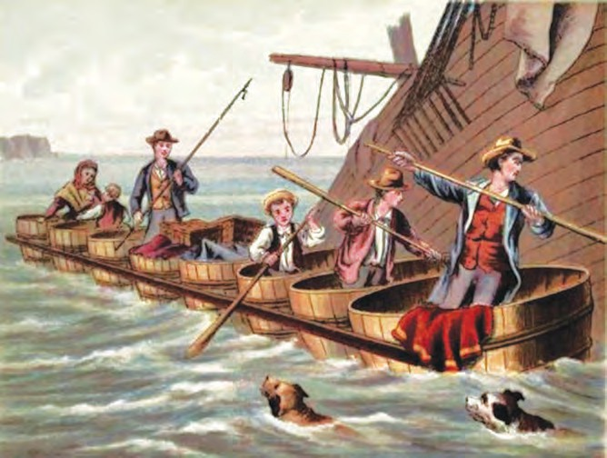

7

* How did the mother occupy herself while the tree house was being built ?
* What was the third place the family decided to reside in ? Why did they wish to shift there ?
* What made the family change over to their fourth

residence ? What precaution did they take before building it ?

* Do the changes in the family’s residence remind you of the history of man’s evolution ?
* exuding : giving out, emitting
* abutting : having common boundary
* oppressive : distressing

melons, pumpkins, and cucumbers were already growing. The next day, only the father and Fritz travelled to the woods, exploring and finding such exotic plants as one with waxy fruit, from which candles could be made. Fritz discovered a tree exuding a rubbery sap, from which his father claimed that they could make boots.

Thinking ahead of the next winter, father decided to create a place safe from the elements, a strong storage spot to protect themselves and their belongings. Fritz came up with the idea of a cave. Not finding one, they thought of carving out their own cave in the rock abutting their camping site. On the smooth face of the rock, father marked the dimensions for an opening and they picked away at the hard surface with their axes, chisels, hammers, and shovels. Over the next several days, the family cut windows in the rocks to allow for crosscurrents of air and for sunlight to enter the cave. When they had finished, they had four rooms, complete with a fireplace. They now had a new winter home.

Because of the low light, the cave house they had built felt oppressive. To remedy this, father and Jack rigged up a new light. They found a bamboo pole that would reach from the floor to the ceiling. Then after securing it, Jack climbed to the top of the pole and hung a large oil lamp that they had rescued from the ship.

One day, they found that one of the family’s huts had been completely destroyed and the cultivated fields around it had been trampled and ruined. There were huge footmarks everywhere. Father saw massive damage to trees as well as many huge footprints, which he identified as belonging to an elephant herd.

The next morning, the family began to design a new defence to discourage all wild animals from entering their cultivated lands. They also finalised their ideas about the new residence. Rather than building a house on stilts, which the elephants could knock down easily, they would use four strong trees growing in a square near one another as the foundation. The trees were of equal size, approximately twelve feet apart. Thus, they built another safe home.

8

Ten years passed and the young boys were now young men, and their parents were very proud. They called the island New Switzerland. Many adventures occurred over the years.

On the shore of another island, Fritz had knocked down an albatross, which was threatening to attack him and found a rag tied to the large bird’s leg. On the rag was a message that an Englishwoman had been stranded on the ‘smoking rock.’ Fritz had no idea how old the message was. His father suggested that “smoking rock” sounded like a reference to a volcano. Since there were no volcanoes in the vicinity, the bird might have come from hundreds of miles away. However, Fritz felt that someone needed his help, and he was determined to do his best to find the sender. Before returning home, he had written his own note on the rag, retied it to the albatross’s leg, and had watched the bird fly off. The note told whoever received it “Do not despair. Help is near!” Fritz, then successfully, rescued the young woman, Jenny Montrose. Though shy at first, soon, she got used to living with the Robinson family.

One day, they saw a ship, which had laid anchor. An encampment had been set up on one of the smaller islands. After checking the people through their spyglass, Fritz and his father decided to announce themselves after they had returned home and cleaned it up. They did not want the crew to think they were savages. The next day, Fritz and his father, met the captain and told him their own history as well as Jenny’s. To everyone’s surprise, it had been Jenny’s father who had inspired the captain’s search; he believed his daughter was still alive after three years. The captain had decided to attempt to find her.

With a burst of celebration, the family, passengers, and crew of the British vessel headed towards New Switzerland. Everyone was amazed by the prosperity and good health of the survivors.

As the day ended, the father realised that decisions must be made about who wanted to stay on the island or return with the ship. Elizabeth and her husband did not wish to live anywhere but on the island. They had

* + How did Fritz learn about another victim, forsaken on a far away island ?
  + Who was the victim and how long had she survived ?
  + Who is included in the word ‘Everyone’ in ‘Everyone was amazed ...’ ?
* albatross : a large, long-winged sea-bird
* stranded : left alone helpless
* vicinity : close to

9

* How does the adventure come to a happy end ?

been there for so long and had grown used to their life. Jenny asked if anyone would support her return to England. Fritz was the first to respond. He offered cheers for ‘us’ who were going to Europe. Ernest, on the other hand, wanted to stay on the island. Jack also decided to stay back. Franz, the youngest boy, decided to join Fritz in leaving. Franz wanted a chance to receive an academic education. Before Fritz left, he told his parents of his love for Jenny and his wish to marry her.

The father had kept a record of all the adventures they had had on the island. He handed over the journals to the captain to be published. Then the ship departed.

**ENGLISH WORKSHOP**

1. Two separate words combine together to make a new word with a different meaning. They form **Compound Words**. Using a dictionary, find the meanings of the following compound words.
   * armloads
   * driftwood
   * cross - currents
   * footprints
   * fireplace
   * spyglass
2. The following words can be used as nouns as well as verbs. Make two sentences of your own, using them as a noun in one and a verb in another.
3. hold : (a) Noun - She has a strong **hold** over her children
4. Verb - Let me **hold** the bag for you
5. value : (a) Noun -
   1. Verb -
6. knot : (a) Noun -
   1. Verb -
7. travel : (a) Noun -
   1. Verb -
8. return : (a) Noun -
   1. Verb -
9. reach : (a) Noun -
   1. Verb -
10. knock : (a) Noun -
    1. Verb -
11. attack : (a) Noun -
    1. Verb -
12. mark : (a) Noun -
    1. Verb -

10

1. Given in a mixed order below are some good human attributes of the family. Pick out each from the box and write it against each line that reflects it.

(1) courage and daring (2) perseverance and positive attitude (3) foresight

(4) family bonds (5) humanity and sensitivity (6) resourcefulness (7) knowledge and its application (8) cautiousness

1. The father told Fritz, the gourds would make excellent bowls and spoons and they cut them into various utensils.
2. After some days, Elizabeth informed that she wanted the family to move to a safer place.
3. Thinking ahead of winter, father decided to create a place safe from the elements.
4. Father taught the boys geometry and how to use triangles to measure big objects.
5. ........ he believed, his daughter was still alive, after three years.
6. Ten years had passed and the young boys grew to be young men and their parents were proud of them.
7. Fritz felt that someone needed his help and he was determined to find the sender.
8. Write in your own words, how the Robinson family made each of their homes.

First home

Second home

Third home

Fourth home

1. Expand the following ideas in a paragraph or two :-
2. Where there is a will, there is a way.
3. Courage and resourcefulness are the keys to overcome problems.
4. **Individual Project :**

Choose any novel / book that you enjoyed. Prepare a **synopsis** of the novel. It should include the major events and the links between them as described in the novel.

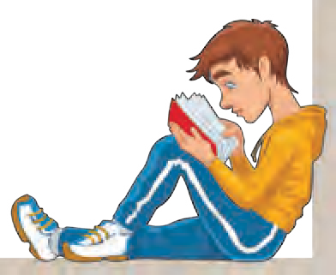You may prepare a chapterwise outline first, and then put the outlines together to write a brief synopsis.

1. **Read about** the novel ‘Robinson Crusoe’ by Daniel Defoe and ‘Gulliver’s Travels’ by Jonathan Swift.

11

## Have you ever seen...?

   **Warming up ! **  

1. Words that have the same spelling, but differ in meaning when used in different contexts are called **homographs**. For example,
   1. A temple fair attracts a lot of crowd. Her performance in the test was fair.
   2. A rose is the king of flowers. The sun rose with a golden glow.

* Think of 5 homographs and list them below. Then write 2 sentences of your own, to bring out the difference in meanings.

|  |  |
| --- | --- |
| Homograph | Sentences |
| (1) | (a)  (b) |
| (2) | (a)  (b) |
| (3) | (a)  (b) |
| (4) | (a)  (b) |
| (5) | (a)  (b) |

1. When words with the same spelling or pronunciation are used in such a way that they convey **more than one meaning,** the figure of speech involved is called **pun**. A pun is a play upon words. For example,

A : Hello ! How’s life ?

1. : Hell, O ! It’s a strife.

Find other examples of pun with the help of your parents/teacher.

(1) (3)

(2) (4)

1. In poetry, when a question is asked, not to get an answer, but to emphasise a point or fact, it is an example of **Interrogation**.

For example : • When can their glory fade ? • Isn’t it time for the autumn’s glow ?

From a popular book of poems/the internet, write down 3-4 examples of Interrogation used in poetry.

(1) (3)

(2) (4)

12

* hose : 1. a flexible tube 2. a pair of stockings or tights.

**Have you ever seen...?**

Have you ever seen a sheet on a river bed? Or a single hair from a hammer’s head ?

Has the foot of a mountain any toes ? And is there a pair of garden hose ?

Does the needle ever wink its eye ?

Why doesn’t the wing of a building fly ? Can you tickle the ribs of a parasol ?

Or open the trunk of a tree at all ?

Are the teeth of a rake ever going to bite ? Have the hands of a clock any left or right ? Can the garden plot be deep and dark ?

And what is the sound of the birch’s bark ?

*- Anonymous*

* parasol : umbrella
* plot : The word plot is also used to mean ‘an evil or wicked plan’.
* birch : a tree

**ENGLISH WORKSHOP**

1. From each line in the poem, pick out the word that is a homograph. Write its meaning in the context of the phrase used in the poem. Then write the other meaning implied in the question.

|  |  |  |  |  |
| --- | --- | --- | --- | --- |
| Stanza | Word | One meaning |  | Other meaning |
| First | (1) bed | piece of furniture | → | bottom of river, sea, etc. |
| (2) |  | → |  |
| (3) |  | → |  |
| (4) |  | → |  |
| Second | (1) |  | → |  |
| (2) |  | → |  |
| (3) |  | → |  |
| (4) |  | → |  |
| Third | (1) |  | → |  |
| (2) |  | → |  |
| (3) |  | → |  |
| (4) |  | → |  |

13

1. Write 2 lines from this poem which you find most humorous. Justify your choice.
2. Find from the poem, three examples of each :
   1. Interrogation (1)

(2)

(c) Personification (1)

(2)

(3)

* 1. Pun

(1)



(2)

(3)

(d) Alliteration (1)

(2)

(3)

1. Form groups of four or five. Think, discuss and add at least one more stanza, using the same style and devices as the poet has used. It should include homographs, interrogation and the same rhythm and rhyme-scheme.

Have / Does / Are

1. Read the following sentences carefully. Then fill in the blanks using appropriate words from the brackets, to make puns.

(struck, numbered, too tired, developed, put down, homeless, old fashioned, reaction)

1. She had a photographic memory but never it.
2. He was struggling to figure out how lightning works when it him.
3. Every calendar’s days are .
4. A bicycle cannot stand on its own because it is .
5. I’m reading a book on anti-gravity. It’s impossible to the book .
6. I’d tell you a chemistry joke but I know I wouldn’t get a .
7. What do you call Watson when Sherlock isn’t around ? .
8. I would tell a history joke, but it’s too .
9. **Read :** ‘Alice in Wonderland’ by Lewis Carroll.

14

## Have you thought of the verb ‘have’...

 We also use have to refer to eating or drinking :

1. We have breakfast at 8 am.
2. Have a slice of cake.
3. What would you like to have – tea or coffee?
4. Can I have a glass of water, please?

 We also use have to refer to events, activities and experiences :

1. I am going to have a bath in the river.
2. Let us have a party for your birthday.
3. The class has a short break at 11AM.
4. Did you have a good time at the wedding?
5. I have a meeting this evening.

 Have is also used to refer to a medical / physical condition :

1.

2.

3.

I have a headache.

He has a cold.

Grandfather

attack.

had

a heart

How many times do you use the verb ‘have’ in your conversation or writing ? Try to keep a count of it for an hour or so. What do you find ?

Perhaps you have always thought of this versatile verb as an auxiliary verb or a helping verb as we call it. The helping verb ‘have’ is used to form what we call perfect tenses (They *have come* ! I *had* clean *forgotten* all about it !) and to make negative sentences (They *haven’t come*. I *hadn’t forgotten* it). But as a main verb, it is used to mean much more than you think !

Here are a few examples we use very frequently :

 In the following sentences, ‘have’ indicates possession or ownership of something :

1. My friend has a pet cat. (possession)
2. I have a new pen.
3. Do you have a cycle ?
4. Our school has six computers. (ownership)
5. The Municipality has six vans and two cars.



In some cases, ‘have’ is used

to indicate relationships :

1.

2.

I have two sisters.

The

couple

do

not have

children.

3. I don’t have a brother.

15

In sentences where ‘have’ is used as a main verb, it is always used in the simple present or past. The present continuous form is not used in such cases. We do not say -

pass

* I am having a bicycle. **x**
* He is having a cold. **x**
* I am having a lot of homework. **x**

Similarly, it is not used in the negative form as a main verb.

* He hasn’t a car. **x**
* I haven’t a cold. **x**

To indicate the negative, we use the auxiliary ‘do’ along with the main verb ‘have’.

* He doesn’t have a car.
* I don’t have a cold.

Have fun exploring the uses of ‘have’!

   **ENGLISH WORKSHOP ** 

1. Add your own sentences to those given in the passage to illustrate the uses of ‘have’.
2. To show possession (d) To show ownership
3. To indicate relationship (e) To refer to events, activities and experiences
4. To refer to eating/drinking (f) To refer to a physical condition
5. Look up the following verbs in a good dictionary. List at least 20 different uses of each. You may include their use with different prepositions, adverbs, and in idioms.

catch

go to bed

go down

go

get

put

16

## The Necklace

**Warming up !**

#### Talking about Myself

Write a few lines about yourself - your name, appearance, family, the place where you live, your school, your friends, neighbours, relatives, your likes, dislikes, hobbies, what you are good at, etc.

Now create an imaginary ‘persona’ for yourself. It can be quite different from your real self. Or, you may choose a fictional character - a character from a novel, story, etc. Write a few lines about this imaginary persona and **introduce yourself** in that role.

Hi, I am

**Real Self**

Hi, I am

**Imaginary Persona**

**My Dream Possession**

Is there something that you would like to own more than anything else ? Describe your dream possession with the help of the following points. You may add your own points, too.

What you would do to get it

Why you want it so much

How you

Whether you would share it with others

My Dream Possession : What it is ?

Its appearance - colour, shape, size, etc.

Its use

Where you

would use it What you would use it for

saw it first

17

* Why was Mathilde married to a ‘minor official’ ?

## The Necklace

#### Part I

Mathilde was a pretty and charming girl, born, as if by an error of fate, into a family of clerks. She had no means of becoming known, understood, loved or be wedded to an aristocrat; and so she let herself be married to a minor official at the Ministry of Education.

She dressed plainly, because she had never been able to afford anything better. She suffered endlessly, feeling she was entitled to all the luxuries of life. She suffered because of her shabby, poorly furnished house. All these things, that another woman of her class would not even have noticed, tormented her and made her resentful. She dreamed of a grand, palatial mansion, with vast rooms and inviting smaller rooms, perfumed for afternoon chats with close friends.

**Reflection :**

Is anyone entitled to all luxuries of life due to reasons of birth or other innate qualities ?

Yet, she had no rich dresses, no jewels, nothing; and these were the only things she loved. She wanted

* Why

weep

did Mathilde with misery

so much to charm, to be envied, to be sought after.

She had a rich friend, a former schoolmate at the

after visiting her schoolmate ?

* What did the

convent, whom she avoided visiting, because afterwards she would weep with regret, despair and misery.

One evening her husband came home with an air

envelope

hold ?

of triumph, holding a large envelope in his hand. “Look,” he said, “here’s something for you.”

She tore open the paper and drew out a card, on which was printed the words:

“The Minister of Education and Mme. Georges Rampouneau request the pleasure of M. and Mme. Loisel’s company at the Ministry, on the evening of Monday, January 18th.”

M. stands for Monsieur and Mme stands for Madame, French terms of address (like Mr and Mrs in English).

Instead of being delighted, as her husband had hoped, she threw the invitation on the table resentfully, and muttered, “What do you want me to do with that ? And what do you expect me to wear if I go ?”

He hadn’t thought of that. He stammered, “Why,

18

the dress you go to the theatre in. It seems very nice to me ...”

He stopped, stunned, distressed to see his wife crying. He stuttered, “What’s the matter ? Let’s see, Mathilde. How much would a suitable dress cost ?”

She thought for a moment, computing the cost, and also wondering what amount she could ask for without an immediate refusal. At last she answered hesitantly, “I don’t know exactly, but I think I could do it with four hundred francs.”

He turned a little pale, because he had been saving that exact amount to buy a gun for a hunting summer, in the country near Nanterre, with a few friends. However, he said, “Very well, I can give you four hundred francs. But try and get a really beautiful dress.”

The day of the party drew near, and Madame Loisel seemed sad, restless, anxious, though her dress was ready.

One evening her husband said to her, “What’s the matter ? You’ve been acting strange these last three days.”

She replied : “I’m upset that I have no jewels, not a single stone to wear. I would rather not go to the party.”

“You could wear flowers,” he said, “They are very fashionable at this time of year.”

She was not convinced.

The next day she went to her friend’s house and told her of her distress.

Madame Forestier went to her mirrored wardrobe, took out a large box, brought it back, opened it, and said to Madame Loisel :

“Choose, my dear.”

First Mathilde saw some bracelets, then a pearl necklace. She tried on the jewellery in the mirror.

She kept asking, “You have nothing else ?”

* + Was the husband a considerate person ? How do we know that ?
  + Why did Mathilde go to her friend’s house and tell her of her distress ?
  + What did Madame Forestier’s large box contain ?

19

* + Which sentences tell us that Mathilde greatly desired the necklace ?
  + Try to express the thoughts that must have passed through Mathilde’s mind on seeing the necklace, in Mathilde’s own words.

**Think and answer:**

* + Why did Mathilde not notice the loss of her necklace earlier?
* rapturously : with great joy
* panic-stricken : with a sudden feeling of fear
* distraught : worried, disturbed

“Why, yes. But I don’t know what you like.”

Suddenly she discovered, in a black satin box, a superb diamond necklace, and her heart began to beat with uncontrolled desire. Her hands trembled as she took it. She fastened it around her neck and stood lost in ecstasy as she looked at herself.

Then she asked anxiously, hesitating, “Would you lend me this, just this ?”

“Why, yes, of course.”

She threw her arms around her friend’s neck, rapturously, then fled with her treasure.

The day of the party arrived. Madame Loisel was a success. She was prettier than all the other women, elegant, gracious, smiling, and full of joy.

She danced wildly, with passion, forgetting everything in the triumph of her beauty and success, floating in a cloud of happiness.

Mathilde and her husband left at about four o’clock in the morning. When they were finally in the street, they could not find a cab. They walked down toward the Seine, till they found one. They were dropped off at their door in the Rue des Martyrs, and sadly, it was all over, for her.

In front of the mirror, she took a final look at herself in all her glory. But suddenly she uttered a cry. She no longer had the necklace round her neck !

“What is the matter ?” asked her husband.

She turned towards him, panic-stricken, “I have ... I have ... I no longer have Madame Forestier’s necklace.”

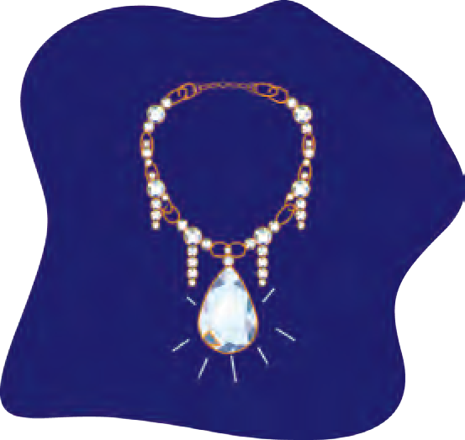He stood up, distraught, “What !... how ! …That’s impossible !”

20

   **ENGLISH WORKSHOP ** 

1. Read each of the following sentences aloud. Write who said it and to whom.
   1. “Look, here’s something for you.”
   2. “Why, the dress you go to the theatre in !”
   3. “I would rather not go to the party.”
   4. “Choose, my dear.”
   5. “You have nothing else?”
   6. “Would you lend me this, just this?”
   7. “What ! ... how ! ... That’s impossible! ”
2. Write a few lines about what Mathilde had and what she dreamt about.
3. Write what you think about the following thoughts and actions of Mathilde.
   1. Mathilde was beautiful, and so she wanted to marry an aristocrat.
   2. Mathilde was sad because she did not get any luxuries.
   3. Mathilde felt that her house was shabby and poorly furnished.
   4. Mathilde wanted other people to envy her.
   5. Mathilde was not happy to see the invitation.
   6. Mathilde wanted a new dress for herself.
   7. Mathilde borrowed a diamond necklace from her friend and wore it to the party.



Mr and Mrs

of the

solicit the pleasure of your company on the occasion

of their

on

(day), date

.

Venue

Time

(Include other requests like *RSVP*, *No presents please*, etc. at the bottom.)

(h) Mathilde lost the necklace.

**Prepare a formal invitation** using the following format:

1. Read the following :

* The necklace  an error  all these things
* another woman  one evening  her husband.

In all these phrases we see some words used before the nouns.

They specify or make it clear what noun we are talking about. These words that are used at the beginning of a noun phrase are known as **determiners**.

Determiners include **articles** (a, an, the), **possessive pronouns** (my, our, your, her, etc.), **demonstratives** (words like this, that), **quantifiers** (much, many, etc.), **numerals**, etc.

Write your phrases using each of type of determiner.

21

* What efforts did Loisel make to find the necklace ?

**Note the expressions :**

* glimmer of hope
* sick with grief and anguish
* **What is implied in**

**-** ‘a hollow, pale figure’ ?

* cloak : a garment worn over other clothes. It has

no sleeves and fastens at the neck.

* glimmer : faint, wavering light
* jewel : Here, it means the

diamond necklace.

#### Part II

They looked in the folds of her dress, in the folds of her cloak, in her pockets, everywhere. But they could not find it.

“Are you sure you still had it on when you left the hall ?” he asked.

“Yes. I touched it in the hall at the Ministry.” “But if you had lost it in the street we would have

heard it fall. It must be in the cab.”

“Yes. That’s probably it. Did you take his number ?” “No.”

They stared at each other, stunned. At last Loisel put his clothes on again. “I’m going back,” he said, “Over the whole route we walked, and see if I can find it.”

He left. She remained in her ball dress all night, her mind blank. Her husband returned at about seven o’clock. He had found nothing.

He went to the police, to the newspapers to offer a reward, to the cab companies, everywhere the tiniest glimmer of hope led him.

She waited all day, in despair at this frightful disaster.

Loisel returned in the evening, a hollow, pale figure; he had found nothing. “You must write to your friend,” he said, “tell her you have broken the clasp of her necklace and that you are having it mended. It will give us time to look some more.”

She wrote as he dictated.

At the end of one week they had lost all hope. And Loisel, who suddenly looked aged, declared, “We must consider how to replace the jewel.”

And so, they went from jeweller to jeweller, looking for a necklace like the other one, consulting their memories, both sick with grief and anguish.

In a shop at the Palais Royal, they found a string of diamonds which seemed to be exactly what they were looking for. It was worth forty thousand francs. They could have it for thirty-six thousand.

22

So they begged the jeweller not to sell it for three days. And they made an arrangement that he would take it back for thirty-four thousand francs if the other necklace was found before the end of February.

Loisel had eighteen thousand francs which his father had left him. He would borrow the rest.

And he did borrow. He gave notes, made ruinous agreements, dealt with every type of money-lender. Then he went to get the new necklace, and laid down on the jeweller’s counter thirty-six thousand francs.

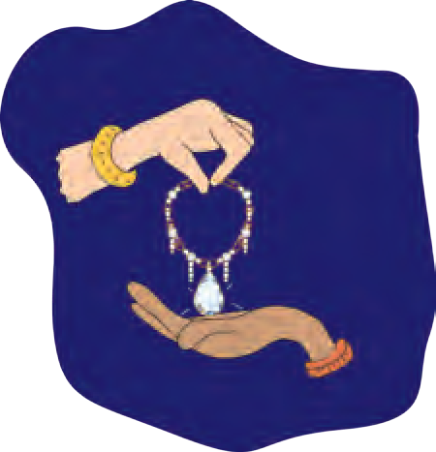When Madame Loisel took the necklace back, Madame Forestier said coldly, “You should have returned it sooner, I might have needed it.”

From then on, Madame Loisel knew the horrible life of the very poor. But she played her

part heroically. The dreadful debt must be paid. She would pay it. They dismissed their maid; they changed their lodgings; they rented a garret under the roof.

She came to know the drudgery of housework, the odious labours of the kitchen. She washed the dishes, the dirty linen, she carried the garbage down to the street every morning, and carried up the water, stopping at each landing to catch her breath and dressed like a commoner. She had to bargain at markets, quarrel and face insults over every miserable sou.

Each month they had to pay some loans, renew others, get more time.

Her husband worked extra, every evening, doing accounts for a tradesman, and often, late into the night, he sat copying a manuscript at five sous a page.

And this life lasted ten years. At the end of ten years they had paid off everything, even the interest.

Madame Loisel looked old now. Often, she brooded over the past - What would have happened if she had not lost that necklace ? How strange life is, how fickle ! How little is needed for one to be ruined or saved !

One Sunday, as she was walking in the Champs Élysées suddenly she saw Madame Forestier, still young, still beautiful, still charming.

* + What was the arrangement with the jeweller ?

Do you think it was fair ?

**Discuss :**

* + Why did Madame Forestier speak coldly to Mathilde ?
  + What is meant by ‘the horrible life of the very poor’ ?
  + What contrast is implied by the use of the word ‘still’ in ‘still young, still beautiful, still charming’ ?
* ruinous : leading to a heavy loss, ruin
* sou : French coin of low value used in the past
* garret : a small, uncomfortable room at the top of the house.
* brooded : thought sadly, unhappily

23

* + Why did Mathilde decide to speak to her friend ?

**Discuss :**

* + - Who do you think was responsible for Mathilde’s misery ? Was it her friend, she herself, her husband or the circumstances ?
* familiarly : showing closeness, familiarity

Madame Loisel felt emotional. Should she speak to her ? Yes, of course. And now that she had paid, she would tell her all. Why not ?

She went up to her, “Good morning, Jeanne.”

The other, astonished to be addressed so familiarly by this common woman, did not recognise her. She stammered:

“But - Madame - I don’t know. You must have made a mistake.”

“No, I am Mathilde Loisel.”

Her friend uttered a cry, “Oh ! ... my poor Mathilde, how you’ve changed ! ...”

“Yes, I have had some hard times since I last saw you, and many miseries ... and all because of you ! ...”

“Me ? How can that be ?”

“You remember that diamond necklace that you lent me to wear to the Ministry party ?”

“Yes. Well ?” “Well, I lost it.”

“What do you mean ? You brought it back.”

“I brought you back another exactly like it. And it has taken us ten years to pay for it. It wasn’t easy for us, we had very little. But at last it is over, and I am very glad.”

Madame Forestier was stunned.

“You say that you bought a diamond necklace to replace mine ?”

“Yes; you didn’t notice then ? They were very similar.”

And she smiled with proud and innocent pleasure.

Madame Forestier, deeply moved, took both her hands.

“Oh, my poor Mathilde ! Mine was an imitation !

It was worth five hundred francs at most ! ...”

*- Adapted from* ‘*The Necklace*’ *by Guy de Maupassant*

24

   **ENGLISH WORKSHOP ** 

1. Complete the following table.

|  |  |  |  |  |
| --- | --- | --- | --- | --- |
| No. | Utterance | Who said it | To whom | When |
| (a) | I touched it in the hall at the ministry. |  |  |  |
| (b) | It will give us time to look some more. |  |  |  |
| (c) | I might have needed it. |  |  |  |
| (d) | You must have made a mistake. |  |  |  |
| (e) | Well, I lost it. |  |  |  |
| (f) | Mine was an imitation. |  |  |  |

1. **Write what you think** about the following thoughts and actions of Mathilde :
   1. Mathilde despaired over the loss of her necklace.
   2. Mathilde wrote a note to her friend as dictated by her husband.
   3. Mathilde and her husband decided to replace the necklace.
   4. Mathilde returned the diamond necklace to her friend.
   5. Mathilde did not tell her friend about the loss and replacement.
   6. Mathilde worked very very hard to pay the debt.
   7. Mathilde and her husband paid off the debt in ten years.
   8. Mathilde told her friend about the lost necklace.
2. Form pairs. Discuss how ‘Part II’ of the story could have been different. Write your storyline in the form of bullets showing the main events.
3. Imagine what must have happened after Mathilde’s friend discovered that the diamonds were real. Do you think she would return the necklace to Mathilde ? Would that make Mathilde happy ?
4. Discuss the following and write about each in your own words in 5-6 lines.
   1. What would you do, if something like this happens to you ?
   2. What opinion do you form about Mathilde’s husband from her story ?
   3. Which events in the story (Part I and Part II) changed Mathilde’s life ?

25

1. Read, recall and remember. Read the table of verb forms given below.

|  |  |  |  |  |
| --- | --- | --- | --- | --- |
| base | -s form | past tense | present participle | past participle |
| give draw eat show take say come go | gives draws eats shows takes says comes goes | gave drew ate showed took said came went | giving drawing eating showing taking saying coming going | given drawn eaten shown taken said come gone |

* The **base form** is used as an **infinitive** : You may *go*. She will *go*;

in **orders** : *Go* home; and in the **simple present tense** : I *go* to school. We *go*

home. Do you *go* there every day ? The children / They *go* up, etc.

* Note that we use the ‘-**s form**’ with ‘he’, ‘she’, ‘it’, **third person singular subjects**

to show the **simple present.**

* The **past tense form has ‘-ed’** at the end. But many commonly used verbs have different past tense forms. Examples : *came, went, spoke*.
* The **‘-ing’ form** is known as the **present participle**. It is used with forms of ‘be’ to show **continuous action** - Examples : I *am eating*. You *were eating*. She *was eating.* It is also used in certain constructions like : He sat *copying* a manuscript.
* The **past participle** used with forms of ‘have’ shows **completed action** - Examples : I *have eaten*. They *have come*, etc.

It is also used in certain constructions like ‘They looked at each other, *stunned !*’ It is also used in **passive** constructions.

* 1. **Make a table of verb forms for your own reference.** Try to arrange the verbs in alphabetical order. Keep adding new verbs to your table from time to time. When you write, **check your work to see whether you have used the correct verb form**.
  2. List at least 10 verbs, the last letter of which is doubled in the present participle.

Example : put - putting

* 1. List at least 10 verbs, the last letter of which is doubled in the past participle.

Example : write - written

* 1. List at least 10 verbs, the last letter of which is doubled in the past tense form. Example : sob - sobbed.

1. **Read :** ‘The Gift of the Magi’ by O. Henry.

26

## Invictus

**Unit Two**

**Warming up !**

Let’s introspect !

1. Think and respond with ‘YES’ or ‘NO’.

When you are faced with a very serious problem or some grave danger, what do you experience ?

panic

wishing you were never born hopelessness

Your feelings

helplessness no emotion

calmness and composure willingness to tackle it

break down and cry run away and hide pray to God

Your reactions

ask for help build up courage

take it as a challenge

* Write about your feelings and reactions in 4-5 lines.

You may describe your feelings and reactions using other words than those given here.

* Form groups of four. Discuss what you actually feel and do in difficult situations and some of the things you could do and would like to do in those situations.

1. Guess what the following symbolise and match the pairs.
   1. a tall mountain (a) beauty
   2. a dark night (b) freedom
   3. a rose (c) deep distress
   4. sunrise (d) anger
   5. a flying bird (e) strength/firmness
   6. thunder (f) hope

27



**Invictus**

Out of the night that covers me, Black as the Pit from pole to pole I thank whatever gods may be

For my unconquerable soul.

In the fell clutch of circumstance I have not winced nor cried aloud. Under the bludgeonings of chance

My head is bloody, but unbowed.

Beyond this place of wrath and tears Looms but the Horror of the shade, And yet the menace of the years

Finds, and shall find, me unafraid.

It matters not how strait the gate.

How charged with punishments the scroll, I am the master of my fate :

I am the captain of my soul.

*- By William Ernest Henley*

* What is the poet thankful for ?
* Which lines show that the poet has suffered his hardships bravely ?
* What is meant by the ‘place of wrath and fears ’ ?

|  |  |  |
| --- | --- | --- |
| * What | does | the poet |
| have | full | control |
| over ? |  |  |

* invictus : unconquered
* pit : a large deep hole in the ground
* wrath : anger
* fell clutch : wicked trap
* bludgeonings : violent beating with a club
* winced : jerked with pain
* menace : threat
* looms : hangs overhead

28

**ENGLISH WORKSHOP**

* 1. Choose the correct option :
     1. Out of the night that covers me, Black as the Pit from pole of pole
        1. There is a pit between two poles which you cannot see at night.
        2. I am in a pit that is covered with a black sheet.
        3. The circumstances are as bad as they can be with nothing to hope for from any corner.
     2. In the fell clutch of circumstance, I have not winced nor cried aloud
        1. I fell down and cried aloud.
        2. I have not expressed my grief even when I had to suffer great pains.
        3. I freed myself from a difficult situation and cried.
     3. Under the bludgeonings of chance, My head is bloody, ...
        1. I have suffered many setbacks and losses, for which there was no reason.
        2. I got hurt due to my own faults.
        3. My enemies hit me till I started bleeding.
     4. And yet the menace of the years, Finds, and shall find, me unafraid
        1. My enemies threaten me but cannot find me.
        2. A great bully found me once, but shall not find me in future.
        3. Even though I am growing old, I am not, and shall not be, afraid.
     5. How charged with punishments the scroll, ...
        1. The scroll is very expensive.
        2. I may have to pay for many of my mistakes.
        3. I have to pay money as punishment.
     6. I am the master of my fate :
        1. I take responsibility for everything that happens in my life.
        2. My fate is my master.
        3. I am the master of this world.
     7. I am the captain of my soul.
        1. I am the captain of a team.
        2. My soul is the captain of my team.
        3. My actions are the result of my own feelings.
  2. Write the rhyme scheme of the poem.
  3. **Read the poem :** ‘Where lies the land...’ by A. C. Clough.

29

## A True Story of Sea Turtles

   **Warming up ! **  

**It is our world, too !**

1. Observe the following photographs. What is common among all these animals ? They are all endangered species. They are likely to die out completely, one of the reasons being human activity in their habitat. If these animals could think and speak like humans, what would they say ?

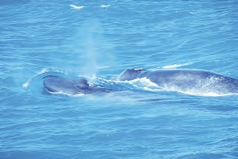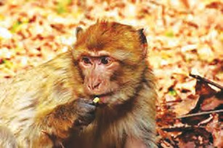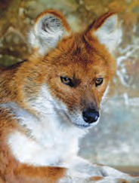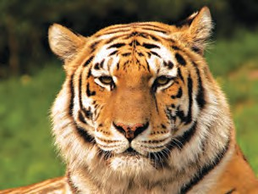

Form groups of 5-8. Prepare short autobiographical speeches for each of these animals (10-15 lines). Use the following points :

* + How the animal lives - It’s the only way he/she can.
  + How he interacts with nature and other animals.
  + How humans interact with that species - whether it is fair, necessary or desirable, etc.
  + The possible ill effects of the way human beings treat the animals, for the whole living world.
  + The animal getting ready to bid farewell to this world.

1. Hold a classroom discussion on the following topics and later on, expand the themes on your own. (10-15 lines)
   * Why human beings need to use more and more natural resources.
   * Should we conserve only the most beautiful and most useful things in nature ?
   * What is ‘beautiful’ or ‘useful’ ? Who has the right to decide that ?

30

## A True Story of Sea Turtles

We were surveying the white bellied sea-eagles in the summer that year. As we roamed the coasts, one of the volunteers in our team saw some shallow pits with white egg shells nearby. Enquiries with the villagers revealed that they were turtle eggs. This came as a surprise. We had never come across turtle eggs in our walks along the beaches of Konkan in all these years. We decided to study this unusual occurrence further. We learnt that the beach where we had found the egg shells had been sealed to the public for nearly one month, after people smuggling silver bricks were caught in that area. But what we learnt further shocked us to the core.

Turtles nest along the entire coastline of our State. There are a few people in every village who keep combing the beach in the early hours of the morning, throughout the year. When the female turtle comes on shore to nest and to lay eggs, she

leaves behind a trail just like a track of wheels on the sand. The egg hunters follow this trail right up to the nest which is about half a metre deep. They dig up the nest, and steal all the 100-

150 eggs that are laid inside. These eggs are then either eaten or are sold in the market. If a turtle is spotted while

it is still laying eggs, it is allowed to live till the laying is over. As soon as the eggs are laid, it is caught, and then killed and eaten. This ruthless practice is observed in all parts of the world. However, in India, sea turtles have been given protection by including them under Schedule I of the Indian Wildlife (Protection) Act 1972. That means turtles have been given as much protection as tigers. Therefore, all this business of gathering turtle eggs and killing turtles is carried on in a secret, hush-hush manner. This information was distressing. We began to think seriously about it. We decided to undertake a project for the protection and conservation of turtles and their nests in Maharashtra.

* What unusual occurrence did the volunteers notice ?
* Why were turtle eggs seen on the beach after it had been sealed to the public ? What were the implications ?
* Why have these turtles been protected in India ?

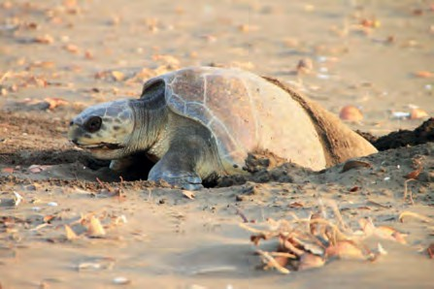

31

* Why were the people asked to look for the eggs or nests in the morning ?

We had no experience regarding sea-turtles, so first of all we undertook a study of turtles. We contacted institutes that work for the protection of turtles in India. The next step was launching a Turtle Protection Campaign at Velas, Taluka Mandangad, District Ratnagiri. This was done with the

support and co-operation of the Forest Department. As part of the campaign, a few local people were specially appointed to look for turtle nests on the beach in the morning. When they came across a nest, they had to carefully remove the eggs from the nest, and bury them again in a similar pit, but one protected with wire fencing. They

had to watch over the protected nest to prevent thefts. In the first year, we could successfully protect 50 nests in this manner. When the babies hatched out of the eggs, what an event that was! The whole village rushed to the beach to witness the spectacle. When the tiny turtle hatchlings hurried across the silver sands to meet the rolling boundless sea, what an ovation they received from the onlookers! Some of the elderly villagers confessed that though they had seen (and stolen) turtle eggs right from their school days, it was for the first time that they had seen the hatchlings rushing to the sea.

* The elderly persons had seen the hatchlings

for the first time. What does it indicate ?

There are seven types of sea turtles in the world, five of which are found in India. The Olive Ridley turtles nest along the entire coastline of Maharashtra. Green turtles and Hawksbills have also been found. An amazing characteristic of turtles is that when the female turtle reaches maturity, that is, nearly after a gap of 15 years, she returns to the shore to lay her eggs at the same place where she was born. The female comes on shore, just to make a nest in the sand and lay her eggs, and immediately returns to the sea. She does not return to the nest after that. The eggs hatch after a period of 45 to 50 days, using natural heat. Innumerable dangers await the little hatchlings in the deep sea, and they have to face them all on their own. Their survival rate

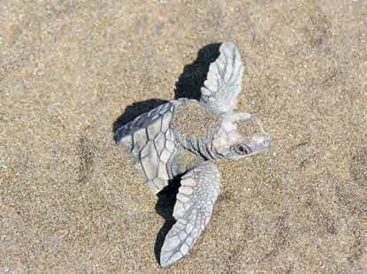

32

is therefore as low as just one or two turtles out of a thousand. Turtles perform an important function - they keep the sea clean. Thus, they occupy an important place in marine ecology. Considering all these factors, it is vital to undertake their protection on a large scale.

After the success at Velas, we started implementing the project in other places too. Within five years, the entire coastline of Maharashtra was surveyed. Protection was offered in eighty of the villages where turtle nests were found. Our strategy was to engage those who had so far been involved in stealing the eggs, then to train and involve them in the work of protection. We started the ‘Turtle Friend Awards’ (*Kasav Mitra*) to encourage more people to be a part of the protection campaign. A comprehensive booklet and a short film on the protection of turtles was prepared to spread the message.

The year 2006 saw the beginning of a novel concept - Turtle Festival or *Kasav Mahotsava* - an opportunity for tourists to witness the unique spectacle of the hatchlings rushing out to the sea. A short film on turtles and the natural beauty of Konkan were additional features of the festival. At the same time, we were quite firm on one issue - the hatchlings should not come to even the slightest harm due to this tourist activity. The tourists were accommodated in the homes of the villagers. The response

to this novel concept of ‘homestay’ was excellent. A Turtle Friends Club was established in each village, the members being all the villagers offering ‘homestay’. All villages would now offer the same rate for ‘homestay’. They gave ten percent of their income from ‘homestay’ for the Turtle Protection Fund. The fund

would be utilised for the purpose of protection and conservation of turtles. Modern technology also helped. The festival reached all corners of the world through the medium of the internet and our website. People around the world began to contact the small villages

* Why was it necessary to undertake turtle protection on a large scale ?
* Why were those who had stolen the eggs earlier involved in the work of

protection ? Give at least two reasons.

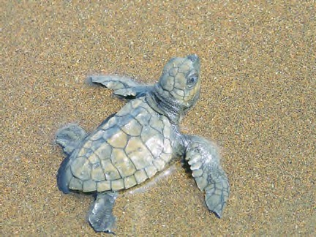

33

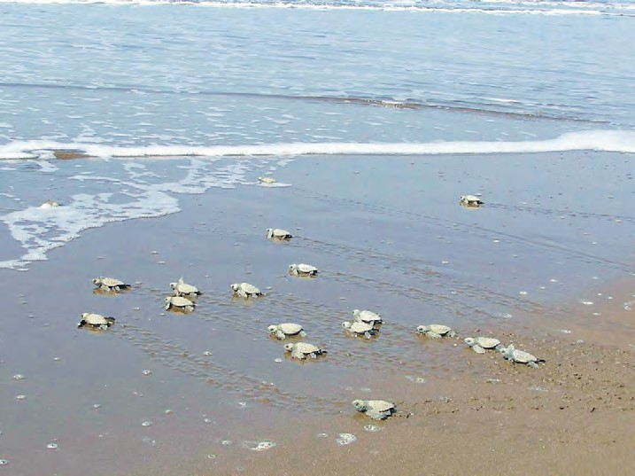

**Protect the turtles and enrich the seas!**

* What do the ‘homestay’ families do ?
* Why was the project entrusted to the local people ?

of Konkan. More and more villagers came forward to do this work and the number of ‘homestay’ families went up to 35. As many as eight hundred people began to visit Velas in the Turtle Season. This meant more business for the villagers. Now they realised that tourism can be a source of income. Tourists bring in money, and in order to earn that money, it was important to protect the turtle hatchlings. This was ‘Conservation of Nature through Livelihood’ in its true sense. Velas became the project’s main success story.

Sahyadri Nisarg Mitra, our organisation believed that it is only the local villagers who can ultimately offer excellent protection to the local species. If they are given the freedom to do that, the conservation projects became sustainable. With this belief, we entrusted the project to the Forest Department, the Gram Panchayat, the villagers and their Turtle Friends Club. All of them are handling it wonderfully. Now we are happy to see the project running smoothly and offer help only when necessary.

*- Bhau Katdare Sahyadri Nisarg Mitra*

34

**ENGLISH WORKSHOP**

1. Form groups. Discuss the first two paragraphs. Try to present their content in the form of a series of conversations among the (a) volunteers (b) the volunteers and the villagers.
2. Prepare a short note on sea turtles with the help of the information given in the passage.
3. Prepare a poster to illustrate how the turtle eggs were/are protected. Include the following in the poster.
   * Some pictures of sea turtles and their habitat
   * Information about turtle nests and eggs
   * A picture and information about a ‘protected nest’
   * Appeal to the public to spread awareness about their conservation
   * Some data (figures) regarding the achievements so far
4. Prepare a simple brochure regarding the ‘homestay’ facilities made available in the villages. Form groups and discuss the points you will use in the brochure. Remember to include the precautions that tourists have to take at the site, in your brochure.
5. Explain the idea of ‘Conservation of Nature through Livelihood’ briefly, using the example given here.
6. Prepare bullet point presentations on the following :
7. Scope for tourism in your locality
8. Prudent utilisation of natural resources
9. Read the following entries in the ‘Language Study’ pages :

(a) clause (b) sentence

Underline the main clause in the following sentences.

1. There are a few people in every village who keep combing the beach in the early hours of the morning, throughout the year.
2. When the female turtle comes on shore to nest and to lay eggs, she leaves behind a trail just like a track of wheels on the sand.
3. The egg hunters follow this trail right up to the nest which is about half a metre deep.
4. **Read :** ‘Last Chance to See’ by Douglas Adams and Mark Carwardine

35

## Somebody’s Mother

   **Warming up ! **  

1. Read the following proverb that has a biblical reference. ‘Do unto others as you would have others do unto you.’

Now find at least 5 other proverbs / axioms / quotations which convey the same message. Search the internet / dictionary of proverbs.

1. Study the following sets of words :

Set A – pleased, happy, joyful, ecstatic Set B – letter, word, sentence, paragraph

Note :- The words in these sets are arranged in an ascending order, each word showing a higher degree than the previous one. Now rearrange the following groups of words in the ascending order.

|  |  |  |  |  |  |  |  |  |
| --- | --- | --- | --- | --- | --- | --- | --- | --- |
| (a) | (1) | adult | (2) | aged | (3) infant | | (4) | youth |
| (b) | (1) | cold | (2) | freezing | (3) | cool | (4) | chill |
| (c) | (1) | brilliant | (2) | genius | (3) | bright | (4) | intelligent |
| (d) | (1) | mountain | (2) | peak/summit | (3) | mound | (4) | hill |

* + Prepare similar word chains using the following ideas.
    - rain - drizzle
    - wind - breeze
    - sunshine - warm
    - waterbody - pool
    - size - big
    - size - small

36

## Somebody’s Mother

The woman was old and ragged and gray, And bent with the chill of a winter’s day; The streets were white with a recent snow, And the woman’s feet with age were slow.

At the crowded crossing she waited long, Jostled aside by the careless throng

Of human beings who passed her by, Unheeding the glance of her anxious eye.

Down the street with laughter and shout, Glad in the freedom of ‘school let out’, Came happy boys, like a flock of sheep, Hailing the snow piled white and deep; Past the woman, so old and gray, Hastened the children on their way.

None offered a helping hand to her, So weak and timid, afraid to stir,

Lest the carriage wheels or the horses’ feet Should trample her down in the slippery street.

At last came out of the merry troop The gayest boy of all the group;

He paused beside her and whispered low, ‘I’ll help you across, if you wish to go.’

Her aged hand on his strong young arm She placed, and so without hurt or harm He guided the trembling feet along,

Proud that his own were young and strong; Then back again to his friends he went, His young heart happy and well content.

**Guess the following, using references from the poem :**

* + - * The setting - the region, the locality
      * The time -

the time of the year and the day

* + - ragged : wearing old and torn clothes
    - throng : large crowd
    - unheeding : neglecting
    - hailing : welcoming
    - Lest : for the fear that ...

37

‘She’s somebody’s mother, boys, you know, For all she’s aged, and poor and slow; And someone, some time, may lend a hand To help my mother - you understand? - If ever she’s old and poor and gray,

And her own dear boy so far away.’

* lend a hand : help

‘Somebody’s mother’ bowed low her head

In her home that night, and the prayer she said Was: ‘God be kind to that noble boy,

Who is somebody’s son and pride and joy.’

*- Mary Dow Brine*

   **ENGLISH WORKSHOP ** 

1. Pick out lines from the poem that help create images of the following in our mind and write them in the table.

|  |  |  |  |
| --- | --- | --- | --- |
| No. | Old Woman | The Street | Schoolboys |
| 1. |  |  |  |
| 2. |  |  |  |
| 3. |  |  |  |

1. Write at least 5 rhymes from the poem.
2. Give, in your own words, TWO reasons for each of the following :
   1. The woman was reluctant to cross the street by herself.
   2. The schoolboys were in a happy mood.
   3. One of the schoolboys helped the old woman cross the street.
   4. We must help those who are in need.
3. Think and write in 5-6 lines, why most of the people on a road/street ignore those in need of help. What about you? Write about your feelings after you have helped/ not helped, when needed.
4. **Read the poem :** ‘Home they brought her warrior dead’ by Alfred Lord Tennyson.

38

## The Fall of Troy

**Group Leader**

**7**

**6**

**5**

**4**

   **Warming up ! **  

#### Building a Story

Form groups of eight. The group leader prepares slips

**1** of paper for each of the seven points given below and distributes them among the others. The group sits in a circle, taking their seats according to the number on the

**2** slip they have. Then each one completes the sentence on his/her slip without sharing it with the others. The group leader collects the slips and reads all the sentences aloud

**3** as one continuous passage. Does the story make sense ? The group then works on the story to make it more

This game may be played again, changing the groups, to form new stories.

meaningful and interesting.

1. Once there was a
2. Who lived in a
3. He/She ate
4. She/He went
5. There she/he saw
6. She/He was
7. That is why

**Interviews**

* 1. **Why ? :** Form groups of five. Choose a familiar character from any one of the epics you know. One person from the group plays the role of that character. Others in the group frame questions related to that character’s life. The condition is that all the questions should begin with ‘Why ... ?’. They interview the character using these ‘Why - ?’ questions. Practise and present the interview in the classroom.
  2. **How ? :** Follow the above procedure. Now all questions should begin with ‘How -?’
  3. Prepare a short script of your interviews.

39

* How were epics transmitted from generation to generation ?
  + Have you seen any of these stories in TV serials or movies ?
  + Who are considered to be the authors of epics ‘Ramayana’ and ‘Mahabharata’ respectively ?
  + Why is Homer honoured with the title ‘Father of European Poetry’ ?

## The Fall of Troy

#### Part I

Epics are long poems that relate the deeds of a great national hero or a great national war. They often tell of a nation’s early history. They may be composed and sung or recited for many years before they are actually written down.

The two famous Sanskrit epics are *The Ramayana* and *The Mahabharata*, and the two great epics of European literature, written in ancient Greek, are *The Iliad* and *The Odyssey*. Just as in Indian literature we go back to stories from *The Ramayana* and *The Mahabharata,* so in the literature of western countries, they go back to *The Iliad* and *The Odyssey*. Just as children all over India know the names of stories of Ram and Sita, Yudhishthira and Arjuna and Draupadi, so children in western countries know the names of Hector and Odysseus and Achilles and Helen of Troy, the most beautiful woman in the world, because of whom the Greeks and Trojans fought for ten long years.

Nobody knows for certain who the author of these early epics is. It is thought that they arose and developed with the nation itself, and were handed down from singer to singer till perhaps one great poet gave them their final form.

It is believed that *The Iliad* and *The Odyssey* were composed and recited by a blind poet named Homer, who lived about 900 BCE and who wandered from one Greek city or village to another, singing his poems to all who would receive him in their homes and give him hospitality. This wandering singer has been honoured through the ages, not only in Greece but in all Europe, as the Father of European Poetry.

*The Iliad* is the story of Ilium or Troy, a rich trading city in Asia Minor near the narrow sea that leads from the Aegean to the Black Sea. It was well situated, both for commerce and agriculture. In front of the city was the sea over which sailed the ships of

40

Troy, carrying goods and grain. At the back rose the high peak of Mount Ida, from which flowed many rivers and streams. The valleys among the hills were well-watered and fertile, with corn growing in fertile fields and cattle feeding on the rich grass of the meadows while sheep fed on the slopes of the hills.

Round their city the Trojans had built a strong wall so that no enemy should attack them from the sea. The wall was so broad that people could stand and sit and walk on it. The great gates stood open, and people could go to the seashore outside and come in as they pleased. But in time of war the gates would be closed; and then the city was like a strong fortress, quite safe from all attack, protected by the walls surrounding it, as well as by the hills behind.

Thus, Troy was a strong city, strongly protected by its walls and strongly defended by its brave soldiers. But all the kings and heroes of Greece had declared war against the Trojans, because Paris, a prince of Troy, had persuaded Helen, wife of a Greek king Menelaus, to elope with him. He had brought her to Troy. The Greeks wanted to take revenge on Troy for the wrong done to Menelaus. They sailed to Troy and laid siege to the city. The Trojans, too, fought hard and the siege continued for ten long years.

The fighting went on daily, but the siege did not end. On the one hand, the Greeks could not take the city, and on the other hand the Trojans could not force them to sail away. Every day the Trojans came out of their gates, and the Greeks came out of their tents and ships, and the fighting went on. Sometimes there were great battles between the two armies. Sometimes there were single fights between two great heroes. Sometimes the Trojans had the better of it and sometimes the Greeks. But still the fighting went on.

Great heroes on both sides were killed in the course of the war. After leading the defence of his city for nine years, the brave Hector was at last killed by Achilles, whom none could resist. But Achilles himself was killed later on by a poisoned arrow that entered

* + - How did the location of Troy help it to grow into a very rich, prosperous city?
      * How were the Trojans protected during wartime?
      * What was the cause of the ten year old war between the Greeks and Trojans?
      * Find the story of why Helen was persuaded by the goddess Aphrodite to elope with Paris.

41

his heel, the only part of his body where he could be wounded. Still later, Paris himself was killed, also by a poisoned arrow. The Trojans were tired of being shut up in their city, and the Greeks were longing to see their homes again. But still the fighting went on.

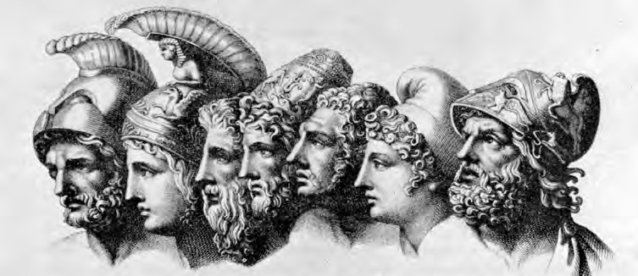

   **ENGLISH WORKSHOP ** 

1. Read the passage and name the following.
   1. He composed the Illiad and Odyssey :
   2. He persuaded Helen to elope with him :
   3. She was wife of the King Menelaus :
   4. He led the defence of Troy for nine years :
   5. He was killed by a poisoned arrow that entered his heel :
2. Find antonyms of the following from the passage.
   1. barren 🞨 (b) offended 🞨

(c) cowardly 🞨 (d) peace 🞨

(e) surrender 🞨 (f) exposed 🞨

(g) defenceless 🞨

1. From other sources find synonyms of the following words used in the story.

(a) great (hero) (b) beautiful (woman) (c) fight (verb) (d) rich (city)

(e) safe (f) strong (city) (g) brave

1. **Correct** the following sentences **using facts from the passage**.
   1. Troy traded in cattle and grass, with other cities.
   2. During war, Trojans jumped over the fort gates to fight the enemy.
   3. Helen eloped with Menelaus.

42

* 1. Troy was attacked because it was a strong, rich city.
  2. The Greek armies and heroes always defeated the Trojans.
  3. Both the enemies were eager to continue fighting.
  4. The great heroes avoided one another.
  5. Achilles was killed by an arrow that pierced his heart.

1. **State the counter - action** for the following actions.

Action Counter-action

* 1. Helen eloped with Paris.
  2. The Greeks sailed to Troy and attacked it.
  3. Hector was killed by Achilles.
  4. The siege continued for ten long years.

(1)

(2)

(3)

(4)

1. From either of our two Indian epics, find out which battle/war lasted the longest? Write down about its cause, the enemy armies, its heroes, its duration and the final outcome.
   1. *Cause*
   2. *The enemy armies*
   3. *Heroes*
   4. *Duration*
   5. *Final outcome*
2. Complete the following sentences with reference to the passage.
   1. Epics are long poems that .
   2. They may be composed and sung or recited for many years before  .
   3. Nobody knows for certain who .
   4. It is believed that Homer, who and who

to all who .

* 1. At the back rose the high peak of Mount Ida, from which .
* Underline the **clauses** in the above sentences and also the **words that link or connect**

the clauses.

43

* How did Odysseus plan to defeat the Trojans?
* What was the reason for Troy to rejoice and celebrate?

**Think and answer:**

* Was it enough to use the wooden horse to hide ?

What was done to make the Trojans take it inside the city ?

#### Part II

At last Troy was taken, not by force but by a trick. It was the cunning Odysseus who thought of a plan to obtain the victory.

“Let us build a great wooden horse”, he said, “big enough to hold men inside it, and let some of our best fighters hide in the horse. Then let us burn our tents and pretend to sail away in our ships. But instead of sailing away, we will return in the night. When the Trojans are asleep, we will attack the city and burn and kill.”

The Greek leaders decided to follow the advice of the wise Odysseus. So a great horse of wood was made by a skilful engineer, and the greatest heroes, Menelaus, Odysseus himself, and others entered it, the last man to go in being the architect himself who knew the secret of opening and shutting the entrance. That evening the Greeks burned their tents and sailed away in their ships, but they did not go very far. Only one man was left behind to persuade the Trojans to drag the horse into their city.

Next day the Trojans woke up, expecting to go out and fight as they had done for the past ten years. What delight and surprise they felt at the sight they saw on the seashore outside the walls ! It seemed that the long siege was over at last. The tents had been burnt. The shore was deserted. The Greek ships had all gone.

“It’s peace at last,” they cried, and opened wide their gates and came out in large numbers on the plain, glad to be free again to go where they pleased. Then they saw on the sands the huge, wooden horse. They gathered round it in astonishment, for it was indeed a wonderful piece of work.

As they were wondering how the horse had been built and why it had been left behind, they found a Greek with his hands tied together lying under it. When the Trojans dragged him out, the man pretended to be very frightened of them. When he was commanded to tell them why the Greeks had gone and why they had left this horse behind, he pretended to tremble very much and refused to speak. When at last they threatened

44

to kill him, he spoke and told them this false tale. “The Greeks are tired of the long war and have

sailed away in their ships,” he said. “But they are

afraid of the long voyage home too, and so they have made this horse and left it as an offering to the god of the sea. They wanted also to kill me and offer me as a sacrifice to the sea-god; but I escaped and hid from them.”

“But why did the Greeks make such a huge horse ?” some of the Trojans asked. And the cunning Greek made this reply : “If they had made a smaller offering, you might have taken it into your city. Then the luck would have gone to the Trojans and not to the Greeks. That is why they made it too big to go inside your gates.”

The Trojans were delighted to hear this. “The Greeks have gone,” they said, “and the walls are no longer necessary. Let us make a hole in the wall and drag the horse in.”

Their wise priest warned them not to do so. “It may be a trick that will ruin us,” he said. “You will bring disaster on the city if you break down the walls,” But they were so excited that they paid no attention to his words. They broke down part of their strong wall in order to drag the horse in.

All that day the Trojans feasted and drank and celebrated. After all their celebrations, they went to sleep and slept soundly. But that day of rejoicing was soon followed by a night of terror and death.

The Greek ships had not sailed far. As soon as they were hidden by an island, they had lowered their sails and dropped anchor and waited for the night. In the darkness the fleet sailed back, and the leading ship, which was Agamemnon’s, bore a red light high on its mast. The Greek, who was watching for the return of the fleet, crept to the wooden horse and gave the signal. The side of the horse opened, the Greeks climbed out and opened the gates. The whole Greek army entered the sleeping city. Immediately the Greeks set fire to houses and towers and palaces, and began to burn and kill.

* How did the cunning Greek explain the presence of such a large wooden horse?
* Do you think the Greeks and Trojans were superstitious ? Give reasons for your answer.
* What reckless, thoughtless step did the Trojans take?
* How did the Greeks enter the city of Troy ?
* How did the Greek ships remain hidden from Troy?

45

* What distressing sounds and sights could be witnessed at Troy, that fateful night?
* What was the destiny of the royal family of Troy and that of Helen?

**Think and answer :**

* How could the fall of Troy have been avoided ?

Troy was filled with the sight of leaping flames and the sound of shouting and the noise of weapons and the cries of weeping women. The sleeping Trojans sprang out of their beds, but they were taken by surprise. Their enemies were right inside their walls, and many of the Trojans were killed before they could put on their armour and seize their weapons.

A bright light lit up the night sky as palaces and houses, temples and towers, went up in flames. The Trojans fought as well as they could, but it was all in vain. Old King Priam was killed with all his brave sons. Hector’s wife and his old mother and sister were carried off as slaves by the conquerors. Their fate was in contrast to Helen’s when King Menelaus rushed through the city, looking for her and found her in her palace. She hung her head in shame and sorrow as she faced her former husband. Her voice was choked with emotion and she could not speak. But Menelaus forgave her and she went back with him, for it was only Aphrodite who had turned her heart away from her home and her husband and her child.

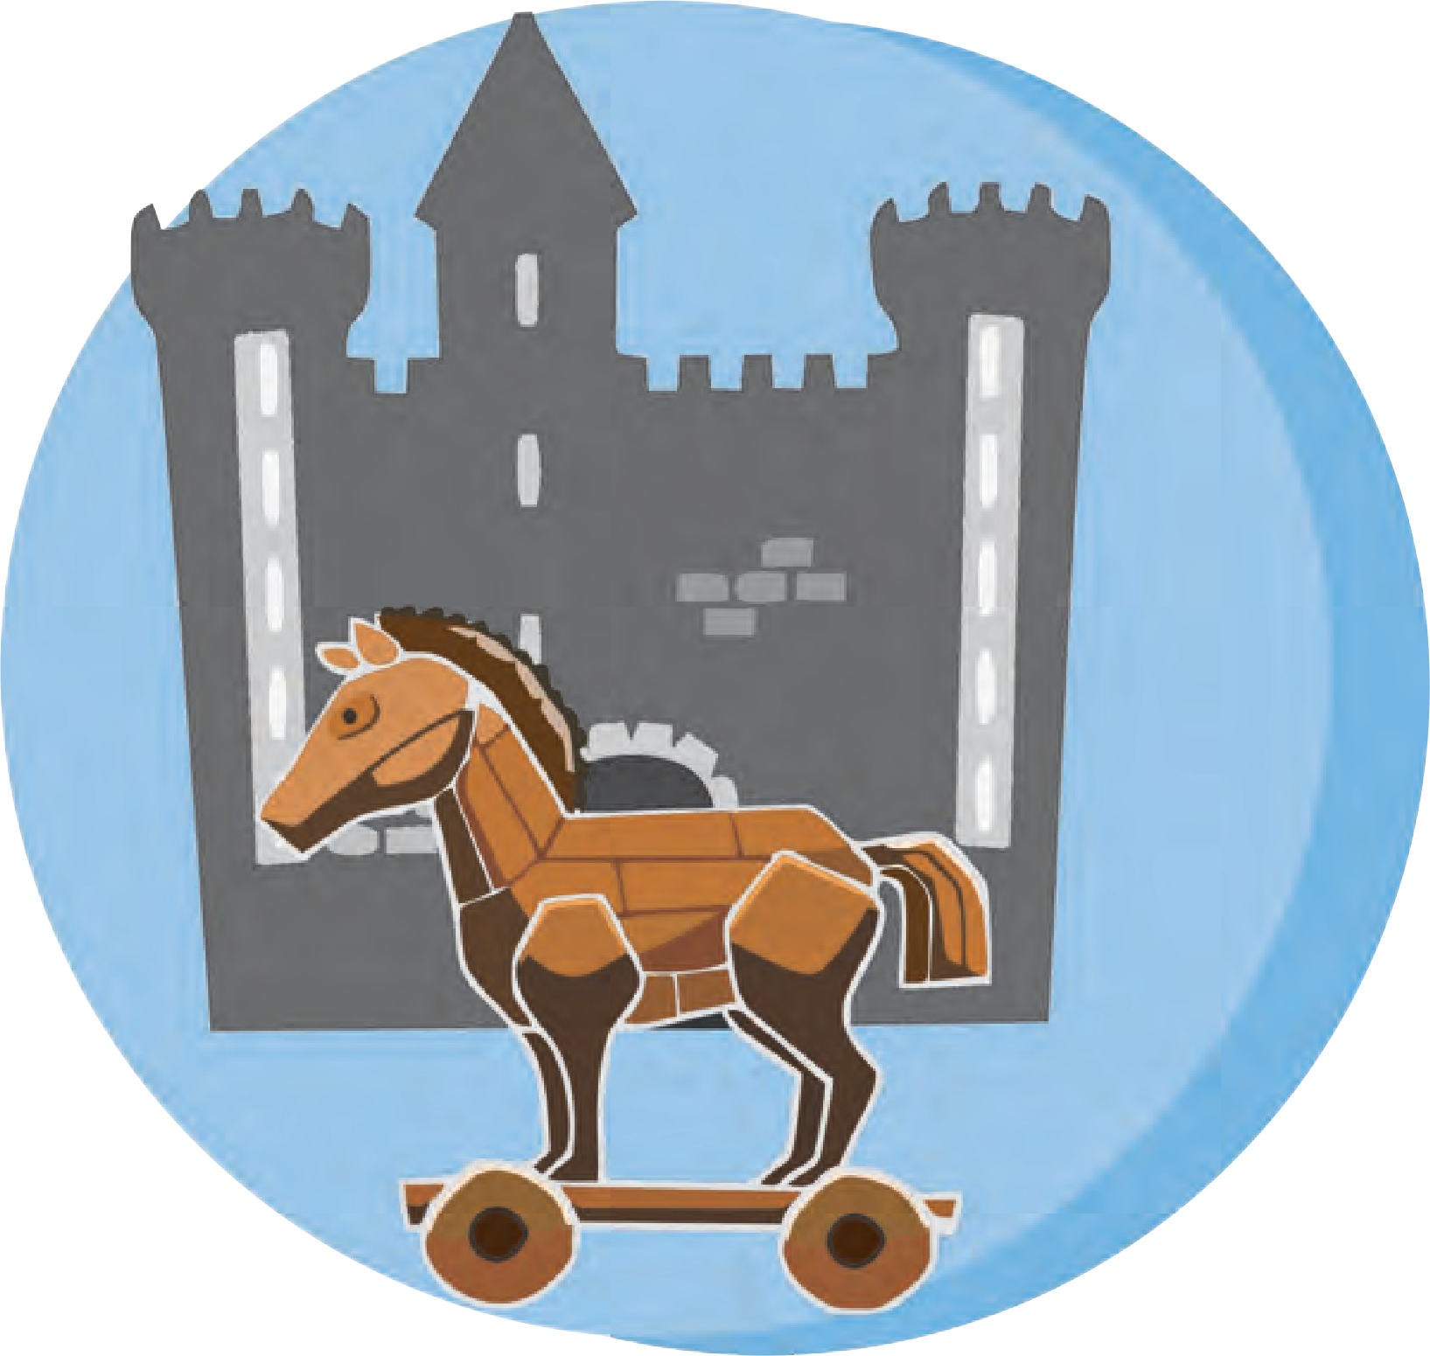When morning came, nothing was left of the proud, rich city that had resisted attack for ten years.

46

**ENGLISH WORKSHOP**

1. Find and write the Greek and Trojan names used in the story (Part I and II).
2. List all the words related to ‘war’ from both parts of the story.
3. Note the following constructions carefully and then use them to express your ideas :
   1. A horse **big enough** to hold men inside it ...

enough to .

* 1. The Greeks were **tired of** the long war.

tired of .

* 1. They **are afraid of** the long voyage home, too.

afraid of .

* 1. They made it **too big to go inside** your city.

too to .

* 1. They were **so excited that** they paid no attention to his words. so that

1. Put the following events in the order in which they took place. Number them accordingly.
   1. The Trojans found a Greek man under the big wooden horse.
   2. They broke down part of the wall and brought the horse in.
   3. The cunning Odysseus thought of a plan.
   4. The Greeks burnt their tents and sailed away.
   5. Troy was burnt down.
   6. The Greeks built a big wooden horse.
   7. The great heroes hid inside the horse.
   8. The priest warned the Trojans not to break the wall.
   9. The Trojans were happy to see the Greek ships go.
   10. The Trojans slept soundly.
   11. The Greeks came out of the horse and opened the gates.
   12. The Greek army entered the city.
2. Form pairs. Imagine you are a pair of Trojans and you have come to know about Odysseus’s plan. Make a counter plan to defeat the Greeks. Write down your plan as you would explain it to your fellow Trojans.

47

1. Identify one example of a main clause and one example of a dependent clause from page 46. (Read the entry regarding clause in the Language Study pages.)
2. Be a writer.



‘The Magic Glasses’

*After ten years of diligent experimenting on ‘light’, Jayant, a brilliant scientist, created a pair of eye-glasses which would enable him to see through all opaque objects, doors, walls, metal structures etc.*

*On Monday, he put on his ‘magic’ glasses and stepped into the busy street outside*

*And so, Jayant received the ‘State Award for Brave Citizens’*

* 1. Now read the beginning and end of a sci-fi story given below and complete the story using your imagination.
  2. Read the following and observe the use of tenses.

*‘Last week I witnessed a strange accident. Let me tell you about it.*

*The signal flashes green. Vehicles start from the opposite direction. They move fast. Suddenly a speeding motorcyclist tries to cut across, from the wrong side. He is about to collide with a loaded truck. He applies the brakes. He falls and slides out with his bike from under the truck. He comes out unscathed on the other side.’*

* + - When an event, which has occured in the past, is narrated in the Present Tense to create a dramatic effect its Tense is called the ‘Dramatic Present Tense.’
    - Now try to relate Jayant*’*s sci-fi story, in brief, in the dramatic past tense.



48

## Autumn

**Warming up !**

1. What changes do you see in nature in each of the following seasons ? A few sentences are given below as examples. Use these and your own to describe a season appropriately.
   * New grass sprouts.  We see mist in the morning.
   * Tender leaves shoot out on plants or trees.  There are sudden showers and
   * Migratory birds return. hailstorms.
   * The sun shines brighter than before.  Trees blossom.

**Winter**

**Summer**

**Monsoon**

1. Name the six seasons according to the Indian calendar. Which of the seasons is equivalent to Autumn ?
2. What changes do we see in the life of human beings when the season changes ? Write with reference to their (a) clothes (b) diet (c) celebrations.
3. Guess what is personified and fill in the gaps. Choose from the brackets. (Sun, alarm, bird, car, wind, stars, machine)
4. The weary  was also petrol - hungry.
5. The playful  whistled among the trees.
6. The annoying  screamed at 5 am.
7. The naughty  winked at me from above.
8. The rising  stretched its arms.
9. The cheerful  sang as it perched on a tree.
10. The tireless  hummed as it worked hard.

49

## Autumn

* Why is Autumn called a ‘maiden fair ’?
* What is the cooing of birds compared to ?
* How does Autumn dress up at night ?

THE autumn comes, a maiden fair In slenderness and grace,

With nodding rice - stems in her hair And lilies in her face.

In flowers of grasses she is clad; And as she moves along,

Birds greet her with their cooing glad Like a bracelet’s tinkling song.

* slender : slim
* diadem : crown
* bars (here) : patches
* ruffles : disturb a smooth surface

A diadem adorns the night ! Of multitudinous stars;

Her silken robe is white moonlight, Set free from cloudy bars;

And on her face (the radiant moon) Bewitching smiles are shown :

She seems a slender maid, who soon Will be a woman grown.

*- Kalidas*

*Translated by Prof. A. W. Ryder*

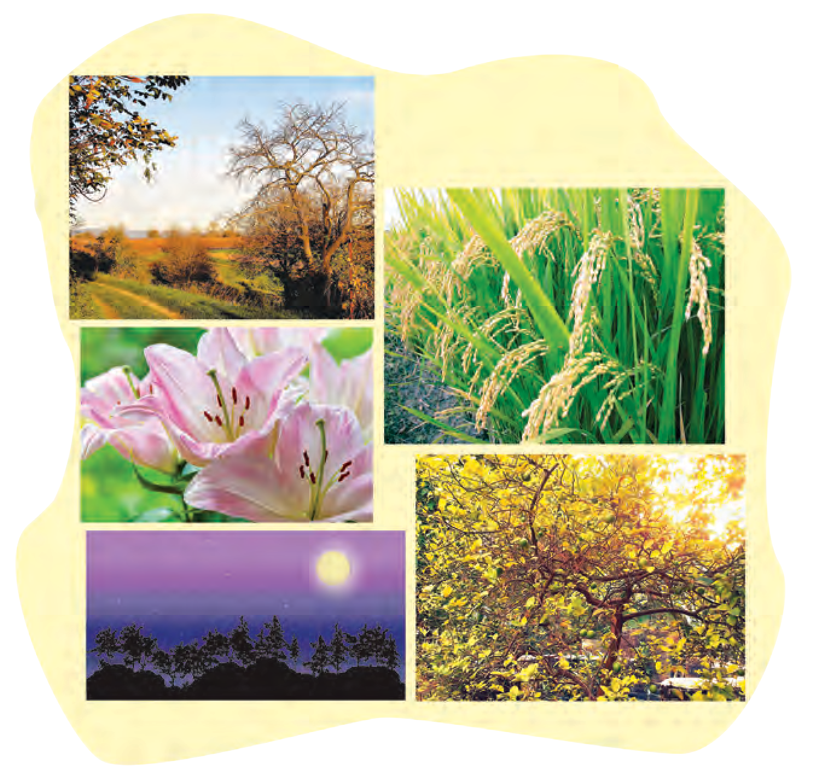

50

   **ENGLISH WORKSHOP ** 

1. Find three lines each, that contain images of nature in the autumn season.  During daytime (1)

(2)

(3)

At night (1)

(2)

(3)

1. Pick out words from the poem that describe the following. List them in Column ‘A’. Substitute each of those describing words with another word/phrase of the same meaning.

|  |  |  |
| --- | --- | --- |
|  | A (Poetic words) | B (Your own words) |
| the ‘Autumn’ | a maiden fair |  |
| stars |  |  |
| moonlight |  |  |
| cooing of birds |  |  |

1. Find one example of each of the following from the poem :
   * Simile  Metaphor
2. Write the rhyme scheme of the poem. (Refer to the Language Study pages.)
3. Think and write in your own words.
4. Why is the maiden Autumn said to wear rice stems in her hair ?
5. How can the tender maiden Autumn become a full grown woman ? What change in nature does this imply ?
6. Why do you think, birds greet the autumn season gladly ?
7. Compare the Indian Monsoon season to a powerful king of a prosperous kingdom. Write down a few similarities. Use them to compose a poem of your own.
8. Which is your favourite ‘Nature’ poem from your mother tongue ? Write the poem and try to translate it into English. Your translation can be in the form of a poem or a paraphrase.



8. Read the ode ‘To Autumn’ by the famous poet John Keats. ‘Season of mists and mellow fruitfulness...’

51

## The Past in the Present

**Warming up !**

**Components of a Play**

1. We find the following in the script of a skit or play. Rearrange these steps in the proper order and write them down in the form of a flow chart.

Title

Dialogues

Scene

Curtain

Characters

1. Think of a play / skit which you have seen enacted on the stage and which has impressed you. Write the following details about it.

Climax

* + Name of the play / skit :
  + Important characters :
  + Any famous actors / actresses :
  + Theme :
  + Climax :
  + Ending :
  + Use of lights and special effects if any :
  + Use of background music and sound effects if any.:
  + Use of sets :
  + The costumes, make up, etc. of the characters :
  + How well the actors present the play : and behave on the stage.
  + Your own opinion about the play :

:

1. Present these points in the form of a review, and give it a suitable title.
2. Prepare a ‘Power Point’ presentation, using one slide for each of the above points. Present your review in a PPT format in the classroom.

52

## The Past in the Present

#### A Skit

**Characters**

✪ *Neel* - A young teenager  *Mom* - Neel’s mother

✪ *A boy from 1950s* - Neel’s Grandpa  *A lady from 1950s* – The boy’s

(Grandpa’s) mother

✪ *A 1910 boy* - Neel’s great-great  *A lady from 1910* - The boy’s mother grandfather

✪ *An 1800 boy* - Double great-great  *A lady from 1800* – The boy’s mother

... Grandpa

✪ *A 1500 boy* - Double double great-  *A lady from 1500* – The boy’s mother great ... Grandpa

✪ *A 1000 boy* - Triple great-great-  *A lady from 1000* - The boy’s mother great ... Grandpa

✪ *A 100 CE boy* - Triple great, triple  *A lady from the first century* – The great, triple great-great ... Grandpa boy’s mother

✪ *An ancestor from 3000 BC* - Neel’s  *A lady from 3000 BC* - The ancestor 5000 years ago. ancestor’s mother

**Scene -** *A typical teenage boy’s room, in a messed up state*.

**Neel :** Mom, I put the dishes in the dishwasher, just as you asked me to. Now I am going out to meet my friends. (*Enter Mom in a mod outfit.*)

**Mom :** You haven’t cleaned up your room. **Neel :** Awww ! I cleaned it only 2 days ago. **Mom :** You have to clean it up every day.

**Neel :** (*Picking up his books, clothes, head phones, etc. from the floor and bed and putting them in their places.*) Is it necessary to clean up every day? What difference does it make?

**Mom :** It does ! It builds up the right habits, the right attitude........

**Neel :** (*Cuts her short*) All right! All right! I get enough of lectures when school is on.

**Mom :** (*After Neel finishes his chores*) That looks much better now. But you forgot to make your bed. Do that and you may go out.

**Neel :** (*Irritated*) Mom! It’s getting late! The bed is going to be messed up again, when I sleep after lunch. Why do I have to make my bed? Why?

**Mom :** Hmmm..... That reminds me of something I heard about your Grandpa,

53

when he was in his teens. He had many more daily chores to finish and much tougher ones too.

**Mom :** On that day his mom had told him firmly ---------

(*A teenage boy from 1950s wearing loose trousers and shirt, enters with his mother in a silk saree.*)

**The Boy’s Mother :** Make your bed, before going out.

**1950s Boy :** But Mama I have already watered the garden, brought home the groceries, dusted the living room, cleaned my bicycle. Now why do I need to make my bed ?

**The Boy’s Mother :** (*To her son*) Let me tell you about your grandfather in his teens. (*1950s boy and mother recede and stand behind and 1910 boy enters dressed*

*in kurta-pyjamas and cap with his mother in a nine-yard saree, nose ring and*

*jewellery*)

**1910 Mother :** You can’t go out unless you make your bed.

**1910 Boy :** Mummy, I fetched water and filled up the pots, swept the terrace, collected wood for the stove, cleaned the grinding stones.

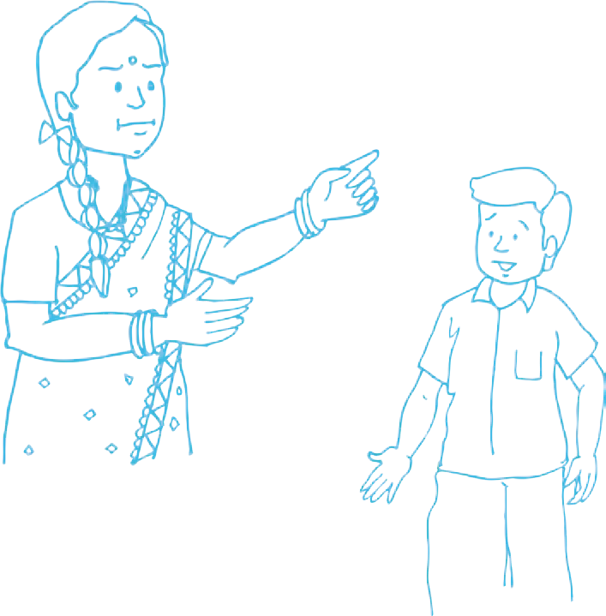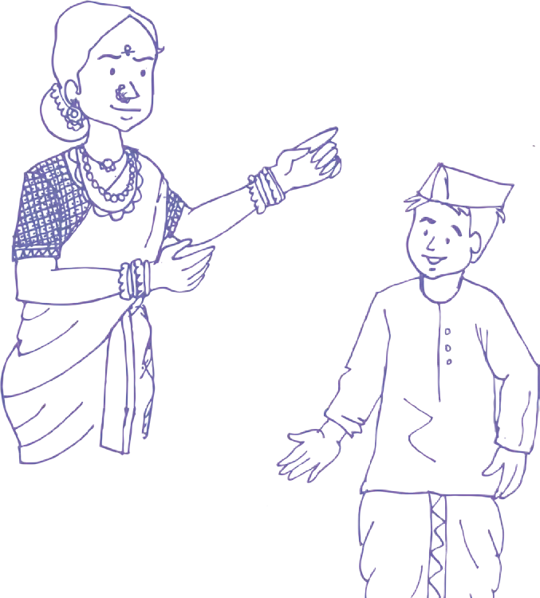

**Neel :** (*To his mom*) What are grinding stones? Ahhh! Yes! They didn’t have any electric grinders in those days!

**Mom :** No electricity either in most towns and cities, in India, then.

(*Neel looks surprised*)

**1910 Boy :** I promised to go to the riverside with my friends. Why do I have to make my bed now ?

**The Boy’s Mother :** (*To her son*) Let me tell you about your great-grandfather who lived in the 19th century. When he was young ...

(*1910 boy and mother recede to where the previous pair stands. 1800 boy enters in dhoti, kurta and small turban with his mother in a nine-yard saree and*

*traditional jewellery*)

**1800 Mother :** Son, make everyone’s beds.

54

**1800 Boy :** Mother dear, I have washed clothes at the river and put them up to dry. I also chopped the wood, fixed the broken fence, took the goats up the hill to graze. I want to play atya - patya with my friends. Why do I have to make the beds ?

**The Boy’s Mother :** That’s your daily work. Your great, great grandfather did even more. Now go and make the beds.

(*1800 boy and mother recede to where the previous pairs stand. Enters1500 boy dressed in a loose sleeveless V-neck top and short dhoti with his mother in a nine-yard saree.*)

**Neel :** And this forefather of mine is from -?

**Mom :** The 16th century.

**1500 Boy :** My dear mother, I have already milked the cows, taken them to graze, fetched vegetables from our farm, stacked them, swept the back yard and front yard. Now may I please go to play Ashtapada with Sampatbhau and Mahadevbhau. Why should I make my bed now ?

**The Boy’s Mother :** Why ? Don’t talk back. Think of your double great-great-great grandfather when he was about 14 years old.

(*1500 boy and his mother recede. Enters 1000 boy in a flare tunic and churidar, waist band and turban with his mother in a saree, upper garment and plenty*

*of jewellery*)

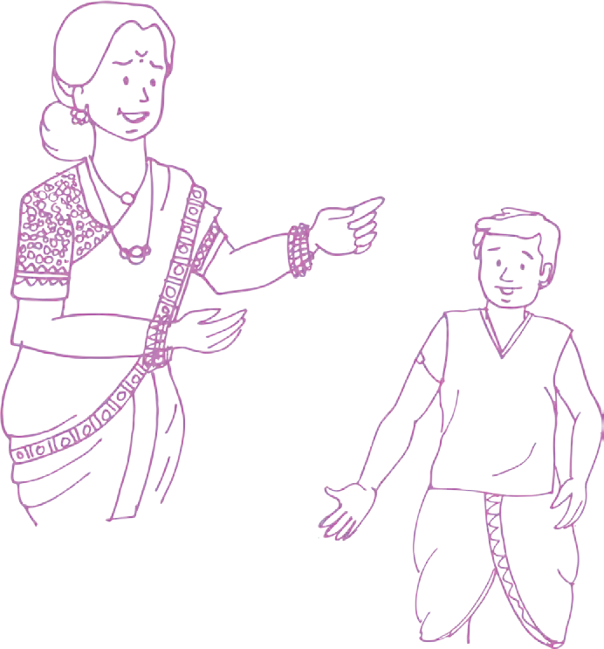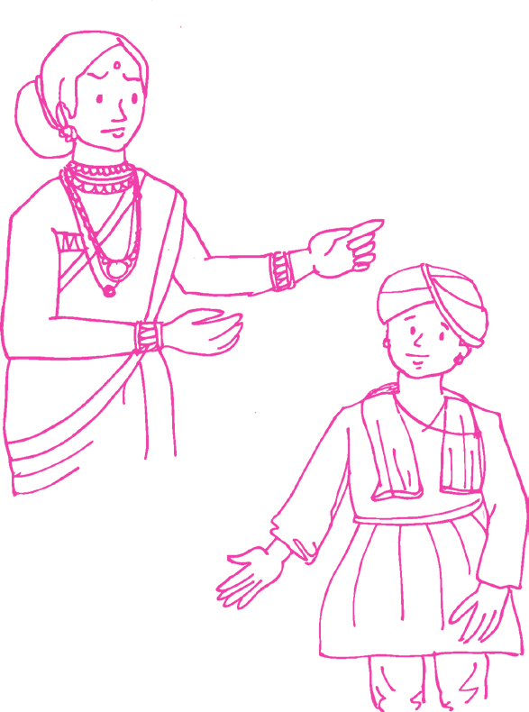

**1000 Boy :** Most revered mother, I have fetched water from the lake and poured it into the farm channels to water our crops, I cleared the blocked channels and pulled out weeds. At home I patched the mud walls, where there were cracks. Now I have no time for anything else. I wish to go to watch the puppet show. Why do I have to make my bed?

**The Boy’s Mother :** Do not grumble, dear son. Your triple great, triple great, triple great grandfather; had to do much more when he was your age.

55

(*1000 boy and his mother recede. Enters 1st century ce boy dressed in a dhoti and a waist band - no shirt, and his mother in a saree and an upper garment, and beads jewellery.*)

**100 (CE) Boy :** Matadevi, I fed the poultry, tended the sheep, kept the birds away for four hours in our field using a sling, also plastered the yard with dung. I wish to go and play Bagh-chal with my friends now. Why do you wish me to make the beds, right now?

**The Boy’s Mother :** Because that is what boys have to do. Let me tell you about your ancestor 3000 years ago.

(*1st Century boy and mother recede. Enter boy from 3000* BCE. *A cloth around the waist held by a cord, long hair in a bun or ponytail and his mother, saree, a veil, stone and beads jewellery.*)

**3000 (BCE) Boy :** Me bow to thee ! Me hunted down the food for our family. Me helped father to carve stone bricks for our new house. Me dusted our leather clothes, moulded mud pots for cooking and put them to dry. Me need your kind permission to go and play Chaupar with me friends. Why dost thou needs me to make me bed ?

**The Boy’s Mother :** Because me say so! Do it now.

(*All mothers to their sons in turn repeat, ‘Do it now’, with the boys answering ‘Yes, mother’.*)

**Neel :** Ok, so young teenage boys have had chores to do outdoors as well as in their homes.

**Mom :** Very much so ! Absolutely right.

**Neel :** I wish I had a robot to make my bed and tidy up my room.

**Mom :** Nothing is impossible. If you try you can make such a robot. But even for that you need to work hard ! The bottom line is Go and make your bed.

(*Curtain*)

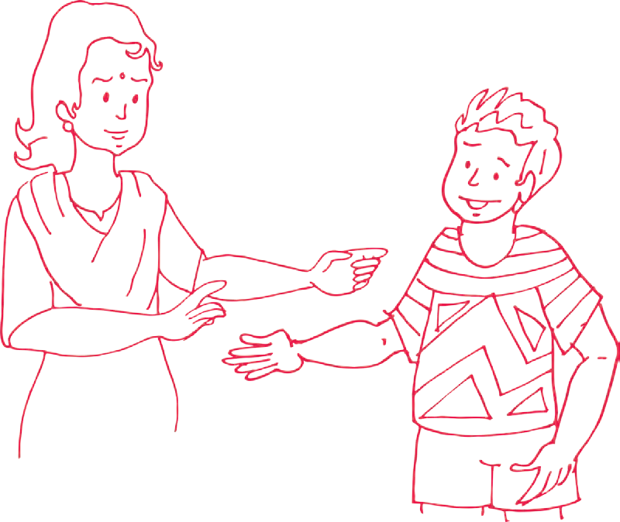

56

   **ENGLISH WORKSHOP ** 

1. In the diagram below encircle the various features that make the script of a skit/ play. List the other words and mention the form of writing of which it is a feature.
2. Choose the proper alternative to complete the following.
   1. The skit covers a period of about in the past.

(a) 3000 years (b) 1000 years (c) 5000 years (d) 1800 years

* 1. characters from Neel’s ancestral lineage make an appearance in the play.

(a) Fourteen (b) Seven (c) Sixteen (d) Twelve (iii) The task that all boys abhorred was

(a) cleaning up their room (b) farm-work (c) filling up water (d) making their beds.

(iv) The skit conveys that doing your daily chores at home

(a) makes you stronger (b) sharpens your intellect (c) saves a lot of expenses

(d) inculcates a sense of responsibility.

1. Fill in the table.

|  |  |  |  |  |  |
| --- | --- | --- | --- | --- | --- |
| Period | Way of Addressing a Mother | Boy’s Costume | Lady’s Costume | Daily Chores | Games |
| 1950s |  |  | silk saree |  |  |
| 1910 |  | Kurta pyjama and cap |  |  |  |
| 1800s |  |  |  |  |  |
| 1500s |  |  |  |  |  |
| 1000 |  |  |  |  |  |
| 100 AD |  |  |  | feed poultry tend sheep keep away birds  plaster the yard |  |
| 3000 BC |  |  |  |  | Chaupar |

57

1. Answer in your own words.
2. What excuses did Neel give to avoid cleaning his room ?
3. Why does mother tell Neel about his Grandpa ?
4. What task did Grandpa wish to avoid ?
5. What did the ancestor from 1910 wish to do instead of making his bed ?
6. How many chores did the ancestor from 1800 have to do ?
7. How is the boy from 1500s dressed ?
8. What chores did the boys from 1000 CE and 1st Century CE, do on their farms/fields ?
9. What did Neel realise from his encounter with his ancestors ?
10. In the play two devices that make use of wheels are given. The devices are (1) (2)

From the internet or other sources, trace the history of the use of the wheel. Write ‘An Autobiography of a Wheel’.

1. Imagine that the ancestor from 1910 (AD) visits Neel in his dream. Compose a dialogue between the two about the various gadgets the visitor sees in Neel’s room.
2. Imagine and compare an argumentative dialogue between the mothers of the 20th/21st century and those of the earlier era, about which life was better for women.
3. Read the entry about ‘voice’ in the ‘Language Study’ pages. Note that the speeches of all the boys are in the ‘active’ voice. Turn them into passive constructions.

Example :

**Neel -** I put the dishes in the dishwasher. (active)

Dishes have been put in the dishwasher. (passive)

**1950s Boy -** I have watered the garden

brought home the groceries dusted the living room

cleaned my bicycle ...

1. Think of suitable names for the boys from the earlier centuries.
2. Form groups of 5-8. Translate the play into your mother tongue (or Hindi) as a



group activity. Enact the translation in the classroom.

11. **Read** ‘The Story of the Amulet’ by E. Nesbit.

58

## Silver

**Unit Three**

   **Warming up ! **  

1. Imagine that your class has to be divided into groups or houses. Each house will have their own colour, symbol / emblem, motto, dress code, a common room with objects of their interest and suitable furniture. Think of sets of four names for the groups. Form groups and work out the (imaginary) details for each set. Some suggestions are : Neem - Colour, yellow; Symbol, the sun; Motto, ‘Health is wealth’; Dress code, yellow waist belt; etc. Cane furniture, green and yellow curtains and herbariums in the common room.

|  |  |  |  |  |
| --- | --- | --- | --- | --- |
| Category | Names | | | |
| Metals | steel | copper | silver | gold |
| Flowers |  |  |  |  |
| Stars or galaxies |  |  |  |  |
| Trees | Neem | Banyan | Gulmohur | Ashoka |
| Seasons |  |  |  |  |

1. Read the lines of the following poem. Guess and fill in suitable words to make the lines rhyme -

**Golden Glow**

Soon after dawn, rises the ;

It wakes and enlivens every .

It scares away the long, dark . The shining stars go out of .

From tree to tree birds flit and ,

Searching for food, with a sharp .

The buds that open now show their ,

As flowers they dance with beauty and .

The hill slope wears a grassy green ,

The curved sparkling river, it gold .

The cock then crows to give a loud ,

Come on ! wake up, folks ! One and .

I, then wake up, ‘Good Morning’ to ,

Let’s all look forward to a golden .

59

## Silver

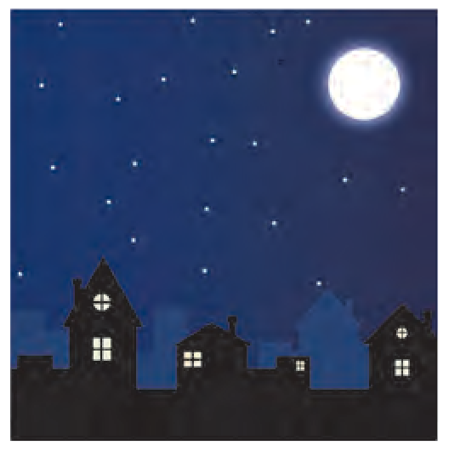

* Which of the objects, animals, etc. in the poem are at rest without any motion?
* cote : small shelter for birds
* moveless : still, motionless
* shoon : shoes

Slowly, silently, now the moon Walks the night in her silver shoon;

This way, and that, she peers, and sees Silver fruit upon silver trees;

One by one the casements catch

Her beams beneath the silvery thatch;

Couched in his kennel, like a log, With paws of silver sleeps the dog;

From their shadowy cote the white breasts peep Of doves in silver feathered sleep

A harvest mouse goes scampering by, With silver claws, and silver eye;

And moveless fish in the water gleam, By silver reeds in a silver stream.

- *Walter de la Mare*

   **ENGLISH WORKSHOP ** 

1. If you were asked to draw a detailed picture of the scene described in the poem, what object, animals, natural features etc. will you show in the picture? Make a list.
2. Write the rhyming words and the rhyme scheme of the poem. (See the ‘Language Study’ pages given at the end.)
3. Underline the word silver/silvery in the poem. In which lines does it occur? What pattern does it show?
4. Can you think of a parallel scene of dawn or evening when everything is steeped in golden light?
5. The same landscape appears different at different times. What message can we draw from this?
6. **Read :** ‘The Listeners’ and ‘Someone’ - poems by Walter de la Mare.

60

## Reading Works of Art

**Warming up !**

1. Complete the following idioms using the appropriate colour term. (blue, black, green, red)
   * give someone a look (a look of anger, dislike, etc.)
   * the sheep (of the family) a person who brings disgrace

(to the family)

* + a list

(a list of defaulters)

* + a belt

(area of fields, woods, etc. around a city)

* + to have fingers (be good at gardening)
  + be with envy (feel very jealous)
  + give someone/get the signal (give/get permission to do something)
  + a bolt from the

(a sudden shock, surprise)

* + out of the

(suddenly, unexpectedly)

* + once in a moon (very rarely)
  + vanish into the

(leave without any trace)

* + blood

(royal blood, aristocratic origin)

* + eyed boy

(favourite person)

* + catch someone handed (catch someone in the act of doing something wrong)
  + roll out the carpet (give a special welcome)
  + a herring (something that diverts attention from the main issue
  + see

(become angry)

1. What are you reminded of when you think of the following colours.
   * purple  orange  yellow  pink  white

61

## Reading Works of Art

### Sayed Haider Raza

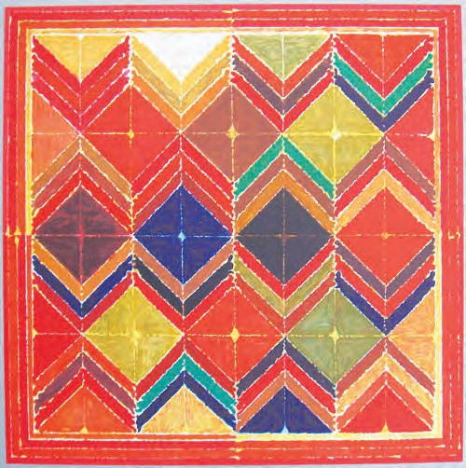Sayed Haider Raza, popularly known as Raza, was a renowned Indian artist. Simple geometric shapes, striking colour combinations, captivating compositions - these are some of the characteristic features of his paintings, and so are the colours blue and orange. You will find them in almost all his paintings. None of his paintings depict lifelike human figures or copies of scenes from his environment. His paintings belong to the abstract style of paintings. Such paintings are not inspired by any

external factor. They originate when the artist tries to peep into his own inner mind. They are made by arranging circles, triangles, squares, rectangles, lines, dots in different compositions using effective techniques of applying paint, attractive colour combinations, achieving balance in some places and creating imbalance in other places.

Raza found his paintings through his study of Indian art and its heritage, cultural context and philosophy. His pictures seem to radiate peace and life at the same time. We realise that the painting is a visible form of very deep thought. Very few abstract paintings communicate with the viewers as much as Raza’s do.



62

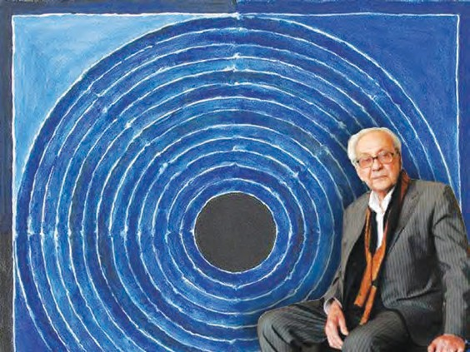Raza was born in a small village in Madhya Pradesh. He began to paint from the age of twelve. He studied art at the ‘Chitrakala Mahavidyalaya’ at Nagpur and then at the J. J. School of Art in Mumbai. Later, he went to France to study Art. After a few years, he decided to settle in France. His wife was French. He won many national and

international awards. He was honoured with all the three Padma awards - Padma Shri, Padma Bhushan and Padma Vibhushan. With all the awards and honours, his paintings were exploring a spiritual, metaphysical path. Gradually, the ‘bindu’ or point came to be the core of his paintings. He described his work in these words - ‘My work is my own inner experience and involvement with the mysteries of nature and form which is expressed in colour, line, space and light’.

Sometimes, an artist’s thoughts appear to be too complex or even complicated when they are expressed through words. For him, the effective medium of communication is his work - his paintings. Raza had great creativity. His paintings are very expressive. This great artist passed away on 23 July 2016 at the age of 94, leaving behind a legacy of sensitive paintings (achieved through extra-ordinary compositions of lines and colours) that depict extra-ordinary compositions.

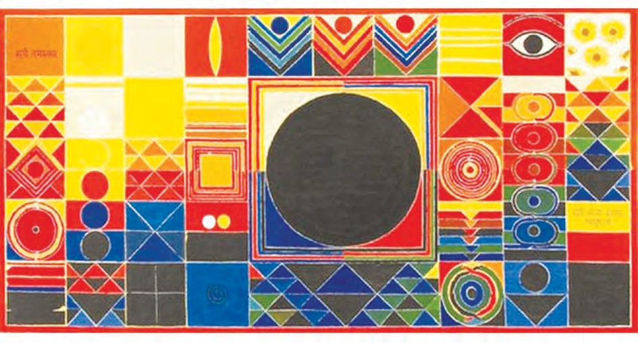

63

## Gond Art

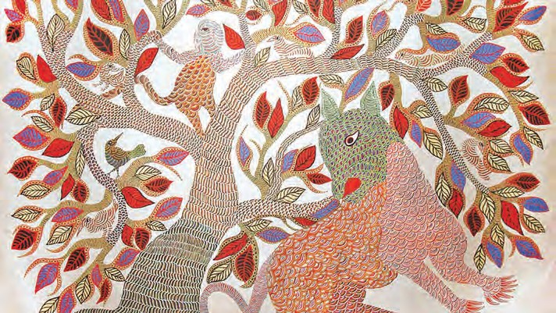

Gond Art is a tribal art. It has been developed and preserved by the Gond tribal people residing largely in the Madhya Pradesh, Maharashtra, Telangana, Andhra Pradesh and Odisha States of India. From their traditional tales and mythology, we learn that they have lived in India for thousands of years even before the other inhabitants came here. The Gondi language is similar to Telugu, a Dravidian language.

Gond art has spread mainly in Central India. Originally, people used to draw pictures on the earthen walls of their houses. Most folk arts involve natural techniques of preparing colours and use of several mediums. They are transferred from generation to generation in a smoothly flowing process. Gond art is no exception to this. A house decorated with beautiful pictures creates a pleasant atmosphere. Also, art is a medium of recording and preserving what is seen.

In folk arts, you yourself prepare the ‘canvas’ - the surface on which to

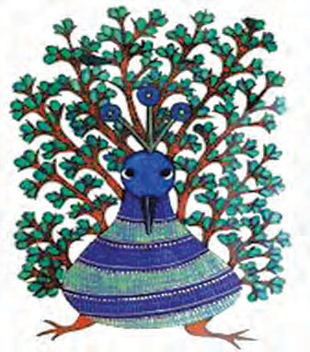draw and the colours with which you draw. That is why creating folk art is a very enriching experience. This richness is reflected in the choice of their medium. In the days of past, several things in nature such as soils of different shades, the juice of plants, leaves, tree bark, flowers, fruits and even things like coal and cow-dung were used to prepare colours. The different colours, various textures and patterns were used year

64

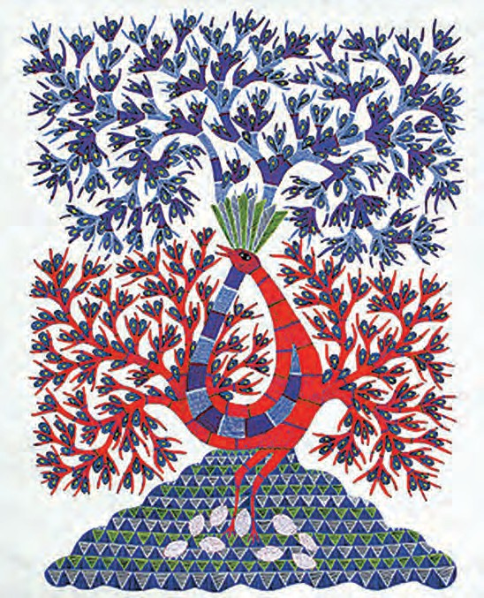

after year, lending a simplicity to the art. When we see these pictures, we realise that a picture drawn this way or the other can look equally beautiful. What a deep thought this art conveys - and so easily !

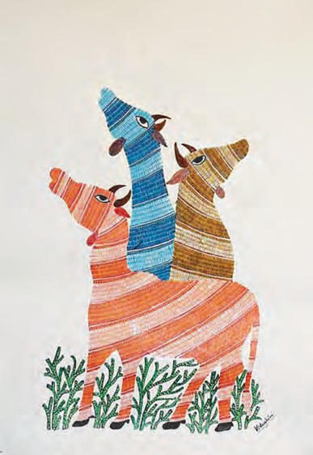In the Gond style of art, we see that the outlines may vary a little from artist to artist but the designs that fill it make the whole picture look lively and attractive. The designs include simple textures achieved using dots, straight lines, dotted lines, curvy shapes and circles. Special attention is given to the choice of various colours so that the total effect is amazing and beautiful.

In today’s age of commercialisation many men have taken up Gond art. But the roots of folk arts probably lie in women’s daily chores like cleaning and decorating the house, dealing with natural colours in the course of cooking and in their leisure time activities.

*- Abha Bhagwat*

65

**ENGLISH WORKSHOP**

1. **Spot the error in the spelling** of the following words with reference to the passage

|  |  |  |  |  |
| --- | --- | --- | --- | --- |
| and **rewrite** | **them** | **correctly**. |  | |
| * renouned |  | * feetures | * tribel | * circals |
| * geomatric |  | * figars | * mithology | * acheiving |
| * penting |  | * innar | * erthen | * diffarent |
| * vilage |  | * mediam | * dicided |  |

1. Complete the following with reference to the passage.

Characteristic features of Raza’s paintings

Simple ...... Striking ...... Captivating ...... Colours ......

1. Complete the following diagram.

Outlines

Preparing colour

Variation in drawing

Preparing the canvas (medium)

Gond art

Texture designs

Developed and preserved by ...

A medium of ...

1. Complete the following with reference to the passage.
   1. Raza’s paintings do not depict .
   2. Raza’s paintings are done in the style.
   3. Raza’s paintings are not inspired by .
   4. Raza’s paintings present images from his own .
   5. Raza’s paintings radiate .
   6. The became the core of Raza’s paintings.
   7. For an artist like Raza, his work, or paintings are an effective .

66

1. Write about the following important features of Gond art with the help of the passage.
2. Why does the author think that the roots of folk art lie in women’s chores?
3. From the passages, list the words related to -

(a) geometry (b) colours (c) designs

1. These two passages are examples of a short introduction to works of art - a short review. They cover the following points:

* The creator
* The theme or subject matter
* Type of art
* Individual style
* Presentation techniques
* Its effect on viewers
* Message or interpretation

Compare the points with those you used for a book review and the review of a play. Present the comparison in the form of a chart.

|  |  |  |
| --- | --- | --- |
| Book Review | Review of a play | Review of a painting |
|  |  |  |

1. Using the information given in the passage, write a short note on the following in your mother tongue.
   1. The paintings of Raza (b) Gond art.
2. Gather information on any one of the following by talking to your elders, family members and from other sources in your mother tongue and write a short note on it in English.

* A special type of embroidery  A special dish that is prepared on a special occasion at home.  Something that you use to decorate your home on special occasions.

1. Read the following from the Language Study pages :

* adjective clause  adverb clause  noun clause

Find one example of each from the passages. (Note the linking word when you do that.)

67

## The Road Not Taken

**Warming up !**

1. After your SSC Exams/Result you may have to take a decision regarding the choice of a career. What factors will you consider ?

Choose from the block below and complete the web-diagram.

* 1. Is the option easy/difficult ? (6) Your skills/inborn talents
  2. Your capability (7) Study the ‘Job Profile’ carefully
  3. Your likes/dislikes (8) Easy money
  4. Friends’ decision (9) Possible difficulties
  5. Parents’ profession (10) Your ultimate aim

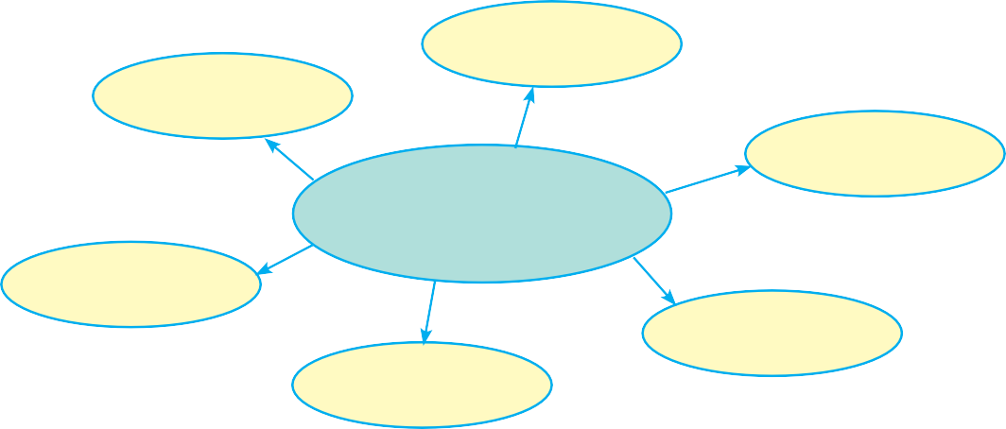

**Decision - making**

1. Form pairs or groups of four. Think of the situations when you have to choose between two things. Make a list of those situations. Some of them may be minor or trivial things

- for example, what to wear when going out. Some choices may be related to important things, for example, having to decide between games and studies, whether to confront a close friend about something that he/she did, owning up to your mistakes, etc.

1. Discuss how to decide what to choose.
2. Write what you feel when your decision proves right.
3. Write what you feel when you regret the decision.

68

## The Road Not Taken

Two roads diverged in a yellow wood, And sorry I could not travel both

And be one traveller, long I stood

And looked down one as far as I could To where it bent in the undergrowth;

Then took the other, as just as fair, And having perhaps the better claim,

Because it was grassy and wanted wear; Though as for that the passing there Had worn them really about the same

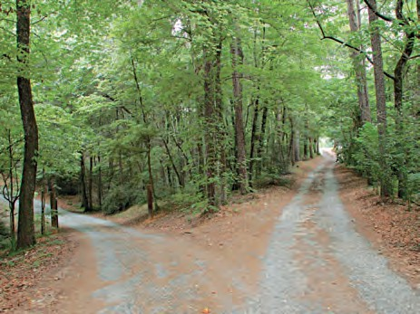

And both that morning equally lay In leaves no step had trodden black. Oh, I kept the first for another day !

Yet knowing how way leads on to way, I doubted if I should ever come back.

I shall be telling this with a sigh Somewhere ages and ages hence : Two roads diverged in a wood, and I - I took the one less travelled by,

And that has made all the difference.

*- Robert Frost*

* + Why does the poet feel sorry ?
  + Did the poet choose the road quickly ?
  + Was one of the roads better than the other ?
  + Does the poet tell us what difference it made ?
* diverge : separate and go in different directions
* wanted wear : needed to be used

69

   **ENGLISH WORKSHOP ** 

1. Read the poem again. Does it have a uniform rhyme scheme throughout ? Write down the rhyme scheme of every stanza separately.

1st stanza 2nd stanza 3rd stanza 4th stanza

1. Write the symbols that are used in the poem to represent the following ideas.
   1. Choice of two options
   2. I made a rare choice
   3. Equally good options
   4. It was tempting and needed to be tried
   5. Some other time
2. Rearrange the following facts in the proper order and fill in the flow chart.
   1. He chooses the one barely travelled.
   2. Choosing the lesser-used road has made a great difference.
   3. He observed one, as far as he could.
   4. The traveller came to a fork in the road.
   5. He planned to travel along the previous one some other time.

70

1. Think and write in your own words.
   1. In which season does a greenwood turn to a yellow wood ? Which stage in our life can be compared to that season ?
   2. Why did the traveller choose the road less travelled ? What attribute of the traveller does it bring out ?
   3. Why does the traveller doubt that he shall ever come back ?
   4. If you were in the traveller’s place, which road would you choose ? Justify your choice.
2. From any collection of classic poetry or the internet, find another famous poem by Robert Frost titled ‘*Stopping by the woods on a Snowy Evening*’. Try to understand the symbolism used in that poem in 8-10 lines.
3. Write a letter to your friend or cousin telling him / her about a difficult choice you have recently made, for example, pursuing one sport or hobby rather than the other or choosing between your studies and hobbies.

Tell your friend / cousin how his / her example helped you to take a decision.





1. Collect quotations on the topic ‘choice’. Example :

‘Decisions are the hardest thing to make, especially when it is a choice between where you should be and where you want to be.’

Present the quotations in a beautiful hand on cardpaper.

71

## How the First Letter was Written

**Warming up !**

1. List the materials that man has used for the following purposes in the different ages.

|  |  |  |  |
| --- | --- | --- | --- |
| Objects | Neolithic Age  (Later Stone Age) | 1st Century CE | Modern Age |
| Weapons | stone / bones / animal teeth |  |  |
| Fuel |  |  |  |
| Utensils |  |  |  |
| Food |  |  |  |
| Clothes |  |  |  |

1. Write your name in Bold Capitals.
   1. Now, within 3 minutes try to make as many words as you can using the letters in your name. You cannot use the same letter twice in a word, unless it is so in your name.
   2. You may use the above idea to devise a game with your friends.
2. List words from your mother tongue or from Hindi which do not have an exact English equivalent. Try to write their meaning in English.
3. Now, list at least twenty English words which do not have an exact equivalent in your mother tongue.
4. Browse the internet to find names of people /places, etc. in any language that is not familiar to you . Can you pronounce the names correctly ? How will you find the correct pronunciation ?

72

## How the First Letter was Written

Once upon a most early time was a Neolithic man and he lived cavily in a Cave, and he wore very few clothes, and he couldn’t read and he couldn’t write and he didn’t want to, and except when he was hungry he was quite happy. His name was Tegumai Bopsulai, and that means, ‘Man-who-does-not-put-his- foot-forward-in-a-hurry’; but we, O Best Beloved, will call him Tegumai, for short. And his wife’s name was Teshumai Tewindrow, and that means, ‘Lady-who- asks-a-very-many-questions’; but we, O Best Beloved, will call her Teshumai, for short. And his little girl- daughter’s name was Taffimai Metallumai, and that means, ‘Small-person-without-any-manners-who-ought- to-be-spanked’; but I’m going to call her Taffy. And she was Tegumai Bopsulai’s Best Beloved and her own Mummy’s Best Beloved, and she was not spanked half as much as was good for her; and they were all three very happy.

Now attend and listen!

One day Tegumai Bopsulai went down through the beaver-swamp to the Wagai river to spear carp-fish for dinner, and Taffy went too. Tegumai’s spear was made of wood with shark’s teeth at the end, and before he had caught any fish at all he accidentally broke it clean across by jabbing it down too hard on the bottom of the river. They were miles and miles from home and Tegumai had forgotten to bring any extra spears.

‘Here’s a pretty kettle of fish!’ said Tegumai. ‘It will take me half the day to mend this.’

‘There’s your big black spear at home,’ said Taffy. ‘Let me run back to the Cave and ask Mummy to give it me.’

‘It’s too far for your little fat legs,’ said Tegumai. ‘Besides, you might fall into the beaver-swamp and be drowned. We must make the best of a bad job.’ He sat down and took out a little leather mendy-bag, full of reindeer-sinews and strips of leather, and lumps of bee’s-wax and resin, and began to mend the spear.

* Give one word for the meanings of each of the names :

- Tengumai Bopsulai

- Teshumai Tewindrow

- Taffimai Metallumai.

* Who is the author telling this story to ?
* swamp : a marshy land
* a pretty kettle

of fish : a messy situation

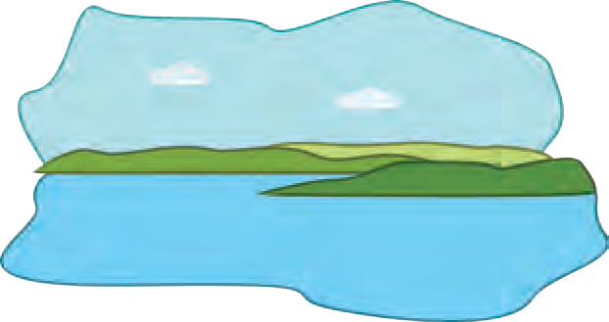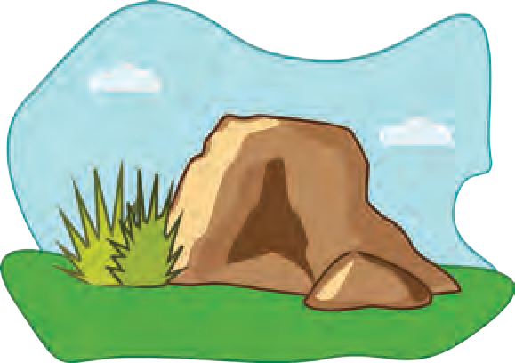

73

* Why had Taffy stamped her foot ? What did the stranger make of it ?

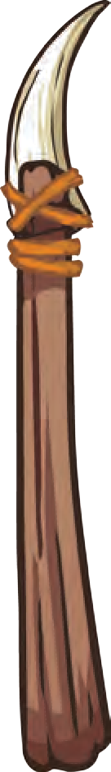

* hank : loosely tied bundle of strings

Taffy sat down too, with her toes in the water and her chin in her hand, and thought very hard. Then she said - ‘I say, Daddy, it’s an awful nuisance that you and I don’t know how to write, isn’t it? If we did, we could send a message for the new spear.’

Just then a Stranger-man came along the river, but he belonged to a far tribe, the Tewaras, and he did not understand one word of Tegumai’s language. He stood on the bank and smiled at Taffy, because he had a little girl-daughter of his own at home. Tegumai drew a hank of deer-sinews from his mendy-bag and began to mend his spear.

‘Come here’, said Taffy. ‘Do you know where my Mummy lives?’ And the Stranger-man said ‘Um!’

‘Silly!’ said Taffy, and she stamped her foot, because she saw a shoal of very big carp going up the river just when her Daddy couldn’t use his spear.

‘Don’t bother grown-ups,’ said Tegumai, so busy with his spear-mending that he did not turn round.

‘I aren’t’, said Taffy. ‘I only want him to do what I want him to do, and he won’t understand.’

‘Then don’t bother me’, said Tegumai, and he went on pulling and straining at the deer-sinews with his mouth full of loose ends. The Stranger-man - a genuine Tewara he was - sat down on the grass, and Taffy showed him what her Daddy was doing. The Stranger-man thought, ‘This is a very wonderful child. She stamps her foot at me and she makes faces. She must be the daughter of that noble Chief who is so great that he won’t take any notice of me.’ So he smiled more politely than ever.

‘Now,’ said Taffy, ‘I want you to go to my Mummy, because your legs are longer than mine, and you won’t fall into the beaver-swamp, and ask for Daddy’s other spear - the one with the black handle that hangs over our fireplace.’

The Stranger-man thought, ‘This is a very, very wonderful child. She waves her arms and she shouts at me, but I don’t understand a word of what she says.

74

But if I don’t do what she wants, I greatly fear that, that haughty Chief, Man-who-turns-his-back-on-callers, will be angry.’ He got up and twisted a big flat piece of bark off a birch-tree and gave it to Taffy. He did this, Best Beloved, to show that his heart was as white as the birch-bark and that he meant no harm; but Taffy didn’t quite understand.

‘Oh!’ said she. ‘Now I see! You want my Mummy’s living-address? Of course I can’t write, but I can draw pictures if I’ve anything sharp to scratch with. Please lend me the shark’s tooth off your necklace.’

The Stranger-man (and he was a Tewara) didn’t say anything, so Taffy put up her little hand and pulled at the beautiful bead and seed and shark-tooth necklace round his neck.

The Stranger-man (and he was a Tewara) thought, ‘This is a very, very, very wonderful child. The shark’s tooth on my necklace is a magic shark’s tooth, and I was always told that if anybody touched it without my leave they would immediately swell up or burst, but this child doesn’t swell up or burst, and that important Chief, Man-who-attends-strictly-to-his-business, who has not yet taken any notice of me at all, doesn’t seem to be afraid that she will swell up or burst. I had better be more polite.’

So he gave Taffy the shark’s tooth, and she lay down flat on her tummy with her legs in the air, like some people on the drawing-room floor when they want to draw pictures, and she said, ‘Now I’ll draw you some beautiful pictures! You can look over my shoulder, but you mustn’t joggle. First I’ll draw Daddy fishing. It isn’t very like him; but Mummy will know, because I’ve drawn his spear all broken. Well, now I’ll draw the other spear that he wants, the black-handled spear. It looks as if it was sticking in Daddy’s back, but that’s because the shark’s tooth slipped and this piece of bark isn’t big enough. That’s the spear I want you to fetch; so I’ll draw a picture of me myself ‘splaining to you. My hair doesn’t stand up like I’ve drawn, but it’s easier to draw that way. Now I’ll draw

* + Why did the stranger offer Taffy a big piece of birch - bark?
  + Why did the stranger’s admiration for Taffy grow ?
  + Who does the author refer to when he says ‘some people’?
  + Is Taffy’s drawing realistic ? In how many ways does it fail to show the real picture ?

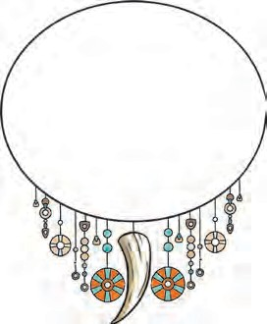

75

* Write ‘fended’ and ‘splain’ with their proper spellings.
* How did the stranger interpret Taffy’s drawing ?
* What mistaken notions made the stranger race off like the wind ?
* slain : killed mercilessly

you. I think you’re very nice really, but I can’t make you pretty in the picture, so you mustn’t be ’fended. Are you ’fended?’

The Stranger-man (and he was a Tewara) smiled. He thought, ‘There must be a big battle going to be fought somewhere, and this extraordinary child, who takes my magic shark’s tooth but who does not swell up or burst, is telling me to call all the great Chief’s tribe to help him. He is a great Chief, or he would have noticed me.

‘Look,’ said Taffy, drawing very hard and rather scratchily, ‘now I’ve drawn you, and I’ve put the spear that Daddy wants into your hand, just to remind you that you’re to bring it. Now I’ll show you how to find my Mummy’s living-address. You go along till you come to two trees (those are trees), and then you go over a hill (that’s a hill), and then you come into a beaver-swamp all full of beavers. I haven’t put in all the beavers, because I can’t draw beavers, but I’ve drawn their heads, and that’s all you’ll see of them when you cross the swamp. Mind you don’t fall in! Then our Cave is just beyond the beaver-swamp. It isn’t as high as the hills really, but I can’t draw things very small. That’s my Mummy outside. She is beautiful. She is the most beautifullest Mummy there ever was, but she won’t be ’fended when she sees I’ve drawn her so plain. She’ll be pleased of me because I can draw. Now, in case you forget, I’ve drawn the spear that Daddy wants outside our Cave. It’s inside really, but you show the picture to my Mummy and she’ll give it you. I’ve made her holding up her hands, because I know she’ll be so pleased to see you. Isn’t it a beautiful picture? And do you quite understand, or shall I ’splain again?’

The Stranger-man (and he was a Tewara) looked at the picture and nodded very hard. He said to himself, ‘If I do not fetch this great Chief’s tribe to help him, he will be slain by his enemies who are coming up on all sides with spears. Now I see why the great Chief pretended not to notice me! He feared that his

76

enemies were hiding in the bushes and would see him. Therefore he turned to me his back, and let the wise and wonderful child draw the terrible picture showing me his difficulties. I will away and get help for him from his tribe.’ He did not even ask Taffy the road, but raced off into the bushes like the wind, with the birch- bark in his hand, and Taffy sat down most pleased.

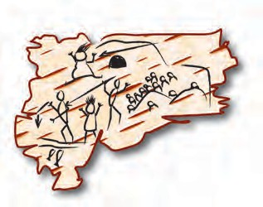

* What was the

stranger’s impression of Teshumai Tewindrow ?

* Is it possible to

promise that one will be surprised ?

* What terrible

message had Taffy’s drawing conveyed to her mummy ?

* brambles : wild

prickly pushes

Now this is the picture that Taffy had drawn for him!

‘What have you been doing, Taffy?’ said Tegumai. He had mended his spear and was carefully waving it to and fro.

‘It’s a little berangement of my own, Daddy dear,’ said Taffy. ‘If you won’t ask me questions, you’ll know all about it in a little time, and you’ll be surprised. You don’t know how surprised you’ll be, Daddy! Promise you’ll be surprised.’

‘Very well,’ said Tegumai, and went on fishing. The Stranger-man - did you know he was a

Tewara? - hurried away with the picture and ran for some miles, till quite by accident he found Teshumai Tewindrow at the door of her Cave, talking to some other Neolithic ladies who had come in to a Primitive lunch. Taffy was very like Teshumai, especially about the upper part of the face and the eyes, so the Stranger- man - always a pure Tewara - smiled politely and handed Teshumai the birch-bark. He had run hard, so that he panted, and his legs were scratched with brambles, but he still tried to be polite.

As soon as Teshumai saw the picture she screamed like anything and flew at the Stranger-man. The other Neolithic ladies at once knocked him down and sat on him in a long line of six, while Teshumai pulled his hair.

‘It’s as plain as the nose on this Stranger-man’s face,’ she said. ‘He has stuck my Tegumai all full of spears, and frightened poor Taffy so that her hair stands all on end; and not content with that, he brings me a horrid picture of how it was done. Look!’ She

77

* Point out two humorous expressions from - ‘all the Neolithic ladies sitting patiently on the Stranger-man’.

showed the picture to all the Neolithic ladies sitting patiently on the Stranger-man. ‘Here is my Tegumai with his arm broken; here is a spear sticking into his back; here is a man with a spear ready to throw; here is another man throwing a spear from a Cave, and here are a whole pack of people’ (they were Taffy’s beavers really, but they did look rather like people) ‘coming up behind Tegumai. Isn’t it shocking!’

*- Rudyard Kipling (Adapted from ‘How the First Letter was Written.’ )*

**ENGLISH WORKSHOP**

1. Read the remaining part of the original story.
2. Make as many 5 to 8 letter words as you can within 5 minutes, from the name.

**TESHUMAI TEWINDROW**

|  |  |  |  |
| --- | --- | --- | --- |
| Five-letter words | Six-letter words | Seven-letter words | Eight-letter words |
|  |  |  |  |

1. How do the following characters in the story live up to their names ? Provide points from the story.
   1. Tengumai Bopsulai :
   2. Taffimai Metallumai :
   3. Teshumai Tewindrow :
2. The story is written in an informal, colloquial style - the way it would be told orally. Find and write the expressions where the author addresses the audience directly in the story - for example, ‘but we, O Best Beloved, will ...’, ‘Now attend and listen !’
3. Write a character - sketch of the ‘Stranger-man’ using examples from the story to support the following attributes .
   1. ignorant, innocent and polite
   2. calm and cool
   3. jumps to wrong conclusions
   4. hasty and unwise at times

78

1. Note the punctuation used in the story. Here, single inverted commas or quotation marks have been used to show conversation. Rewrite the following using double quotation marks :

79

* 1. ‘Here’s a pretty kettle of fish !’ said Tengumai.
  2. ‘It will take me half the day to mend this.’

1. Underline the main clauses in the following sentences :
   1. And she was Tegumai Bopsulai’s Best Beloved and her own Mummy’s Best Beloved, and she was not spanked half as much as was good for her; and they were all three very happy.
   2. One day Tegumai Bopsulai went down through the beaver-swamp to the Wagai river to spear carp-fish for dinner, and Taffy went too.
   3. They were miles and miles from home and Tegumai had forgotten to bring any extra spears.
   4. Just then a Stranger-man came along the river, but he belonged to a far tribe, the Tewaras, and he did not understand one word of Tegumai’s language.
2. Imagine Taffy comes to you for help to write a letter of apology, in the modern script we use. She wants to express her regret to the stranger-man for her mother’s action. Write that letter of apology (informal) on her behalf.
3. Imagine the Stranger-man narrates how the Neolithic ladies overpowered him. Write an account of the same making him the narrator.
4. Making suitable groups, convert the entire episode into a short skit and write it down. Each group leader must discuss at first with the others and add a different end to the skit.
5. Happy ending (3) Surprise ending
6. Sad ending (4) Humorous ending
7. Write a short passage / essay on ‘Women Power’ in the Neolithic, Medieval



and Present Times.

12. **Read : ‘**Just So Stories’ and ‘The Jungle Book’ by Rudyard Kipling.

## Please Listen !

**Unit Four**

**Warming up !**

#### Twenty Questions

Form groups of 6-8. One person (leader) chooses one item - a picture, a paragraph or a lesson from any one of the 9th standard textbooks and writes the reference on a slip of paper and folds it. Others ask him/her questions and try to guess what it is, from his/her answers. Follow the rules given below.

* The maximum number of questions the rest of the group can ask is 20.
* You cannot ask a direct question like ‘What do you have in mind ?’
* You can ask ‘Wh-’ questions or ‘Yes/no’ questions.
* The leader has to give truthful answers.

**Agreements and Disagreements**

Form pairs. List the things on which you have the same opinion and also the ones on which you have different opinions. Prepare a list of ten things in all and see how far you agree or disagree with your friend. Some useful phrases are given alongside.

You could talk about:

* Clothes, latest fashion
* Performance of sportsmen and women
* Traffic/Transport in your area
* Cleanliness and hygiene in your area
* Future occupations/Careers
* Latest news items
* TV programmes
* Mobile Apps
* Any subject of your choice

**Agreement**

* I totally agree with you.
* Exactly/Absolutely!
* You are right.
* I don’t know, I need to think about it. (partial agreement)
* I suppose so.

**Ask for your friend’s opinion:**

* Do you think ...?
* Do you agree ...?

⯌ What do you think?

⯌ What is your opinion?

⯌ How do you feel about that?

**Disagreement**

* No, I don’t think so.
* I totally disagree.
* Not necessarily.
* I’m not sure about that.
* Let’s agree to disagree!

80

|  |  |
| --- | --- |
| **Please Listen !** | * What’s the difference between ‘hear’ and ‘listen’?   **Think, guess and answer :**   * How old is the speaker in   the poem ?   * Who is he/she talking to ? * What must have happened before the speaker says all this ? |
| When I ask you to listen to me and you start giving me advice,  you have not done what I asked.  When I ask you to listen to me and you begin to tell me why I shouldn’t feel that way,  you are trampling on my feelings.  When I ask you to listen to me  and you feel you have to do something to solve my problem,  you have failed me, strange as that may seem.  Listen ! All I ask is that you listen. Don’t talk or do - just hear me.  Advice is cheap; 20 cents will get  you both Dear Abby and Billy Graham in the same newspaper.  And I can do for myself; I am not helpless.  Maybe discouraged and faltering, but not helpless.  When you do something for me that I can and need to do for myself,  you contribute to my fear and inadequacy.  But when you accept as a simple fact that I feel what I feel,  no matter how irrational,  then I can stop trying to convince you |
| ‘20 cents ... newspaper’ - This is a reference to the columns in newspapers where people write about their problems and the columnist offers advice. See if your local papers have it. |
|  |

81

**Think, discuss and answer :**

* + Is the speaker aware of his shortcomings ?
  + Does he/she want to improve ?
  + Is he/she confident that he/she can improve ?
  + How does he/she want to work it out ?
  + Is the poet willing to listen to others?

Discuss how you can be a good listener.

* irrational : illogical, without any reason or base

and get about this business

of understanding what’s behind this irrational feeling.

And when that’s clear, the answers are obvious and I don’t need advice.

Irrational feelings make sense when we understand what’s behind them.

Perhaps that’s why prayer works, sometimes, for some people - because God is mute, and he doesn’t give advice or try

to fix things.

God just listens and lets you work it out for yourself.

So please listen, and just hear me.

And if you want to talk, wait a minute

for your turn - and I will listen to you.

*- Author Unkonwn*

   **ENGLISH WORKSHOP ** 

1. The poet uses a free, conversational style in his poem. It is also called Colloquial style. Pick out and write down such lines or expressions that support the above statement.
   1. you have not done what I asked. (b)

(c)

1. Put the following expressions in a table of Dos and Don’ts as expressed by the poet.

|  |  |  |  |
| --- | --- | --- | --- |
| (a) Please listen. |  | (e) | Just hear me. |
| (b) Give me advice. |  | (f) | Accept as a simple fact. |
| (c) Tell me why. |  | (g) | Contribute to my fear. |
| (d) Solve my problem. | 82 | (h) | Wait a minute. |

|  |  |  |
| --- | --- | --- |
|  | Dos | Don’ts |
|  |  |  |
|  |  |  |
|  |  |  |
|  |  |  |

1. Write in your own words :-
   1. What does the listener do when the poet asks him to just listen ? Give 3 points.
   2. Why does the poet remark that advice is cheap ?
   3. Which two facts show that the poet is confident of overcoming his irrational feeling ?
2. According to the poet, how does God help people, when they pray to him for help ?
3. Why should one learn to tackle one’s problems by one’s own self ?
4. Why should seniors not over - protect or over - pamper juniors ?
5. Find out and write down some proverbs / axioms / quotations that convey a message similar to ‘Self-help is the best help.’
6. Maintain **a diary** at least for a week. Write about your interactions with other people in your surroundings in 3-4 lines. Also write whether you find the interactions happy- unhappy, satisfactory-unsatisfactory, enjoyable-stressful, etc.
7. Write **an informal letter** from a teenager to his/her parent, expressing a few thoughts from the poem.

(My dear ...../Dearest ......./Hi! ..... Are you surprised to see this letter? I wanted to talk to you about this, but then I thought I will be able to express myself better in a letter.... Love,/Yours lovingly/Yours )

1. Read aloud a couple of stanzas of the poem ‘Invictus’ and ‘Please Listen’. In what ways do they differ ? Think and fill up the table with ‘Yes’ or ‘No’.

‘Invictus’ ‘Please Listen’

1. Rhyming lines
2. Steady rhythm
3. Uniformity in length of lines
4. Uniformity of number of lines in each stanza
5. Figurative language

‘Invictus’ is an example of Traditional Poetry. ‘Please Listen’ is an example of Free Verse.

83

## The Storyteller

**Warming up !**

1. Short stories are of many types. Match the type of story in column A with its description in column B.

|  |  |  |  |
| --- | --- | --- | --- |
|  | STORY TYPE |  | DESCRIPTION |
| 1 | Anecdote | a | Serious and ends in a tragedy |
| 2 | Fable | b | Untrue but realistic |
| 3 | Parable | c | Short amusing account of an incident |
| 4 | Myth | d | Where vices and folly are ridiculed |
| 5 | Legend | e | Moral bearing story with animal characters |
| 6 | Fairy Tale | f | Having historical base/characters but may not be true |
| 7 | Tragic Tale | g | Having religious base and a message or moral |
| 8 | Fiction | h | Exaggerated comedy |
| 9 | Farce | i | Having supernatural characters/ a moral for children |
| 10 | Satire | j | Originated in ancient times, authorship unknown |

1. Complete the following story using the verbs in the brackets in their proper form :-

**Footprint**

One night a man (have) a dream. He (dream) that he was (walk) along the beach with god. Across the sky flashed scenes from his life. For each scene, he noticed two sets of foot prints in the sand; one (belong) to him and the other, to God.

After the last scene (flash), he looked back at the footprints in the sand. He (observe) that many times along the path of his life there (be) only one set of footprints and that it (happen)

at the saddest, most (trouble) times of his life.

He (question) God about it. “God, you (say) that once I (decide) to follow you, you (will) walk with

me all the way. So I don’t understand, why you (leave) me alone, when I (need) you most.”

God replied, “During your times of trials and sufferings, where you

(see) only one set of footprints, they (be) mine for it was then that I (carry) you in my arms.”

84

## The Storyteller

It was a hot afternoon, and the railway carriage was correspondingly sultry, and the next stop was at Templecombe, nearly an hour ahead. The occupants of the carriage were a small girl, and a smaller girl, and a small boy. Their aunt occupied one corner seat, and the further corner seat on the opposite side was occupied by a bachelor who was a stranger to their party, but the small girls and the small boy emphatically occupied the compartment. Both the aunt and the children were conversational in a limited, persistent way, reminding one of the attentions of a housefly that refuses to be discouraged. Most of the aunt’s remarks seemed to begin with ‘Don’t,’ and nearly all of the children’s remarks began with ‘Why?’ The bachelor said nothing out loud.

“Don’t, Cyril, don’t,” exclaimed the aunt, as the small boy began smacking the cushions of the seat, producing a cloud of dust at each blow.

“Come and look out of the window,” she added.

The child moved reluctantly to the window. “Why are those sheep being driven out of that field?” he asked.

“I expect they are being driven to another field where there is more grass,” said the aunt weakly.

“But there is lots of grass in that field,” protested the boy; “there’s nothing else but grass there. Aunt, there’s lots of grass in that field.”

“Perhaps the grass in the other field is better,” suggested the aunt fatuously.

“Why is it better?” came the swift, inevitable question.

“Oh, look at those cows!” exclaimed the aunt. Nearly every field along the line had contained cows or bullocks, but she spoke as though she were drawing attention to a rarity.

* How many occupants did the compartment have ?
* Why did the aunt have to use the word ‘Don’t’ so often ?
* emphatically : in a noticeable manner
* fatuously : foolishly
* inevitable : unavoidable

85

* + How did the smaller of the two girls irritate the bachelor ?
  + To which question from Cyril was aunt unable to give a reasonable answer ?
  + How did the children show their disapproval of their aunt’s story ?
* a scowl : an angry look
* resolute : firm
* estimation : opinion
* petulant : unreasonable
* deplorably : in a very bad way

“Why is the grass in the other field better?” persisted Cyril.

The frown on the bachelor’s face was deepening to a scowl. He was a hard, unsympathetic man, the aunt decided in her mind. She was utterly unable to come to any satisfactory decision about the grass in the other field.

The smaller girl created a diversion by beginning to recite ‘On the Road to Mandalay.’ She only knew the first line, but she put her limited knowledge to the fullest possible use. She repeated the line, over and over again, in a dreamy but resolute and very audible voice; it seemed to the bachelor as though some one had had a bet with her that she could not repeat the line aloud two thousand times without stopping. Whoever it was, who had made the wager was likely to lose his bet.

“Come over here and listen to a story,” said the aunt, when the bachelor had looked twice at her.

The children moved listlessly towards the aunt’s end of the carriage. Evidently, her reputation as a story-teller did not rank high in their estimation.

In a low, confidential voice, interrupted at frequent intervals by loud, petulant questionings from her listeners, she began an unenterprising and deplorably uninteresting story about a little girl who was good, and made friends with every one on account of her goodness, and was finally saved from a mad bull by a number of rescuers who admired her moral character.

“Wouldn’t they have saved her if she hadn’t been good?” demanded the bigger of the small girls. It was exactly the question that the bachelor had wanted to ask.

“Well, yes,” admitted the aunt lamely, “but I don’t think they would have run quite so fast to her help if they had not liked her so much.”

“It’s the stupidest story I’ve ever heard,” said the bigger of the small girls, with immense conviction.

“I didn’t listen after the first bit, it was so stupid,” said Cyril.

86

The smaller girl made no actual comment on the story, but she had long ago recommenced a murmured repetition of her favourite line.

“You don’t seem to be a success as a story-teller,” said the bachelor suddenly from his corner.

The aunt bristled in instant defence at this unexpected attack.

“It’s a very difficult thing to tell stories that children can both understand and appreciate,” she said stiffly.

“I don’t agree with you,” said the bachelor. “Perhaps you would like to tell them a story,” was

the aunt’s retort.

“Tell us a story,” demanded the bigger of the small girls.

“Once upon a time,” began the bachelor, “there was a little girl called Bertha, who was extraordinarily good.”

The children’s momentarily-aroused interest began at once to flicker; all stories seemed dreadfully alike, no matter who told them.

“She did all that she was told, she was always truthful, she kept her clothes clean, ate milk puddings as though they were jam tarts, learned her lessons perfectly, and was polite in her manners.”

“Was she pretty?” asked the bigger of the small girls.

“Not as pretty as any of you,” said the bachelor, “but she was horribly good.”

There was a wave of reaction in favour of the story; the word horrible in connection with goodness was a novelty that commended itself. It seemed to introduce a ring of truth that was absent from the aunt’s tales of infant life.

* bristled : got angry
* commended : proved acceptable

87

* + For which three values did Bertha win medals? What was exceptional about it ?
  + How did the Prince reward Bertha ?
  + Why did the children approve of the prince’s decision ?

#### Part II

“She was so good,” continued the bachelor, “that she won several medals for goodness, which she always wore, pinned on to her dress. There was a medal for obedience, another medal for punctuality, and a third for good behaviour. They were large metal medals and they clicked against one another as she walked. No other child in the town where she lived had as many as three medals, so everybody knew that she must be an extra good child.”

“Horribly good,” quoted Cyril.

“Everybody talked about her goodness, and the Prince of the country got to hear about it, and he said that as she was so very good she might be allowed once a week to walk in his park, which was just outside the town. It was a beautiful park, and no children were ever allowed in it, so it was a great honour for Bertha to be allowed to go there.”

“Were there any sheep in the park?” demanded Cyril.

“No;” said the bachelor, “there were no sheep. But there were other small, harmless animals in the park.”

The storyteller paused to let a full idea of the park’s treasures sink into the children’s imaginations; then he resumed:

“Bertha was rather sorry to find that there were no flowers in the park. She had promised her aunts, with tears in her eyes, that she would not pick any of the kind Prince’s flowers, and she had meant to keep her promise, so of course it made her feel silly to find that there were no flowers to pick.”

“Why weren’t there any flowers?”

“Because the animals had eaten them all,” said the bachelor promptly. “The gardeners had told the Prince that you couldn’t have animals and flowers, so he decided to have animals and no flowers.”

There was a murmur of approval at the excellence of the Prince’s decision; so many people would have decided the other way.

88

“There were lots of other delightful things in the park. There were ponds with gold and blue and green fish in them, and trees with beautiful parrots that said clever things at a moment’s notice, and humming birds that hummed all the popular tunes of the day.

Bertha walked up and down and enjoyed herself immensely, and thought to herself : ‘If I were not so extraordinarily good I should not have been allowed to come into this beautiful park and enjoy all that there is to be seen in it,’ and her three medals clinked against one another as she walked and helped to remind her how very good she really was.

Just then an enormous wolf came prowling into the park to see if it could catch a fat little animal for its supper. The first thing that it saw in the park was Bertha; her pinafore was so spotlessly white and clean that it could be seen from a great distance. Bertha saw the wolf and saw that it was stealing towards her, and she began to wish that she had never been allowed to come into the park. She ran as hard as she could, and the wolf came after her with huge leaps and bounds. She managed to reach a shrubbery of myrtle bushes and she hid herself in one of the thickest of the bushes. The wolf came sniffing among the branches, its black tongue lolling out of its mouth and its pale grey eyes glaring with rage. Bertha was terribly frightened, and thought to herself: ‘If I had not been so extraordinarily good I should have been safe in the town at this moment.’ However, the scent of the myrtle was so strong that the wolf could not sniff out where Bertha was hiding, and the bushes were so thick that he might have hunted about in them for a long time without catching sight of her, so he thought he might as well go off and catch a little animal instead.

Bertha was trembling very much at having the wolf prowling and sniffing so near her, and as she trembled the medal for obedience clinked against the medals for good conduct and punctuality. The wolf was just moving away, when he heard the sound of the medals clinking and stopped to listen; they clinked again in

* + - Why did Bertha wish she had never come to the park ?
    - Why was the wolf unable to trace Bertha ?
  + myrtle : bush with shiny leaves and sweet-smelling white flowers
  + ferocity : fierce violence

89

* What gave Bertha away and how did she meet her end ?
* What impact did the story have on the children ?
* Why was their aunt annoyed at the bachelor ?
* dissentient : dissenting, different not agreeing
* assail : attack

a bush quite near him. He dashed into the bush, his pale grey eyes gleaming with ferocity and triumph, and dragged Bertha out and devoured her to the last morsel. All that was left of her were her shoes, bits of clothing, and the three medals for goodness.”

“The story began badly,” said the smaller of the small girls, “but it had a beautiful ending.”

“It is the most beautiful story that I ever heard,” said the bigger of the small girls, with immense decision.

“It is the only beautiful story I have ever heard,” said Cyril.

A dissentient opinion came from the aunt.

“A most improper story to tell to young children! You have undermined the effect of years of careful teaching.”

“At any rate,” said the bachelor, collecting his belongings preparatory to leaving the carriage, “I kept them quiet for ten minutes, which was more than you were able to do.”

“Unhappy woman!” he observed to himself as he walked down the platform of Templecombe station; “for the next six months or so those children will assail her in public with demands for an improper story!”

- *H. H. Munro (Saki)*

**ENGLISH WORKSHOP**

1. From the story (Part I and Part II), find 4 words that begin with the prefix ‘un-’ and write their opposites.

 🞪   🞪   🞪 

 🞪   🞪   🞪 

1. Find one example of the following punctuation marks from the story and copy the sentence in which they are used -
   1. colon (b) semi-colon.

90

1. Read the following pieces from the story and suggest a title for each as shown in the 1st one.

|  |  |  |  |
| --- | --- | --- | --- |
|  | From | Up to | Title |
| 1. | It was a hot afternoon | said the aunt weakly. | ‘Children Pester their Aunt’ |
| 2. | The smaller girl created a diversion | likely to lose his bet. |  |
| 3. | In a low confidential voice | it was so stupid,” said Cyril. |  |
| 4. | She (Bertha) did all that she was told | must be an extra good child. |  |
| 5. | The storyteller paused to let | popular tunes of the day. |  |
| 6. | Bertha was trembling very much | the three medals for goodness |  |

1. Write your opinion, in your own words :-
   1. Why do you think the children dislike their aunt’s story?
   2. Why did they appreciate and praise the stranger’s story?
   3. Do you think Bertha should have met such a glory end to her life? Justify your answer.
   4. What did the aunt fail to realise in Bertha’s story?
   5. What is that one vice which nullifies all virtues that a person has?
   6. Write down two or three proverbs / axioms that suit the message in Bertha’s story.
2. Write 3 to 5 sentences about each of the following characters.

* The Aunt
* The Bachelor

91

* Cyril
* Bertha

1. Say whether you agree or disagree.
   1. The children would have behaved well in the train if their aunt had scolded them harshly.
   2. The youngest child was most irritating.
   3. Being a bachelor, the stranger had no patience with children.
   4. The children showed disinterest even in the bachelor’s story-telling, throughout
   5. Bertha was very good but very proud too.
   6. The prince had rare, uncommon likes and dislikes.
   7. The wolf could not trace Bertha because she was behind a myrtle bush.
   8. The bachelor had narrated an improper story to the children.
2. ‘The Storyteller’ has a story within a story.

Search from the Internet or your library books for other stories which have another story within. List at least 3 to 5 of them.

●

●

●

●

1. List all the verbs related to the verb ‘say’ or ‘tell’ from the story. Note where they occur. Rewrite at least 3 of the speeches near which they occur using indirect speech.
2. **Read :** ‘The Open Window’ by H. H. Munro (Saki).

92

## Intellectual Rubbish

   **Warming up ! **  

1. How will you react in the following situations ?
   1. Your Science teacher tells you that plants exposed to the sunlight grow faster than those always in the shade.
   2. Your aunt tells you not to go for a job interview because it’s a no moon day, that very same day.
   3. Your friend argues with you that Mount Everest is not the tallest peak in the world.
   4. A stranger at your door claims to be a magician and promises your mother to turn all her silver jewellery into gold.
2. What do you notice about the following pairs of words ?

* act naturally  liquid gas  open secret  sound of silence  sweet sorrow
* original copy  only choice  growing smaller

Now try to add a contradictory word to the following :

* 1. What a mess you’ve got us into !
  2. It’s a imitation of a diamond necklace.
  3. My trip to Matheran was a holiday.
  4. With such heavy make up, she looks ugly.
  5. A crowd gathered to see the magic show.

Note :- Contrasting words that go together are examples of the language device called **Oxymoron.**

93

## Intellectual Rubbish

* What erroneous notion did Aristotle have ? What does his example convey to you?
* How can you prevent developing a dogmatic attitude ?
* What do you feel when -
  1. someone opposes your strong belief?
  2. someone insists that 2+2 =5?
* dogmatism : insisting on the truth of one’s opinion without evidence

To avoid the various foolish opinions to which mankind are prone, no superhuman genius is required. A few simple rules will keep you, not from *all* error, but from silly error.

If the matter is one that can be settled by observation, make the observation yourself. Aristotle could have avoided the mistake of thinking that women have fewer teeth than men, by the simple device of asking Mrs Aristotle to keep her mouth open while he counted. He did not do so because he thought he knew. Thinking that you know when in fact you don’t is a fatal mistake, to which we are all prone. I believe myself that hedgehogs eat black beetles, because I have been told that they do; but if I were writing a book on the habits of hedgehogs, I should not commit myself until I had seen one enjoying this unappetizing diet. Aristotle, however, was less cautious....

Many matters, however, are less easily brought to the test of experience. If, like most of mankind, you have passionate convictions on many such matters, there are ways in which you can make yourself aware of your own bias. If an opinion contrary to your own makes you angry, that is a sign that you are subconsciously aware of having no good reason for thinking as you do. If someone maintains that two and two are five, or that Iceland is on the equator, you feel pity rather than anger, unless you know so little of arithmetic or geography that his opinion shakes your own contrary conviction. The most savage controversies are those about matters as to which there is no good evidence either way... so whenever you find yourself getting angry about a difference of opinion, be on your guard; you will probably find, on examination, that your belief is going beyond what the evidence warrants.

A good way of ridding yourself of certain kinds of dogmatism is to become aware of opinions held in social circles different from your own. When I was young, I lived much outside my own country - in France, Germany, Italy and the United States. I found

94

this very profitable in diminishing the intensity of insular prejudice. If you cannot travel, seek out people with whom you disagree, and read a newspaper belonging to a party that is not yours. If the people and the newspaper seem mad, perverse and wicked, remind yourself that you seem so to them. In this opinion both parties may be right, but they cannot both be wrong. This reflection should generate a certain caution.

Becoming aware of foreign customs, however, does not always have a beneficial effect. In the seventeenth century, when the Manchus conquered China, it was the custom among the Chinese for the woman to have small feet, and among the Manchus for the men to wear pigtails. Instead of each dropping their own foolish custom, they each adopted the foolish custom of the other, and the Chinese continued to wear pigtails until they shook off the dominion of the Manchus in the revolution of 1911.

For those who have enough psychological imagination, it is a good plan to imagine an argument with a person having a different bias. This has one advantage, and only one, as compared with actual conversation with opponents; this one advantage is that the method is not subject to the same limitations of time and space. Mahatma Gandhi deplored railways and steamboats and machinery; he would have liked to undo the whole of the industrial revolution. You may never have an oportunity of actually meeting any one who holds this opinion, because in Western countries most people take the advantage of modern technique for granted. But if you want to make sure that you are right in agreeing with the prevailing opinion, you will find it a good plan to test the arguments that occur to you by considering what Gandhi might have said in refutation of them. I have sometimes been led actually to change my mind as a result of this kind of imaginary dialogue, and, short of this, I have frequently found myself growing less dogmatic and cocksure through realising the possible reasonableness of a hypothetical opponent.

* + insular : disinterested in ideas from foreign countries
  + perverse : stubbornly opposed to
  + refutation : that which disproves
  + hypothetical : based on an assumption

95

* What two examples does the writer give to those who have opinions that flatter their self - esteem?
* What is the only way to tackle such self - pride?
* inherently : by nature
* aught : anything
* elixir of life :

a divine substance that made somebody immortal

Be very wary of opinions that flatter your self- esteem. Both men and women, nine times out of ten, are firmly convinced of the superior excellence of their own sex. There is abundant evidence on both sides. If you are a man, you can point out that most poets and men of science are male; if you are a woman, you can retort that so are most criminals. The question is inherently insoluble, but self - esteem conceals this from most people.

We are all, whatever part of the world we come from, persuaded that our own nation is superior to all others. Seeing that each nation has its characteristic merits and demerits, we adjust our standard of values so as to make out that the merits possessed by our nation are the really important ones, while its demerits are comparatively trivial.

Here, again, the rational man will admit that the question is one to which there is no demonstrably right answer. It is more difficult to deal with the self - esteem of man as man, because we cannot argue out the matter with some non - human mind. The only way I know of dealing with this general human conceit is to remind ourselves that man is a brief episode in the life of a small planet in a little corner of the universe, and that for aught we know, other parts of the cosmos may contain beings as superior to ourselves as we are to jelly - fish.

Other passions besides self - esteem are common sources of error. Of these perhaps the most important is fear. Fear sometimes operates directly, by inventing rumours of disaster in war - time, or by imagining objects of terror, such as ghosts; sometimes it operates indirectly, by creating belief in something comforting, such as the elixir of life, or heaven for ourselves and hell for our enemies. Fear has many forms - fear of death, fear of the dark, fear of the unknown, and that vague generalised fear that comes to those who conceal from themselves their more specific terrors. Until you have admitted your own fears to yourself, and have guarded yourself by a difficult effort of will against their myth - making power, you cannot hope to think

96

truly about many matters of great importance, especially those with which religious beliefs are concerned. Fear is the main source of superstition, and one of the main sources of cruelty. To conquer fear is the begining of wisdom, in the pursuit of truth as in the endeavour after a worthy manner of life.

There are two ways of avoiding fear : one is by persuading ourselves that we are immune from disaster, and the other is by the practice of sheer courage. The latter is difficult, and to everybody becomes impossible at a certain point. The former has, therefore, always been more popular. Primitive magic has the purpose of securing safety, either by injuring enemies or by protecting oneself by talismans, spells, or incantations. Without any essential change, belief in such ways of avoiding danger survived throughout the many centuries of civilisation .... Science has now lessened the belief in magic, but many people place more faith in mascots than they are willing to avow... Neither a man nor a crowd nor a nation can be trusted to act humanely or to think sanely under the influence of a great fear. And for this reason poltroons are more prone to cruelty than brave men, and are also more prone to superstition...

But we have been getting too solemn. Superstitions are not always dark and cruel; often they add to the gaiety of life. I received once a communication from the god Osiris, giving me his telephone number; he lived, at that time, in a suburb of Boston. Although I did not enroll myself among his worshippers, his letter gave me pleasure. I have frequently received letters from men announcing themselves as the Messiah, and urging me not to omit to mention this important fact in my lectures.

I admire especially a certain prophetess who lived beside a lake in Northern New York State about the year 1820. She announced to her numerous followers that she possessed the power of walking on water, and that she proposed to do so at 11 o’clock on a certain morning. At the stated time, the faithful assembled in their thousands beside the lake. She spoke to them saying : ‘Are you all entirely persuaded that I can walk

* What two evils does fear lead to ? How can one overcome fear ?
* What is the aim of primitive magic ?
  + talisman : a small object used to fetch good luck
  + incantation : magical words recited in the same tone
  + paltroons : cowards

97

* How did the prophetess befool her believers ?

on water ?’ with one voice they replied : ‘We are’. ‘In that case’, she announced, ‘there is no need for me to do so.’ And they all went home much edified.

Perhaps the world would lose some of its interest and variety if such beliefs were wholly replaced by cold science...

A wise man will enjoy the goods of which there is a plentiful supply, and of intellectual rubbish he will find an abundant diet, in our own age as in every other.

*- Bertrand Russell*

**ENGLISH WORKSHOP ** 

1. The following expressions are a combination of a noun preceded by a describing word.
   1. fatal mistake (e) simple device
   2. foreign customs (f) savage controversy
   3. unappetizing diet (g) modern technique
   4. plentiful supply (h) foolish custom

Replace the describing words with as many others as you can, that go with the underlined nouns.

eg. (a) silly mistake, grave mistake, careless mistake, obvious mistake etc.

1. Use the following idioms / expressions in sentences of your own.
   1. to be prone to
   2. to have a difference of opinion
   3. to go beyond
   4. to have a beneficial effect
   5. to have a bias
   6. to undo
   7. to be wary of
   8. under the influence

98

1. Say ‘WHY’ ?
   1. One should avoid getting angry about a difference of opinion.
   2. The writer found his stay abroad very profitable.
   3. The writer grew less dogmatic and more open-minded.
   4. Men declaring that they are Saints write letters to the writer.
   5. The writer claims that all false beliefs need not be replaced by cold science.
2. Make sentences of your own to show the difference of usage of the following Homophones.
   1.  device
      * devise
   2.  advice
      * advise
   3.  practice
      * practise
3. When a family member is very ill for long, the grandmother of the family urges everyone to send for a person who claims he can cure victims of black magic. Compose a dialogue with her, in which her granddaughter politely convinces her that she should not believe in such things.
4. List the various ways of avoiding error mentioned in the passage.
5. Answer the following questions :
   1. If an opinion contrary to your own makes you angry, what does it indicate ?
   2. What are the most savage controversies about ?
   3. What are the benefits of travel ?
   4. Is the influence of foreign customs always beneficial ?
   5. What are the advantages of an imaginary argument with a person having a different bias?
   6. Why should one be wary of opinions that flatter one’s self - esteem?
   7. How does fear lead us to error ?
   8. What are the two ways of avoiding fear ?
6. What is the meaning of ‘intellectual rubbish’?
7. Find the opposites of the following :

cautious, dogmatic, contrary, savage, beneficial, reasonable, hypothetical, cruelty, immune

1. Write an imaginary dialogue contesting opposite views on a topic of your choice, e.g., ‘Girls should learn to do all the housework and not boys.’

99

## My Financial Career

   **Warming up ! **  

1. When you open a savings account at bank you need to fill up Deposit forms/slips. Observe the following forms and fill up your details.

दिनांक Date

शाखा Branch

के नाम जमा हेतु FOR THE CREDIT OF चालू जमा/ऋण/कैश क्ेदिट खाता सं. Current Deposit/Loan/Cash Credit A/c No.

कृपरा नगि, जमा, इस बैंक पर आहररत दलखतों, समाशोधन दलखतो और बाहरी केंन्द्र के दलखतों के

दलए अलग अलग सस्लप का प्ररोग करें ।

Use separate slips for depositing cash, instruments drawn on his Bank, clearning instruments & outstanding instruments.

दप्रर ग्ाहक, आपकी बेहतर सेवा हेतु कृपरा हमें सहरोग करें, कृपरा जमा पचची के पीछे अपना पता एवं समपक्क बरयौरा अद्यतन करें.

Dear Customer, please help us in serving you better. Kindly update your address and contact details on the reverse of this paying-in-slip

|  |  |  |
| --- | --- | --- |
|  |  |  |

|  |  |  |  |  |  |  |  |  |  |  |  |  |  |  |
| --- | --- | --- | --- | --- | --- | --- | --- | --- | --- | --- | --- | --- | --- | --- |
|  |  |  |  |  |  |  |  |  |  |  |  |  |  |  |

|  |  |  |  |  |  |  |  |  |  |
| --- | --- | --- | --- | --- | --- | --- | --- | --- | --- |
| दजस बँक पर आधाररत Drawn on Bank | | शाखा Branch | | चेक नं.  Cheque No | नकि नोट Cash Notes | रादश Amount  रू. Rs. पै. P. | | | |
|  | |  | |  | 🞪 2000 |  |  |  |  |
|  | |  | |  | 🞪 500 |  |  |  |  |
|  | |  | |  | 🞪 100 |  |  |  |  |
|  | |  | |  | 🞪 50 |  |  |  |  |
|  | |  | |  | 🞪 20 |  |  |  |  |
|  | |  | |  | 🞪 10 |  |  |  |  |
| रू. शबिों मे Rs. In Words | | | | | दसक्े Coins |  |  |  |  |
| खजांची Cashier | स्क्ोल Scroll | | अदधकारी Officer | | रोग Total |  |  |  |  |
|  |  | |  | | जमाकताया (हस्ताक्षर) (Deposited by (Signature) | | | | |
|  | | | | |  | | | | |

|  |  |
| --- | --- |
| सम्पर्क ब्यौरा Contact Details | |
| पता टेलीफोन नं. कारायालर Office  Address : Telephone Numbers :  आवास Residence मोबाईल Mobile |  |
| ई-मेल पतता  E-mail address : |  |
|  | |

1. Write in your own words:-
   1. Why does the bank need so many details of its customer?
   2. What problems do customers face when they have to make a cash deposit at a bank?
   3. What are the latest modern methods of depositing money in your own or somebody else’s account?
2. Make a **word web** of at least 12 words related to BANKING.

100

## My Financial Career

WHEN I go into a bank I get rattled. The clerks rattle me; the wickets rattle me; the sight of the money rattles me; everything rattles me.

The moment I cross the threshold of a bank I am a hesitating jay. If I attempt to transact business there I become an irresponsible idiot.

I knew this beforehand, but my salary had been raised to fifty dollars a month, and I felt that the bank was the only place for it.

So I shambled in and looked timidly around at the clerks. I had an idea that a person about to open an account must needs consult the manager.

I went up to a wicket marked ‘Accountant.’ The accountant was a tall, cool devil. The very sight of him rattled me. My voice was sepulchral.

“Can I see the manager?” I said, and added solemnly, “alone.” I don’t know why I said ‘alone.’

“Certainly,” said the accountant, and fetched him.

The manager was a grave, calm man. I held my fifty-six dollars clutched in a crumpled ball in my pocket.

“Are you the manager?” I said. God knows I didn’t doubt it.

“Yes,” he said.

“Can I see you?” I asked, “Alone?” I didn’t want to say ‘alone’ again, but without it the thing seemed self-evident.

The manager looked at me in some alarm. He felt that I had an awful secret to reveal.

“Come in here,” he said, and led the way to a private room. He turned the key.

“We are safe from interruption here,” he said; “sit down.”

We both sat down and looked at one another. I found no voice to speak.

“You are one of Pinkerton’s men, I presume,” he said.

* What makes the narrator nervous at a bank ?
* What word should he have avoided in his request to see the manager ?
* Why was the manager alarmed ?
* Who did he think was his visitor ?
* rattled : nervous
* rattle : make someone nervous
* jay : a person who talks foolishly
* sepulchral : gloomy, sorrowful

101

* What procedure did the author have to follow to open the account ?
* What error did the author make in the cheque? Did he correct it ?
* Baron Rothschild : The wealthiest most influential man

of the time

* Gould : one of the richest men of that time

He had gathered from my mysterious manner that I was a detective. I knew what he was thinking and it made me worse.

“No, not from Pinkerton’s,” I said, seemingly to imply that I came from a rival agency. “To tell the truth,” I went on, as if I had been prompted to lie about it, “I am not a detective at all. I have come to open an account. I intend to keep all my money in this bank.”

The manager looked relieved, but still serious; he concluded now that I was a son of Baron Rothschild, or a young Gould.

“A large account, I suppose,” he said.

“Fairly large,” I whispered. “I propose to deposit fifty-six dollars now, and fifty dollars a month regularly.”

The manager got up and opened the door. He called to the accountant.

“Mr. Montgomery,” he said, unkindly loud, “this gentleman is opening an account; he will deposit fifty- six dollars. Good morning.”

I rose.

A big iron door stood open at the side of the room. “Good morning,” I said, and stepped into the safe. “Come out,” said the manager coldly, and showed

me the other way.

I went up to the accountant’s wicket and poked the ball of money at him with a quick, convulsive movement, as if I were doing a conjuring trick.

My face was ghastly pale.

“Here,” I said, “deposit it.” The tone of the words seemed to mean, “Let us do this painful thing while the fit is on us.”

He took the money and gave it to another clerk. He made me write the sum on a slip and sign my name in a book. I no longer knew what I was doing. The bank swam before my eyes.

“Is it deposited?” I asked in a hollow vibrating voice.

“It is,” said the accountant. “Then I want to draw a check.”

102

My idea was to draw out six dollars of it for present use. Some one gave me a check-book through a wicket, and some one else began telling me how to write it out. The people in the bank had the impression that I was an invalid millionaire. I wrote something on the check and thrust it in at the clerk. He looked at it.

“What! Are you drawing it all out again?” he asked in surprise. Then I realised that I had written fifty-six instead of six. I was too far gone to reason now. I had a feeling that it was impossible to explain the thing. All the clerks had stopped writing to look at me.

Reckless with misery, I made a plunge. “Yes, the whole thing.”

“You withdraw your money from the bank?” “Every cent of it.”

“Are you not going to deposit any more?” said the clerk, astonished.

“Never.”

An idiot hope struck me that they might think something had insulted me while I was writing the check and that I had changed my mind. I made a wretched attempt to look like a man with a fearfully quick temper.

The clerk prepared to pay the money. “How will you have it?” he said. “What?”

“How will you have it?”

“Oh!” I caught his meaning, and answered, without even trying to think, “In fifties.”

He gave me a fifty-dollar bill. “And the six?” he asked dryly. “In sixes,” I said.

He gave it me, and I rushed out.

As the big doors swung behind me I caught the echo of a roar of laughter that went up to the ceiling of the bank. Since then I bank no more. I keep my money in cash in my trousers pocket, and my savings in silver dollars in a sock.

*- Stephen Leacock*

* + Why did the author pretend to appear like a bad-tempered man ?
    - What decision has the author taken after the episode at the bank ?
    - Is the author’s last decision wise ?

103

**ENGLISH WORKSHOP**

1. Find from the lesson, the antonyms of the following.

(a) afterwards (b) spending (c) careful 

(d) withdraw (e) confidently (f) cheerful

1. Fill in the blanks choosing the appropriate word/idiom from the lesson.
   1. The solved the mysterious crime.
   2. In the examination, I did not know the answer, so I
   3. He was dizzy and he into the room.
   4. While arguing with his elders he had
   5. The sight of a snake
   6. As soon as I of my home, I greet my family.
2. Using the following points frame a character sketch of the narrator. Support each character trait with instances from the lesson.

(1) Diffident and timid (2) Unusual behaviour

(3) Ignorant about banking (4) Nervous and careless (5) Economical

1. Rewrite the following in indirect speech.
   1. “Can I see the manager?” I said, “Certainly” said the accountant.
   2. “Good morning,” I said and stepped into the safe. “Come out,” said the manager coldly.
   3. ….. the words seemed to mean, “Let us do this painful thing while the fit is on us.”
   4. “What! Are you drawing it all out again?” he asked in surprise. “Yes, the whole thing,” I said.
   5. “How will you have it?” he said. “In fifties,” I said.
2. Read the statement, write your views first, and counterview later, in two separate passages. ‘Online/Net Banking is better than going personally to the bank for transactions.’

Views:



Counterview:

104

6. Read the story ‘Lord Ermsworth and the Girl Friend’ by P. G. Wodehouse.

## Tansen

**Warming up !**

* 1. Indian Classical music consists of many Ragas. Find out from an expert or the internet, the names of at least 10 Ragas and the time when they are sung to produce greater effect.

|  |  |  |  |  |  |
| --- | --- | --- | --- | --- | --- |
| No. | Name of Raga | Effective when | No. | Name of Raga | Effective when |
| 1.  2.  3.  4.  5. |  |  | 6.  7.  8.  9.  10. |  |  |

* 1. Archaic words are those that are no longer used in a language, but sometimes their usage adds a historical or old-times flavour to a piece of writing.

Examples :  behold – look  afeared – frightened

* + - forsooth – indeed  hither – this place

Now find out some archaic words from your mother tongue or another language that you are proficient in and write down at least ten of them, and against each, their modern equivalent and meaning in English.

**Archaic Language**

|  |  |  |  |
| --- | --- | --- | --- |
|  | Archaic Word | Modern Equivalent | Meaning in English |
| 1.  2.  3.  4.  5.  6.  7.  8.  9.  10. |  |  |  |

* 1. There are many legends about the ‘nine gems’ in Akbar’s Court. These are popular tales and they may not have a historical basis. Can you name some of the nine gems and the stories associated with them ?

105

**Tansen**

Tansen, the singer, in great Akbar’s Court Won great renown; through the Badshahi Fort

His voice rang like the sound of silver bells And Akbar ravished heard. The story tells

How the King praised him, gave him many a gem, Called him chief jewel in his diadem.

One day the singer sang the Song of Fire, The Deepak Râg , and burning like a pyre

His body burst into consuming flame.

To cure his burning heart a maiden came

And sang Malhar, the song of water cold, Till health returned, and comfort as of old.

— Mighty thy Teacher must be and divine, — Great Akbar said; — magic indeed is thine,

Learnt at his feet. — Then happy Tansen bowed And said, — Beyond the world’s ignoble crowd,

* 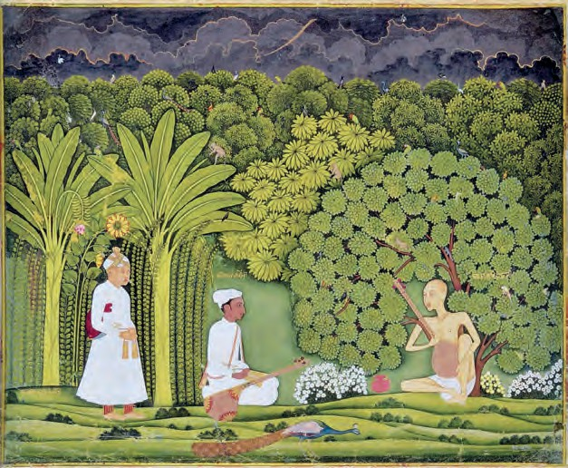How did Akbar reward Tansen for the ecstatic effect of his singing ?
* What happened to Tansen when he sang the Deepak Raga with great vigour ?
* How did he come back to normal, again ?
* What did Tansen tell about his Teacher to Akbar ?
* Why did Akbar change his kingly attire ?
* ignoble : not worthy
* celestial : heavenly

106

Scorning its wealth, remote and far-away He dwells within a cave of Himalay. —

* + Could I but see him once, — desired the King,
  + Sit at his feet awhile, and listening

Hear his celestial song, I would deny

My state and walk in robes of poverty. —

Then said Tansen. — As you desire, Huzoor, Indeed ‘twere better as a slave and poor

To come; for he, lifted above the things

Of earth, disdains to sing to earthly kings. —

Long was the road, and Akbar as a slave Followed Tansen who rode towards the cave

High in the mountains. At the singer’s feet They knelt and prayed with supplication sweet:

* + Towards thy shrine, lo, we have journeyed long, O Holy Master, bless us with thy song! —

Then Ostad, won by their humility, Sang songs of peace and high felicity;

The Malkous Raga all ecstatic rang

Till birds and beasts, enchanted as he sang,

Gathered to hear, o’er Akbar’s dreaming soul He felt the waves of heavenly rapture roll,

But, as he turned to speak his words of praise, Ostad had vanished from his wondering gaze.

* + Tell me, Tansen, what theme this is that holds The soul enchanted, and the heart enfolds

In high delight — ; and, when he knew the name,

* + Tell me, — again he said, — could you the same

Theme sing to lure my heart to paths untrod? —

* + Ah no, to thee I sing; he sings to God. —

*- Hazrat Inayat Khan*

* + What was the magical effect of Ostad’s rendering the Malkous Raga ?
  + What happened before Akbar could come out of his trance ?
  + Why did Tansen’s singing not produce the same effect as that by Ostad ?
* supplication : humble request
* felicity : great happiness;

also, pleasing style

* theme : here it means a musical composition.

107

**ENGLISH WORKSHOP**

1. Pick out Archaic words form the poem and give their modern equivalents

|  |  |  |
| --- | --- | --- |
|  | Archaic Words | Modern Equivalents |
| (a)  (b)  (c)  (d)  (e) |  |  |

1. Who said the following, to whom, and when ?
   1. “Mighty thy Teacher must be and divine.”
   2. “He dwells within a cave of Himalay.”
   3. “As you desire, Huzoor.”
   4. “O Holy Master, bless us with thy song !”
   5. Ah no, to thee I sing: he sings to God.”
2. Rearrange the following in their proper order as in the poem. Write the serial number against each line:-
   1. The Ostad sang the Malkous Raga enchantingly.
   2. Akbar followed Tansen, dressed miserably.
   3. I request you to sing such a song that will I experience unmatched joy.
   4. Ostad was nowhere to be seen.
   5. O Divine Teacher, please gift us the joy of your song.
   6. One day, the singer sang Deepak Raga in the court.
   7. Akbar expressed his wish to meet the Teacher.
   8. He experienced heavenly delight.
   9. Tansen sings to please the earthly king but Ostad devotes his songs to God.
   10. She sang Raga Malhar, which had a cooling effect.
3. Write the reason in your own words.
   1. Akbar strongly desired to hear Ostad sing.
   2. Akbar had to dress like a slave.
   3. After the song Ostad had vanished.
   4. Ostad’s song was more elating than Tansen’s songs.
4. What message does the poet wish to convey through this narrative poem, ‘Tansen’?
5. Summarise this poem in your own words in 8 to 10 lines, highlighting only the main points.

108

# Language Study

The **Language Study** pages aim only at acquainting the students with some terms that are useful when we talk about language and how it works. The entries given here *should not* be treated as teaching items. The information given here *should not* be used for the purpose of evaluating the students’ knowledge of grammatical definitions.

These pages are not meant to be read at a stretch. When opportunities of discussing language arise in the course of classroom teaching, the teacher can refer to the relevant entry or entries and also get the students to read them. The information should then be discussed with the help of examples drawn from the textbook or other familiar sources.

Students, too, can refer to this section from time to time. They may find this information useful while –

* 1. correcting their work
  2. trying to understand a text, and
  3. using dictionaries and other reference books
  4. trying to write literary and non-literary compositions on their own.

If necessary, the teacher should show the students how to look up a word in these pages.

Some words in these pages are printed in colour. It means that they have been explained in these pages at the proper place.

**abbreviation :** a short form of a word, phrase, etc. Examples : *Mr* (Mister), *km* (kilometre/s), *V.I.P.* (very important person),

*S.S.C.* (Secondary School Certificate), *etc.* (et cetera - meaning ‘and other similar things’, ‘and the rest’), *WHO* (World Health Organisation).

Abbreviations are mostly used in writing. While reading aloud or in speech, we use the full forms of abbreviations like ‘Mr’ (Mister) or ‘Dr’ (Doctor). Some abbreviations are read aloud by pronouncing each individual letter, as for example, *V-I-P*. Some short forms are read as if they form a word. For example, PIN is read like the word, ‘pin’.

* Note the abbreviations you come across and find their full forms.

**act :** one of the main parts into which a **play** is divided. A play may have two, three, even five acts or just one act.

**active voice :** See **voice**.

**adjective :** a word that tells us something more about a **noun** or **pronoun**. It may

tell us about the shape, size, colour, quality, material, origin, use, or other features of the noun it describes :

* + - shape : a *round* table, a *square* sheet
    - size : The buildings were *huge* ; *small*

shoes

* + - colour : a *red* rose ; Milk is *white*.
    - quality : You are very *kind* ; a *strong*

medicine

* + - material : *wooden* chairs, a *silver* spoon
    - origin : *Chinese* food, *Indian* birds
    - use : *dining* room, *drinking* water

Many adjectives end with : –ful (*useful*), –less (*careless*), –able (*washable*), –y (*salty*), –ous (*famous, joyous*), –ive (*active, creative*), –al (*practical, optical*).

We can use ‘very’ before most of the adjectives : ‘*very happy*’, ‘*very colourful*’, ‘*very interesting*’.

Adjectives have **comparative** and

**superlative** forms.

Example : big – bigger (comparative), – biggest (superlative).



109

We usually add ‘–er’, ‘–est’ to short adjectives and use ‘more’ and ‘most’ with longer adjectives :

*high – higher – highest nice – nicer – nicest*

*famous – more famous – most famous interesting – more interesting – most*

*interesting*

Note that we use ‘the’ before the

**superlative** : *the best, the most important.*

Sometimes, we use two or three adjectives together to describe a noun. In such cases, the order in which adjectives are used depends on the meaning. The adjectives that express/show your opinion about something are usually put first. The other adjectives are normally put in the following order :

* size, age, shape, colour, origin, material, use or purpose

Examples : a *nice little* basket, a *brave young* woman, a *big, red, plastic* bag, a *noisy*, *old*, *drilling* machine.

* Find phrases where more than two adjectives are used, and note the order in which they are used.

**adjective clause :** a clause that functions as an adjective and tells us more about a noun. Example: • This is the house *that Jack built.*

**adverb :** a word that tells us something more about :

* a **verb** : He runs *fast*. She went *away*. The girl sang *sweetly*. *Suddenly*, the dogs started barking. She did *not* smile.
* an **adjective** : The tea was *too* sweet. The lion was *very* strong.
* another **adverb** : He ran *very* fast.
* a **phrase** or **sentence** : *Luckily*, he remembered the answer.

Adverbs give us information about :

* place, eg., Come *here*. Come *in*.
* time, eg., I saw a movie *yesterday*. I need a pen *now*.
* manner or the way something is done, eg., Read *aloud*. Stand *straight*. Run *fast*.
* degree, eg., The water was *too* hot.
* cause or reason, eg., She was tired and

*therefore* unable to study.

Many adverbs end with –ly. Adverbs, too, have **comparative** and **superlative** forms. They are used for comparing the way something is done, the way something happens, etc.

Examples : Who will run *the fastest* ?

Walk *more gracefully*.

* Find more examples of the comparative and superlative forms of adverbs.

**adverb clause :** a clause that functions as an adverb and tells us more about the main verb (action). Examples: • You can go out to play *after you have done your homework.*

* + They got wet *because they didn’t carry an umbrella.*

**adverbial :** a phrase or clause used as an adverb. For example, Put it *on the table*.

**alliteration :** the occurrence of the same letter or sound at the beginning of words in a phrase, sentence, etc. Example : The *green grass grew* all around.

**alphabet :** a set of letters used for writing the words in a language. The letters have a fixed order in the alphabet. The set of letters we use for writing English is arranged from a to z. It is known as the Roman alphabet.

A, B, C, d, e, f, g, etc. are called letters, not alphabets.

**antithesis :** a figure of speech in which the same sentence includes a striking contract between words. Example: *One man’s medicine is another man’s poison.*

**antonym :** a word that means the opposite of another word. *Strong* is an antonym of *weak*. *Up* and *down* are antonyms.

**apostrophe :** See **punctuation**.

**article :** The words ‘a / an’ and ‘the’ are called articles. They are used before a **noun**.

‘The’ is known as the **definite article**. It shows that the noun refers to a particular example of something, eg., I am looking for *the* blue pen. (And not the red one.)

‘A/an’ is called the **indefinite article**. It shows that the noun refers to a general example of something, eg., I want *a* pen. (Any pen.)



110

Before nouns beginning with a **consonant** sound, we use ‘a’ ; and before nouns beginning with a **vowel** sound, we use ‘an’.

an + vowel

an apple

a + consonant

a pen

We do this both when we speak and when we write. Examples : *a lion*, *a squirrel*, but *an ant*, *an elephant*.

If there is an adjective before the noun and after the article, the use of a/an depends on that adjective.

Examples : I ate *an egg* but I ate *a boiled egg*.

*a story*, but *an unending story*.

The definite article is always written as ‘the’. But when we speak, we pronounce it as ‘ि’ before consonant sounds and ‘दि’ before vowel sounds, eg., *‘*ि*’* ***l****ion* but ‘दि’ ***e****lephant*.

**aspect :** a form of a verb that shows whether an action is complete or is still continuing. Or, it may show that it happened or was happening in the past but is still relevant. The two aspects are perfect (perfective) and progressive or continuous.

Verb forms show both tense (present, past, future) and aspect (perfect, progressive).

* + - progressive : be + v-ing

present progressive : They *are going*. past progressive : They *were going*.

* + - perfect : have + v-ed / -en present perfect : They *have gone*. past perfect : They *had gone*.
    - perfect progressive : have + been + v-ing

present perfect progressive : They *have been going*.

past perfect progressive : They *had been going*.

Sometimes all these forms are referred to as only tenses.

**autobiography :** a book / story that someone writes to tell about their own life.

**auxiliary :** helping verb used with the main verb. It helps to show the tense, form questions and negative sentences ; and to show whether

something is possible, necessary, etc. There are two sets of auxiliary verbs.

1. **be, have, do :**

I *am* going; They *have* gone :

*Did* he go ?

She *did not* go.

1. **modal auxiliarie**s : auxiliaries like can, should, may, must : It *can* fly; They *should* come back; *May* I come in ? She *might* come; A student *must* work hard.

See **modal auxiliary** and **verb**.

**biography :** a book / story of someone’s life written by others.

**capitals :** See **punctuation**.

**characters :** persons in a story, film, play, etc.

**clause :** a group of words that includes a **subject** and a **verb**. A clause can form a complete sentence or be a part of a sentence.

Example : In the sentence ‘I went home because it was getting dark’ ; there are two clauses : *I went home*, and *because it was getting dark*.

In the above sentence, if you read only ‘I went home’, it sounds complete. So, it is the main clause.

There are two types of clauses : **main** and

**subordinate** :

1. main clause : A main clause can stand by itself as a complete sentence. Even if you read just the main clause, it makes good sense.
2. subordinate or dependent clause : It cannot stand by itself as a complete sentence. If you read just the subordinate clause, it does not make good sense. In the above sentence, ‘*because it was getting dark*’ is the subordinate clause. If you read only this clause, you realise that it is incomplete and the sentence includes something else.

Subordinate clauses are further classified into adjective clauses, adverb clauses and noun clauses according to whether they act as adjectives, adverbs or nouns, respectively.

**comedy :** • a play or film with a happy ending

* entertainment such as a film, play, TV



111

programme, etc. that make you laugh.

**comma :** See **punctuation**.

**comparative :** See **degrees of comparison**, **adjective, adverb**.

**complement :** There are two types of complement : **Subject complement** and **object complement**. A subject complement is a word or phrase used after a **verb** and describing the **subject** of the verb. For example, in, ‘I am *hungry*’, *hungry* is a subject complement.

Other examples : She is *clever*. He is a

*teacher*. She became *a doctor*.

An object complement comes after the **object** of a verb and gives us information about the object.

Examples : They made her *secretary*.

She found the letter *interesting*. **complex sentence :** See **sentence. compound sentence :** See **sentence.**

**compound words :** When two or more words

are linked together to produce a word with a new meaning, that word is called a compound. Examples : postman, red-headed.

**conjunction :** a word that joins words, phrases or sentences.

Examples : *and*, *or*, *but*, *because*, *if*, etc.

**consonance :** repetition of consonant sounds especially at the end of the words in a phrase or sentence. Example : *Think tank*.

Make collections of the examples of alliteration and consonance.

**consonant :** a **speech sound** like ‘ब्’, ‘श्’, ‘ट्’, etc., which is not a vowel. A consonant **letter*1*** is a letter that represents a consonant sound, eg., the consonant letter ‘c’ (सी) stands for the sound ‘स्’ in ‘city’ and ‘क् ’ in ‘come’.

The consonant letters we use for writing English are :

*b c d f g h j k l m n p q r s t v w x y z*

**definite article :** ‘the’. See **article**.

**degrees of comparison :** We use different forms of adjectives and adverbs to show

comparisons. They are known as degrees of comparison –

**positive :** He is **as tall as** his brother. **comparative :** He is **taller than** his brother. **superlative :** Their sister is **the tallest**

amongst the three.

See **adjective** and **adverb**.

**determiner :** Determiners are words usually used before a noun. They ‘determine’ or ‘specify’ that noun. They include articles (a, an, the), numbers and words like: this, that, some, any, each, every, much, many, my, your, their, etc.

**dictionary :** a book that lists the words in a language in alphabetical order, and explains their meaning, use, pronunciation, etc.

**direct object :** See **object**.

**epic :** a long poem about the brave and exciting deeds of great men and women. *Ramayana* and *Mahabharata* are epics.

**essay :** a short piece of writing about a particular topic.

**euphemism :** a mild word or expression used for something unpleasant. Example: Use of ‘pass away’ in place of ‘die’.

**exclamation :** a sound, word, phrase or short sentence that shows sudden and strong emotion. For example, ‘*Oh* !’, ‘*What a surprise* !’, ‘*Too bad* !’.

**figure of speech :** a word, phrase, etc. used in an unusual, imaginative way for a better effect. **Simile, metaphor, personification** are figures of speech.

**finite verb :** Finite verb forms show tense (past/present), number (singular/plural) or person (I **am** ..., You **are** ...., She **is** ..., etc.). They can be the main verb in a sentence- We **study** English. She **likes** mangoes. They **were** happy. He **came** home.

**full stop :** See **punctuation**.

**future :** It is the time after the present, the time after now.

* We use ‘will’ with a verb to show that something will happen in the future, eg., ‘She *will tell* us a story *tomorrow*.’ ‘*Next year,* you*’ll be* in Std X.’



112

* + With ‘I’ and ‘we’, ‘shall’ is also used, especially in questions : *Shall* we go ?
  + We can also use (be *+* going to *+* verb) to talk about future plans, events, etc., eg., ‘I am *going to learn* music in the next vacation’.

**gender :** the grammatical divisions of masculine, feminine and neuter into which nouns, adjectives, etc. are divided in some languages. English nouns are not grouped according to gender and normally they do not have special endings to show gender. Some exceptions are : actor-actress, prince- princess.

(Compare this with the nouns in your mother tongue.)

Note that the personal pronouns ‘he’, ‘she’ and ‘it’ show masculine, feminine and neuter gender respectively.

* + Some nouns can be replaced by both he/she according to the context, eg., cook, teacher, doctor, cousin, singer, student.
  + Some nouns can only be replaced by ‘he’

: king, father, boy. • Some nouns can only be replaced by ‘she’ : girl, mother, queen.

* + Some nouns can be replaced only by ‘it’ : inanimate nouns like box, tree, table; names of plants and animals, eg., rose, bird, mouse.
  + Sometimes, people use he / she for pets or other animals.

**gerund :** the ‘–ing’ form of a verb, used as a noun. It is also called *verbal noun*.

Examples : I like *shopping* ; *Swimming* is my favourite sport.

**glossary :** a list of difficult words with their meanings, especially one given at the end of a book or passage.

I

am was

(have/had) been

We

are were

(have/had) been

You are were

(have/had) been

He/She/It is

was (has) been

You

are were

(have/had) been

They are

were (have/had) been

**grammar :** the study or use of the rules for changing the form of words and combining them to make sentences. Each language has its own grammar or set of rules.

**hyperbole :** use of exaggeration to achieve an effect. Example : If I can’t get a smartphone, I will die.

**idiom :** a phrase or a sentence that has a special meaning as a whole, which may be

different from the meaning of the individual words.

For example, ‘I want to *go through* the book’.

Here, ‘go through’ means read. **indefinite article :** ‘a/an’. See **article**. **indirect object :** See **object**.

**infinitive :** the basic form of a verb : *come*, *go*, *be*. In English, this basic form can be used by itself or with ‘to’. Examples : (a) bare infinitive (used by itself) : I can *swim* ; You must *come* ; He made them *cry* ; I let the fish *go*. (b) to infinitive : Who wants *to come* ? ; I like *to sleep* ; She learnt *to ride* a bike ; He asked us *to stand up*.

**intonation :** the rise and fall of voice that adds meaning to what is said. For example, the voice rises or goes up at the end in ‘*You need coffee* ?’ to show that it is a question.

**intransitive verbs :** verbs that do not need an object are intransitive verbs.

Example : *Dogs bark.*

**irony :** use of words to imply the opposite of what they mean.

Example : When Kapil broke the cup while washing it, his mother said, ‘That’s wonderful’ !

**letter*1* :** a written / printed sign that stands for a speech sound. While writing English, we use **capital letters** (*A, B, C,* ...) and **small letters** (*a, b, c,* ...).

**letter*2* :** a written message that is usually sent by post.

**link verb (linking verb) :** a verb that connects the subject of a sentence with its complement. Examples : You *look* beautiful ; He *is* a doctor ; He *is* nice.

Forms of ‘be’ with the pronouns.

113

**metaphor :** an imaginative expression that refers to someone / something as another person or thing. It implies that the person or thing has some quality of that other person or thing. The words ‘as’ or ‘like’ are not used in a metaphor.

Examples : The child was *a fountain of joy* to them; He is a *gem*; The mango is the *king of fruits*.

**modal auxiliary (modal) :** a helping verb. The modal auxiliaries are : can, may, shall, will, could, might, should, would, must, ought to, used to, need, dare

* We do not use ‘to’ before a modal.
* We do not add ‘–ed’ or ‘–ing’ to a modal.
* We can form questions and negative sentences using modals without using the auxiliaries be, have or do.

Examples : *Can* you *swim* ? *May* I *drink* water ? *Must* he *complain* ? He *cannot jump* high. You *must not cry*. One *may not like* it.

A modal auxiliary is always followed by an **infinitive**.

Examples : can *sing*, may *go*, shall *write*, etc. See **auxiliary** and **verb**.

Collect examples of sentences where modal auxiliaries are used. Translate them into your mother tongue, keeping in mind the context in which they are used.

**noun :** a word that is used to name :

* a person (*Rohan*, *Reshma* as also *girl*, *doctor*, *student*)
* an animal (*cow*, *hare*)
* a place (*Mumbai*, *mountain*, *school*)
* a thing (*table*, *house*, *milk*)
* an idea / quality (*anger*, *courage*), etc.

The names given to particular persons or places are known as **proper nouns** (eg., *Anand*, *Nagpur*, *Narmada*). The rest are **common nouns** (eg., *boy*, *city*, *river*, *book*).

Common nouns can be further classified into **concrete** and **abstract** nouns. Concrete nouns stand for things that you can actually touch or see.

Examples : *building*, *lion*, *plant*, *spoon*. Abstract nouns stand for ideas, qualities, feelings, etc. that you cannot actually touch or see. Examples : *bravery, wisdom, pity, poverty, thought, childhood, laughter*.

Some nouns stand for groups of things or people. Such a noun is known as a **collective** noun. Examples : a *crowd* of people, a *class* of children, a *herd* of cattle, a *flock* of birds, *lists* of names, *packs* of wolves.

Some nouns refer to something that can be counted, eg., *two spoons*, *three stars*, *four ideas*. They are **countable nouns**. Some nouns refer to something that cannot be counted, eg., *light*, *water, strength.* They are **uncountable nouns**.

A countable noun has two forms – **singular** and **plural**. When it refers to one thing, it is singular, eg., *moon*, *flower*, *man*, *cat*. When it refers to many things, it is plural, eg., *moons*, *flowers*, *men*, *cats*.

Many nouns end with -ness, -ity, -ment,

-tion.

**noun clause :** a clause that functions as a noun. (As the subject, object or complement in a sentence.)

Example: I want to know *what you think.*

**novel :** a long written story, usually about imaginary characters and events. A novel is usually long enough to fill a book.

**object :** a word, phrase, or clause in a sentence that refers to the person, thing, etc. affected by the action of the verb.

Examples : She cooked *rice* ;

He gave me *a pen* ; She bought *a car*.

There are two types of object : **direct** and **indirect**. The **direct object** is directly affected by the action. For example, in ‘He gave me *a pen*’ ; a pen is the direct object.

**Indirect object** refers to the person or thing to whom/for whom the action is done. ‘He gave *me* a pen’, *me* is the indirect object.

Some verbs do not need any objects. Examples : fly : Birds fly.



114

rain : It rained heavily.

They are called **intransitive verbs**.

Some verbs need an object / objects.

Examples : read : I read a book.

catch : He caught the ball. These verbs are known as **transitive verbs**.

**onomatopoeia :** a word/s imitating the sound of what it refers to - *bang*, *hiss*, *splash*, etc.

**paragraph :** a part or section of a piece of writing. A paragraph starts on a new line. Usually, it has one main idea.

**part of speech :** In grammar, words are divided into classes known as parts of speech. They are : noun, pronoun, verb, adjective, adverb, preposition, conjunction and interjection.

**participle :** a word formed from a verb by adding ‘–ing’ (present participle) or ‘–ed / – en’ (past participle).

**passive voice :** See **voice**.

**past :** it is the time before the present time, the time that has gone by. We use past tense forms of verbs to show actions/ events in the past, eg., ‘She *took* my book yesterday.’ ‘I *was* in Std VII last year.’ ‘Long ago, there *lived* a king.’

**pause :** a temporary stop in speech. When we read aloud, we take a pause at a comma, semi-colon and full stop.

**perfect :** See **aspect**.

**personification :** referring to a thing or quality as if they can think and act like a person.

Examples : Flowers danced in the meadow. Jealousy reared its ugly head.

**phonetic symbols :** symbols that show the different sounds in our speech.

In writing, we use letters to show sounds. But some letters stand for many sounds, for example, the letter ‘c’ stands for both ‘s’ and ‘k’ sounds - ni**c**e, **c**ity, **c**ut, **c**all.

On the other hand, some of the different letters stand for one and the same sound. The ‘a’ in all, the ‘aw’ in dawn, the ‘o’ in born, all stand for the same sound. The sound ‘f’ is shown by different letters in –*f*ish, cou*gh*, gra*ph* and pu*ff*.

Therefore, sometimes a special system of writing is used in which one symbol (letter) stands for only one sound. These special symbols are called phonetic symbols. They are used in a dictionary to show the pronunciation of words.

**phrase :** a short, meaningful group of words; a meaningful part of a sentence.

**play :** a story / piece of writing which actors perform in a theatre. It includes the conversation between the characters and also the stage directions with sound and light effects, that is, description of what happens on the stage. You can perform a play on radio or TV, too.

**plural :** the form of a **noun**, **pronoun** or **verb** which refers to many persons or things, eg., *children*, *tigers*, *caps*, *we*, *they*.

In English, we do not use the plural pronoun ‘they’ to refer to an elderly or senior person. We use ‘he’ or ‘she’.

**poem :** a piece of writing, in which usually there are short lines with rhyming words at the end. Some poems may not have rhyming words at the end. The lines often have rhythm. Poems express deep emotions, memorable experiences or striking images in beautiful, fitting words. There are humorous poems, too.

**predicate :** a part of a sentence that tells us something about the **subject**. In ‘Birds fly in the sky’, ‘Birds’ is the subject and ‘fly in the sky’ is the predicate.

**prefix :** a letter or group of letters added to the front of a word to change its meaning and make a new word.

Examples : *un*+tie, *non*+stop, *dis*+like, *mis*+lead, *super*+man, *over*+eat, *mini*+bus, *counter*+attack, *inter*+national, *re*+wind, *tri*+angle, *vice*+president.

**preposition :** a word/group of words used before a noun or pronoun to show place, time, position, etc. Examples : *in* the park, *on* the table, *at* home, *from* Monday *to* Friday, *after* 5 pm, *in front of* the school, etc.

**present :** the time now. We use the present tense forms of verbs to show the actions/ events that are happening now, eg., She *goes* to school. It *looks* beautiful.



115

**progressive :** See **aspect**.



|  |  |
| --- | --- |
| Examples : *its horns, its cover.*   * With a plural noun ending with ‘s’, we use only the apostrophe and not ’s .   Examples : *Boys’ School, rabbits’ ears.*   * We can use either only ’ or ’s with names ending in ‘s’.   Examples : *Suhas’s bag or Suhas’ bag.*   * The apostrophe is also used to show that a letter / letters have been omitted.   Examples : *I’m* (I am)*, He’ll* (He will). It’s means ‘it is’ or ‘it has’.   * The apostrophe is sometimes used to show the plural of letters and numbers. Example : Dot your *i’s* and cross your *t’s*.   **capital letters :** Capitals or capital letters are used –   * + to begin a sentence :   *I*t is raining ; *B*irds fly ; *W*hat’s your name ? ;  *H*ow nice ! *G*o home.   * + to begin each line of a poem :   *I*nto the sunshine,  *F*ull of the light,  *L*eaping and flashing  *F*rom morn till night !   * + to begin a proper noun and words derived from a proper noun : *S*ushma, *G*eorge, *E*nglish, *I*ndian, *H*imalaya, *P*une.   + In titles of books, films, stories, etc. : *B*albharati, *S*leeping *B*eauty, *T*he *L*ast *L*eaf.   + In some abbreviations : *B*.*A*., *S*mt., PTO | |
|  | The pronoun ‘I’ and the exclamation ‘O’ are always in capital. |
| **colon : :** A colon is used –   * to introduce a list or examples :   + We need the following : a pen, a pencil, a ruler and a piece of paper.   + There are three types of volcanoes : active, dormant and extinct. * between two closely connected sentences. | |

**pronoun :** a word that is used instead of a noun. The pronouns in English are *I*, *we*, *you*, *he*, *she*, *it*, *they* and their forms like *my*, *mine*, *me*.

**pronunciation :** the particular way in which words are said.

**prose :** written language in the ordinary form, not in the form of poems. Examples of prose are passages, stories, reports, etc.

**proverb :** a short, well-known sentence or phrase that gives advice or tells you what is generally true. For example, ‘*A stitch in time saves nine*’ means ‘If one does something in time or immediately, it saves a lot of work later’. A proverb is also known as a **saying**.

**pun :** a play on words based on their different meanings, for a humorous effect.

Example : Writing with a broken pencil is

**pointless**.

**Punctuation**

In writing, we show words and sentences separately. We also show whether a sentence is a question or an exclamation or a statement. We show what each person has said in the course of conversation. We show these and many other things with the help of certain marks. Punctuation is a system of using these marks in writing. We use them to separate or specify certain items.

**apostrophe :** ’ , The apostrophe is a punctuation mark. It is used with ‘s’ (or by itself) to show that a thing or a person belongs to somebody.

Examples : • Raju’s toys

* My brother’s bat • Her friend’s father • the cow’s tail • the princess’s ring
* a week’s holiday

– Note that ’s is used mainly with the names of living things and also in some phrases denoting time. Normally, it is not used with non-living things. We say –

* ‘*the leg of the table*’ and not ‘*the table’s leg*’*.*
* ‘*the surface of the wall*’ and not ‘*the wall’s surface*’*.*

With the pronoun ‘it’, we use only s and not ’s .

116

* + to introduce a quotation, the speech of a character in a play.

**comma : ,** Commas show a slight pause.

They are used –

* + to separate words in a list :
    - There were lions, tigers, horses, monkeys and dogs.
  + to separate **phrases** or **clauses** :
    - ‘By the way, since you are interested in these little problems, and since you were good enough to record some of my experiences, you may be interested in this.’
  + in writing conversations :
    - “Come here,” she said.
    - He said, “That’s right !”
  + to separate an introductory word or phrase that applies to the whole sentence.

As a result, they lost the match.

* + before or after the word or words used to address someone :
    - Elementary, my dear Watson !
    - Daddy, I have a question.

**dash :** - It is used to separate parts of a sentence :

* + - She was counting something in a very low voice – almost a whisper.
    - Sometimes it is used in place of the colon.

**exclamation mark :** ! It is used after an interjection or exclamation :

* + - Congratulations !
    - Wish you all the best !
    - Shocking !

**full stop : .** It is also known as ‘period’.

It shows a longer pause. It is used :

* at the end of a statement or order :
  + Dogs are loyal.
  + Come in.
* in some abbreviations : B.Sc.

**hyphen :** - It is used to connect the parts of a compound word : double-click, easy- going.

It is also used to show that a word continues on the next line.

**question mark :** ? It is used at the end of a question.

* What time is it ?
* Do you know the answer ?
* Why don’t you join us ?

**quotation marks :** They are also known as inverted commas. They are used :

* to mark a quotation, or a specially used word or phrase.
* Double quotation marks are used in writing conversations.

**semi-colon :** ; It shows a pause. It is used to separate clauses, especially those which are NOT joined by a conjunction.

‘ ’

**question :** a sentence or phrase that you use to get information or to ask for something, etc.

**register :** language used in a particular context or subject matter.

**rhyme*1* :** a short poem or song for children.

**rhyme*2* :** If two words rhyme, they end with the same sound. For example, the word ‘king’ rhymes with ‘ring’ but you cannot rhyme ‘pack’ with ‘book’.

**rhyme scheme :** pattern of rhymes used in a poem at the end of lines in each stanza. This pattern of rhymes or rhyme scheme is shown with the help of letters of the alphabet as *aabb* or *abab*, etc.

**rhythm :** a regular repeated pattern of sounds or movement.

**scene :** a part of a play or film. The place and time of action (whatever is happening in the play or film) does not change in the same scene.

**sentence :** A group of words that expresses a complete idea – a statement, a question or a command.

Examples : • *My elder brother is in college*.

* *Do you know this address* ? • *Be quick*. Sentences can be classified into three types

- simple, compound and complex. A

**simple sentence** is one that has only one

117

subject and one predicate. It has only one finite verb. Example: • *Margie was hurt.* Compound and complex sentences have two or more clauses.

A sentence made of two or more main or independent clauses **is compound sentence**. Example: • *Open your books and start reading the poem.* • *I called him, but he did not stop.*

**A complex sentence** consists of one main or independent clause and one or more subordinate (dependent) clauses.

Example: • *I went out because I wanted to play with my friends.*

These subordinate or dependent clauses cannot make independent sentences.

**short story :** a short written story about imaginary characters and events.

**simile :** an imaginative comparison of two different things which have something in common. A simile always includes the words ‘as’ or ‘like’.

Examples : as playful as a kitten

as lovely as a flower.

**simple sentence :** See **sentence.**

**singular :** the form of a **noun**, **pronoun** or **verb** which refers to one person or thing, eg., *child*, *tiger*, *cup*, *I*, *it*, *he*, *she*.

**sound :** a sound is something that you hear.

**stanza :** A stanza is a part of a poem. The lines in a stanza usually have rhyming words at the end. Separate stanzas in a poem are shown by more space/distance between them, or by changing the arrangement of lines.

**statement :** a statement is something that you state, that is, say or write to give definite information. eg., ‘*The sky is blue*.’

**stress :** Stress is the extra force used when pronouncing or saying a **word** or **syllable**. For example, in the word ‘**Eng**lish’, the syllable ‘**Eng**’ is stressed. In the sentence, ‘Say it in **English** !’ the word English is stressed.

**subject*1* :** The subject of a sentence is the part which names the person, thing, etc. that

we speak about. The remaining part of the sentence is known as **predicate**.

**subject*2* :** a word or phrase in a sentence that shows who or what does the action (the action stated by the verb).

Example : *My mother* saw a peacock in the garden.

*The glass* fell from the table. The subject usually comes first in a sentence. The subject is left out in commands : Example : Go home.

The **singular** or **plural** form of the **verb**

depends on the subject :

She was sleeping. All the girls were

sleeping.

Monica likes Monica and her

mangoes. friends like mangoes. He is going home. They are going home. Raju has a sister. They have a cousin.

**suffix :** a letter or group of letters added at the end of a word to make another word.

Examples : cook+*er*, act+*or*, book+*let*, child+*hood*

friend+*ship*, king+*dom*, care+*ful*, read+*able*,

act+*ion* : action, simple+*fy* : simplify, scare+*y* : scary,

perfect+*ion* : perfection.

Sometimes, the last letter / letters of the word may be changed/dropped while adding a suffix.

**superlative degree :** See **degrees of comparison.**

**syllable :** a part of a word. There is one vowel sound in each syllable. It may have one or more consonant sounds at the beginning or at the end. The syllables in some words are shown here : *a-go* (ago), *ac-tion* (action), *crea-ture* (creature), *jo-ker* (joker), *ex-pla- na-tion* (explanation).

Words like *no*, *cat*, *ask, torn, school*

have one syllable.

**synonym :** two or more words from the same language that have the same or more or less the same meaning :



118

good-nice-pretty, shut-closed-sealed.

**tense :** the form of a verb which shows the time at which an action happens – the **past** (She *went*), the **present** (She *goes*) or the **future** (She *will go*). See **aspect**.

**thesaurus :** a type of dictionary that lists words according to their meaning. Words and phrases with similar meaning are put together in a thesaurus. It is very useful for writers.

**title :** the name of a book, poem, story, picture, etc.

**tragedy :** • a play or film with a sad ending.

**transitive verbs :** Verbs that need an object are called transitive verbs.

Example : He *wrote* a poem.

**verb :** a word or group of words that shows action :

* what people or things do and what happens to them (*write*, *fall*, *float*).
* A verb may also describe a happening

: It *rained* ; It *became* dark, or

* a state : She *was* unhappy.

Verbs have different forms that show **tenses**, the time of the action to which the verb refers. (**future**, **past** and **present.**)

Verbs have singular and plural forms only in the case of the present tense : *comes* (singular), *come* (plural).

* Note that we do not use singular forms with ‘I’ and ‘you’ : *I come*, *You smile* ; and NOT I comes, You smiles.

The verbs **be** (am/are, is/are, was/were, being, been), **have** (has, have, having, had) and **do** (does, do, doing, did, done) can be used as main verbs in a sentence.

Examples :

* be : I *am* twelve years old. They *were*

ready.

* have : I *have* a brother. The dinosaur

*had* a long tail.

* do : *Do* your best. She *did* some work.

These verbs are also used with the main verbs in a sentence to show certain

things. Then, they are called **auxiliary** or

**helping** verbs.

* + ‘Be + main verb’ shows that the action is not complete ; it goes on, eg., I *am* running. / It *is* raining. They *were* playing. (The present and the past progressive respectively.)
  + ‘Have + main verb’ shows that the action about which we are talking now, is/was complete, eg., I *have* done my homework. She *had* read the book. (The present and the past perfect respectively.)
  + ‘Do’ is used with the main verb -

1. to form questions : *Do* you *know* the answer ?

*Did* you *see* the bird ? What *do* you *want* ?

What *did* the queen *tell* them ?

1. to form negative sentences : We *did not go* back.

‘Be’ and ‘have’ auxiliaries can also form questions and negatives. ‘Do’ is not needed when these are used.

Examples :

1. Questions : *Are* you *writing* a story ?

*Have* you *written* this ? Why *have* you *come* back ?

1. Negatives : I *was not feeling* well.

She *had not seen* the book.

There are other verbs like *can*, *could*, *may*, *might*, *will*, *would*, *shall, should*, *must*, *ought to*, *used to*, etc. which show whether something is possible, allowed, necessary, etc. These are known as modal verbs or **modal auxiliaries**. They, too, are used as auxiliaries with the main verbs.

Examples : I *can* swim.

You *may* come in. You *should* not work too hard. *Must* you go ? See **tense**, **aspect**, **auxiliary**.

**verse :** • poems in general, or

* + a group of lines forming a unit in a poem or song, eg., a song with four verses.



119

**voice :** the form of a verb that shows whether the subject of a sentence does an action (active voice) or has an action done to it (passive voice).

Examples : The policeman *stopped* the traffic. (active voice)

The traffic *was stopped* by the policeman. (passive voice)

Note that the **object** in the active sentence becomes the **subject** of the passive sentence and the verb form includes a form of ‘be’ + past participle.

We normally use the passive voice to emphasise what happened, happens, etc. rather than ‘who’ or ‘what’ does the action. In the passive sentence, the ‘doer’ of the action may or may not be mentioned. We use ‘by’ before it, when it is mentioned :

The nuts were cracked.

The nuts were cracked *by a squirrel*.

The nuts were cracked *by a squirrel with its teeth*.

**vowel :** a **speech sound** you make without closing any part of your mouth or throat. For example, ‘ॲ ’, ‘आ’. A vowel **letter** is a letter of the alphabet that stands for a vowel sound.

The vowel letters are : *a*, *e*, *i*, *o*, *u*. The letter ‘y’ too, sometimes stands for a vowel.

Note that one letter may stand for different sounds in different words. For example, the same vowel letter ‘a’ stands for different vowel sounds in the words **: *a***ll, ***a***te, ***a***nt, ***a***rm, etc.

**word :** a group of sounds / letters that has meaning. A word is a unit of language. A word is written by leaving spaces on both the sides.

Many times, new words are formed using different processes. They are affixation - adding a prefix or suffix to another word. (b) conversion - changing the class of a word without adding a prefix or suffix. Example: ‘run’ (verb) and ‘run’ (noun). (c) compounding - joining two or more words to produce a word with a new meaning. Example: tea + pot = teapot.

There are also certain other processes of word formation such as -

1. forming reduplicatives by joining two similar sounding elements.

Example : *tick-tock*

1. clipping a word.

Example : photography - photo, telephone

- phone

1. forming acronyms or new words from the initial letters of words.

Example: *TV* (television), *ISRO* (Indian Space Research Organisation.)

🙨 🙨 🙨

120

*E-learning material for the Standards I to XII*

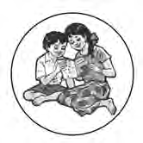

**Available in Marathi and English medium**

### ebalbharati

**Features**

* + Inclusion of prescribed subjects as per subject scheme.
  + Complete E- learning material based on textbook
  + In the form of audio-visual
  + Presentation of chapterwise content and inclusion of questions as per necessity
  + Inclusion of various activities, pictures, figures/diagrams, etc.
  + Use of animation for easy and simple learning
  + Inclusion of exercises.

E-learning material (Audio-Visual) for the Standards One to Twelve is available through Textbook Bureau, Balbharati for the students of Marathi and English medium.

For purchasing E-learning material...

* Register your demand by scanning the Q.R. Code given above.
* Register your demand for E-learning material by using Google play store and downloading ebalbharati app.
* Visit the following websites of the Textbook Bureau. [www.ebalbharati.in](http://www.ebalbharati.in/)

[www.balbharati.in](http://www.balbharati.in/)

